 | 
COUNCIL ASSESSMENT REPORT
HUNTER AND CENTRAL COAST REGIONAL PLANNING PANEL

PANEL REFERENCE & DA NUMBER | PPSHCC-86 – Central Coast –  DA/882/2021 (PAN-125315, CNR-26970)
PROPOSAL | Seniors Housing Development in 2 stages comprising, construction of a residential aged care facility (RACF) and independent living units (ILU’s) with associated on-site support services and communal facilities, parking, landscaping, demolition and other ancillary uses and works under SEPP (Housing for Seniors or People with a Disability) 2004.
ADDRESS | 19 Bias Avenue Lot 524 DP 823143 and  1 Harbour Street Lot 16 DP240129  Bateau Bay (known as Nareen Gardens)
APPLICANT | Gyde Consulting (formerly City Plan Strategy & Development)
OWNER | Uniting Church in Australia Property Trust NSW
DA LODGEMENT DATE | 12 August 2021
APPLICATION TYPE | Development Application with a Capital Investment Value > $30 million
REGIONALLY SIGNIFICANT CRITERIA | Clause 2, Schedule 7 of the SRD SEPP
CIV | $129,718,351 (excluding GST)
CLAUSE 4.6 REQUESTS | Yes - Clause 5 Part 1 Schedule 3 of SEPP (Housing for Seniors or People with a Disability) 2004
KEY SEPP/LEP | - State Environmental Planning Policy (SEPP) (Resilience and Hazards) 2021  - SEPP (Transport and Infrastructure) 2021  - SEPP (Planning Systems) 2021  - SEPP No.65 - Design Quality of Residential Apartment Development  - SEPP (Building Sustainability Index: BASIX)  - SEPP (Biodiversity and Conservation) 2021  - SEPP (Housing for Seniors or People with a Disability) 2004  - SEPP (Housing) 2021  - Central Coast Local Environmental Plan 2022  - Draft Remediation of Land SEPP  - Draft Design and Place SEPP  - Draft SEPP (Environment)  - Wyong Local Environmental Plan 2013  - Central Coast Local Environmental Plan 2022
TOTAL & UNIQUE SUBMISSIONS KEY ISSUES IN SUBMISSIONS | 173 unique submissions comprising 161 objections and 13 submissions in support and a petition containing 459 signatories (under the most recent notification).  The key issues raised include:  Social impacts, physical impacts (privacy, solar access, lighting), bulk, scale and density of development, boundary interface issues, environmental and visual impacts of significant tree removal, landscaping, internal solar access, noise and odour impacts, traffic generation and access, operational aspects, compliance with SEPP-HSPD and ADG and other planning controls.
DOCUMENTS SUBMITTED FOR CONSIDERATION | Council Assessment Report and Attachments A- F  - Attachment A: Draft Conditions of consent  - Attachment B: ADG Compliance Table  - Attachment C: Tables of Compliance – WLEP 2013 and DCP Planning Controls  - Attachment D: SEPP (Housing for Seniors and People with a Disability) 2004 Compliance Table  - Attachment E - Architectural Plans  - Attachment F: - Applicant’s Clause 4.6 Exception to Development Standards
SPECIAL INFRASTRUCTURE CONTRIBUTIONS (S7.24) | No
RECOMMENDATION | Approval subject to conditions
DRAFT CONDITIONS TO APPLICANT | No
SCHEDULED MEETING DATE | 16 November 2022
PLAN VERSION | 1 November 2022 Version No D-03 (& D-02 14 Sept 2022)
PREPARED BY | Principal Development Planner – S Pendergast
DATE OF REPORT | 9 November 2022

EXECUTIVE SUMMARY

- The application seeks approval for the construction of a seniors housing development in 2 stages comprising demolition works, construction of a residential aged care facility (RACF) and independent living units (ILU’s) with associated on-site support services and communal facilities, parking, landscaping, and other ancillary uses and works under SEPP (Housing for Seniors or People with a Disability) 2004.

- The site comprises two lots. The larger lot is 3.76ha and is zoned R1 General Residential and the smaller lot is 623m² and is zoned R2 Low Density Residential under Wyong Local Environmental Plan 2013.

- The larger lot currently contains the 'Nareen Gardens Village' retirement village owned and operated by Uniting since the 1980’s, comprising 114 seniors independent living units, a community hall, office/maintenance building, parking, access and landscaping. On the smaller lot, there is an existing dwelling house.

- The site is identified as bushfire prone land (Category 3 and buffer) and is subject to flooding. The site has a high groundwater and acid sulphate soils (ASS). The site is situated adjoining and to the east of Bateau Bay Sewage Treatment Plant. A significant rising sewer main (and associated easement) extends through the site from the treatment plant to an ocean outfall.

- The site is in an established and well serviced area close to shops, clubs and amenities. The beach and a National Park are located within 600m of the site.

- The site has frontage and existing accesses to Bias Avenue (north) and Altona Avenue (south). There is R2 zoned low density residential development located to the east and south of the site, and aged care residential to the north. Saltwater Creek (a 3m wide open concrete lined channel) extends adjacent to the western boundary of the site.

- During the assessment a number of issues were raised with the key issues including visual and environmental impacts from the substantial loss of trees; social impacts and affordable housing; bulk, height, scale and density; transition to R2 and residential interface; amenity impacts on neighbouring lots; lack of community consultation; traffic generation and access; impact on character of area and streetscape; biodiversity impacts; noise and odour impacts; servicing; flooding and drainage; ASS and groundwater; construction impacts and staging.

- The original notification of the DA from 27 August 2021 until 28 October 2021 resulted in 90 unique submissions comprising 85 objections and 5 submissions in favour of the proposal and a petition objecting to the proposal with 440 names.

- The applicant provided plans for a revised and substantially reduced proposal in May 2022. The amended plans were renotified resulting in a total of 173 unique submissions plus a petition 459 signatories. Of the 173 submissions received there were 161 objections and 13 submissions in favour of the proposal.

- Further amendments were made in September reducing the proposal to 180 apartments and further reducing the bulk and scale of Blocks 2 and 5 to provide a better transition and high level of amenity for residential interface.

- The application was referred to NSW Rural Fire Service (GTAs provided), NRAR (GTA’s provided) and Transport for NSW (no objection and comments provided).

- The proposal complies with the FSR (under Clause 45 of SEPP (HSPD) 2004) for both the R1 and R2 zoned part of the site. The R2 zoned part of the site complies with the maximum height of 8m under the SEPP; noting that the maximum height limit for the R1 zoned land under the SEPP is a standard that cannot be used as grounds to refuse consent. A merit assessment of the revised (further lowered) height for the proposal has concluded it is considered satisfactory.

- A Clause 4.6 Exception of Development Standards has been sought for a non-numerical variation to Clause 5(a) of Part 1 of Schedule 3 of SEPP (Housing for Seniors and People with a Disability) 2004. The proposal seeks variation to the requirement that all parking provision for the ILU’s under the standard must comply with the requirements for parking for persons with a disability set out in AS 2890.

- The jurisdictional prerequisites under WLEP 2013 and the relevant SEPPs have all been satisfied. The proposal generally complies with Council’s planning controls under Wyong DCP 2013 with minor variations sought to setbacks, provision of bicycle parking, visual privacy and waste arrangements.

- There is a 20% reduction in overall density from the previous scheme a reduction in units from 232 apartments to 186 apartments. One building containing 36 dwellings has been removed. Buildings located adjacent to the R2 zoned interface on the eastern boundary and to Altona Avenue have been lowered (with the removal of top floors and lowering of floor levels) and further setback from boundaries. The revised proposal is considered to suitably respond to the context of the site and the sensitive interfaces, particularly to the east and south.

- The revised proposal provides for a good quality urban design outcome. The facades of the buildings show a high level of articulation and a variety of different architectural treatments and finishes have been used. There is a generous provision of perimeter and on-site landscaping, deep soil planting and communal open space. There is retention of 60% more trees across the site than the original scheme, including all trees outside of the boundaries of the subject site. There is also the provision of 256 new trees within the site and additional landscape planting.

- The proposal will allow for the replacement of the existing ageing facility operating on the site with a new, contemporary facility which can deliver a better environment for care including the benefits of co-located ILU’s and a RACF to allow for ‘aging in place’. The proposal includes the provision of 23 affordable housing ILUs and satisfactory information has been provided detailing the transitional and alternative arrangements to demonstrate that no displacement of existing residents will occur.

Following a detailed assessment of the proposal, pursuant to Section 4.16(1)(b) of the EP&A Act, DA 882/2021 is recommended for approval subject to the conditions contained at Attachment A of this report.

- THE SITE AND LOCALITY

  - The Site

The site comprises two lots described as Lot 524 in DP 823143 (the larger lot zoned R1) and Lot 16 in DP 240129 (the smaller lot zoned R2). The total site area is 3.82 ha and levels on site range from RL7.30 to RL14.70 AHD. The site currently contains the 'Nareen Gardens Village' retirement village owned and operated by an arm of the Uniting Church in Australia, comprising 114 seniors independent living units (across 62 single storey buildings) and an associated community hall and an office/maintenance building (on the larger lot) and a dwelling house (on the smaller lot).

To the north, the site has a frontage to Bias Avenue (of approx. 40m) and to the south the site has a frontage to Altona Avenue (of approx. 95m). Access to the site is via both Bias and Altona Avenues with a private access extending midway through the site. The site has a low-density landscaped setting with significant native trees and landscaped gardens on all sides.

The site is identified as bushfire prone land (Category 3 and buffer) and is situated adjoining and to the east of Bateau Bay Sewage Treatment Plant. A significant rising sewer main and associated easement extends through the site from the treatment plant to an ocean outfall. Saltwater Creek (a 3m wide open concrete lined channel) extends adjacent to the western boundary of the site. To the east and south are low density residential dwelling houses and to the north is an existing residential care facility. The site has a relative flat topography. Some existing vegetation is included on the NSW Biodiversity Values Map. The site has high groundwater, acid sulphate soils and is subject to flooding.
Adjoining the site on the northern boundary is single-storey BUPA aged care facility is directly adjacent to the site, with the Elderslee Retirement Village and Reynold's Court retirement village and aged care facility further north.

Adjoining the site to east are 1 to 2-storey detached residential dwelling houses fronting Lakin Street with the rear yards to the subject site. Similar 1-2 storey residential dwelling houses sit opposite the site, on the southern side of Altona Avenue.

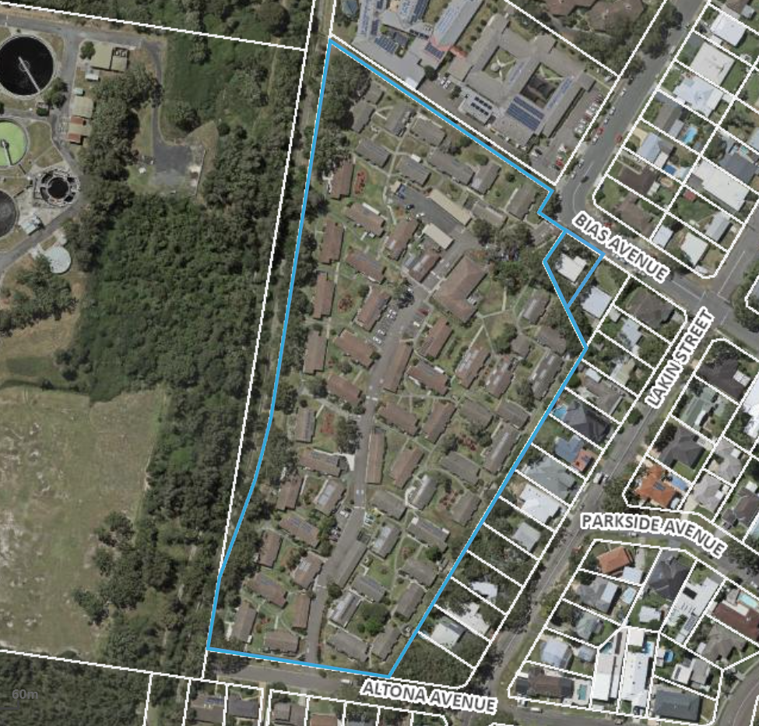
Above: Aerial view of site
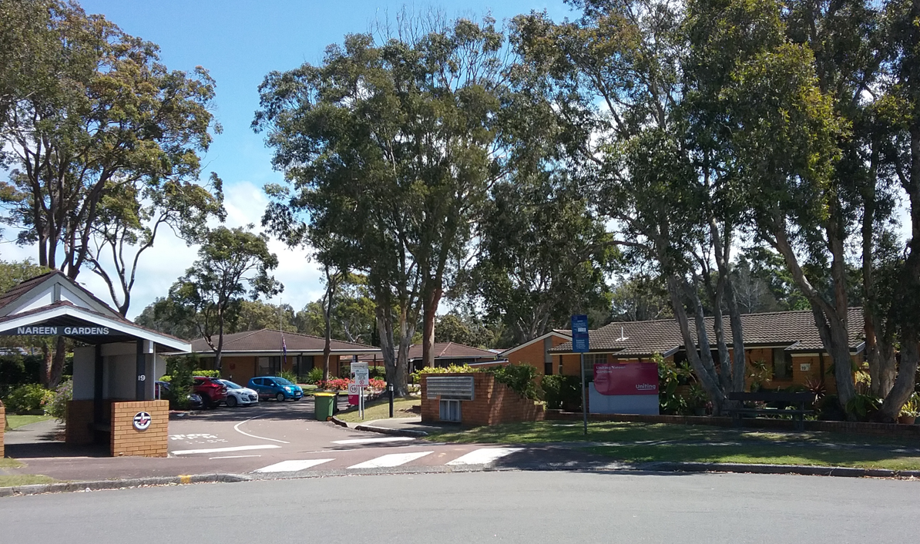
Above: Photo of site from Bias Avenue entry
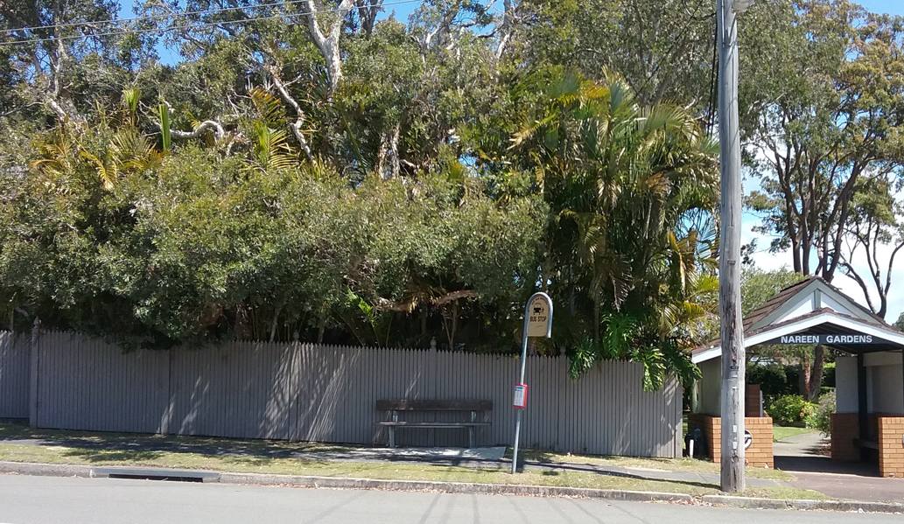
Above: Photo of bus stop in front of the site at 1 Harbour Street

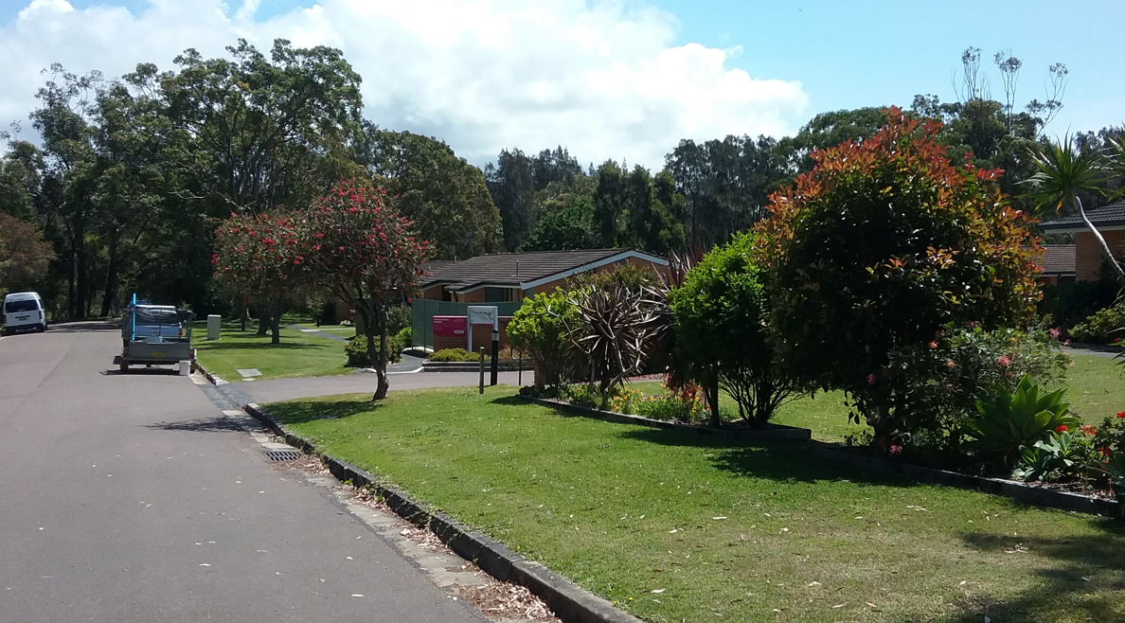
Above: Photo of site along Altona Avenue

  - The Locality

The site is located in the coastal and beachside area of Bateau Bay, approximately 700m from Shelly Beach and 450m to Bateau Bay Beach and Wyrrabalong National Park. The local area comprises a mix of land uses, including low-density residential, short-stay tourist accommodation, retirement villages and recreational facilities.

A local shopping strip is situated to the east (about 150m) and a large shopping centre Bateau Bay Square is 500m from the site to the north-west. The shopping centres include a range of services such as numerous retail outlets, several banks, a library, community centre and a medical centre with general practitioners.

Recreational facilities in proximity to the site include the Bateau Bay Bowling Club, the Entrance District Sporting and Community Centre, and associated sports fields (EDSACC sporting precinct), The Entrance Leagues Club, the Bateau Bay PCYC, and the Shelley Beach Golf Club. The Bateau Bay Golf Driving Range and Bateau Bay Ten Pin Bowl are situated to the south-west of the site. A public bus stop is located at the site's northern boundary fronting Bias Avenue, providing access to Route 21 bus services running between Gosford and The Entrance. Additional bus stops are located on The Entrance Road (approximately 550m walking distance from the site) which provide access to numerous services around the Central Coast.

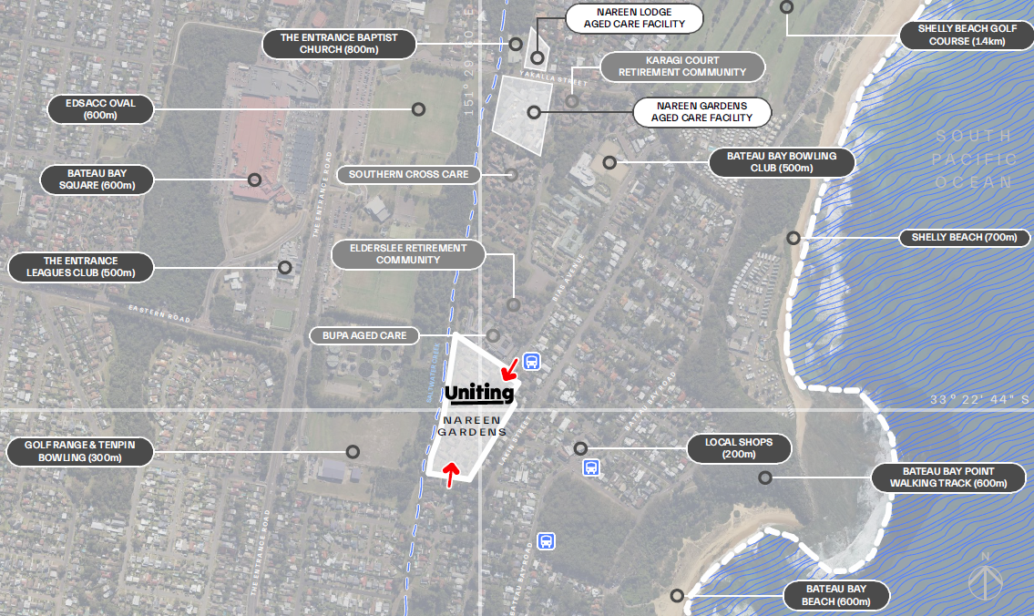
Above: Aerial map of surrounding area

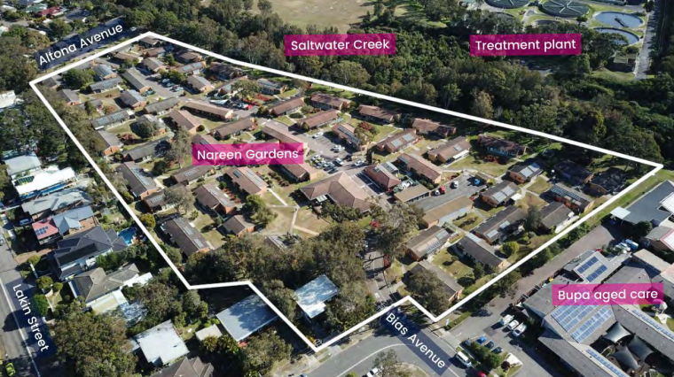
Above: Aerial view of site and immediate surrounds

- THE PROPOSAL AND BACKGROUND

  - The Proposal

The proposal seeks consent for the demolition of all structures on site and construction of a seniors housing development in stages comprising demolition works, construction of a residential care facility (RACF) with independent living units (ILU’s) with associated on-site support services and communal facilities, car parking, landscaping, and other ancillary works.

The proposal specifically includes:

- Demolition of all existing buildings and structures on the site.

- Staged construction of a seniors living development, comprising:
  - a 4 storey building with:
    - a residential aged care facility (RACF) with 160 beds on the first two levels and
    - 40 x Assisted Living Apartments (ALA’s/ILU’s) on the top two levels. The ALA’s comprise 35 x 1 bedroom units, 4 x 2 bedroom units and 1 x 3 bedroom unit.

  - 140 independent living units (ILUs) across five (5) buildings including:
    - Block 1 (3 levels & 27 ILU’s) comprising 5 x 1 bedroom, 17 x 2 bedroom & 3 x 3 bedroom units
    - Block 2 (3 levels & 25 ILU’s) comprising 5 x 1 bedroom, 11 x 2 bedroom & 9 x 3 bedroom units
    - Block 3 (4 levels & 39 ILU’s) comprising 6 x 1 bedroom, 24 x 2 bedroom & 9 x 3 bedroom units
    - Block 5 (3 levels & 25 ILU’s) comprising 4 x 1 bedroom, 11 x 2 bedroom & 10 x 3 bedroom units
    - Block 6 (2 levels & 24 ILU’s) comprising 16 x 1 bedroom, 4 x 2 bedroom & 4 x 3 bedroom units
  - on-site support and communal facilities, car parking, landscaping, and other associated works.

- Internal (private) roads and pedestrian pathways providing clearly separable pedestrian and vehicular linkages throughout the development.

- Parking facilities for residents and staff including a loading dock within the RACF building.

- Bulk earthworks, and tree removal.

- Provision of all necessary utility services.

- Comprehensive landscaping of the site including tree and shrub planting to offset tree removal.

- Provision of on-site support services and communal facilities within the RACF including a café, gym, chapel, cinema, pool and clubroom, hair salon/day spa, consulting/meeting rooms, multi-purpose space and chapel.

The development is to be carried out in two stages as follows:

Stage 1
    - Demolition of 57 ILU’s plus 1 Harbour Street
    - 55 ILU’s to remain & 2 ILU’s repurposed
    - Provision of an onsite carpark with 36 spaces for workers
    - Construction of Blocks 2, 5 & 6 containing 74 ILU’s
    - This stage will be further broken down into Stages 1A (early works) & Stage 1B Building works for 74 ILU’s and Stage 1C Altona Ave connection.

Stage 2
    - Demolition of 57 ILU’s plus community hall
    - Construction of Blocks 1 & 3 and RACF Building
    - Provision of an onsite carpark with 33 spaces for workers
    - This stage will be further broken down into stages 2A (early works), Stage 2B building works for 66 ILU’s and 160 Bed RACF and 40 ALA ILU’s and Stage 2C Bias Avenue connection.

The development will include a concierge service that will provide both reception and wayfinding services between the hours of 8am to 6pm daily, 7 days per week, to provide assistance to the residential community.

The RACF will operate 24 hours per day, 7 days per week, with 3 staff shifts per 24-hour period. The maximum number of staff on site associated with the development at any one time is 70. The employees associated with the use are generally as follows is as follows:

Use | Staff
RACF | 55 (mornings Mon-Fri)  51 (mornings Sat/Sun)  27 (afternoon shift)  9 (night shift)
Assisted Living & Home Community Care | 7 (mornings Mon-Sun)  6 (afternoon shift)  1 (night shift)
Communal Facilities | 6 (mornings Mon-Fri)  2 (mornings Sat/Sun)  4 (afternoon shift)  1 (night shift)
Other | 3 (mornings Mon-Fri)  3 (mornings Sat/Sun)  3 (afternoon shift)  1 (night shift)

Summary of amendments

In response to the public submissions, post-lodgement engagement with stakeholders and matters raised in Council correspondence (in Nov 2021) the applicant undertook substantial amendments to the plans to address the issues raised.

Having considered the applicant’s request to amend the development application under the provisions of Clause 55 of the Environmental Planning and Assessment Regulation 2000, Council is of the opinion that the amendments should be accepted as the amending documentation satisfactorily addresses the issues that have been raised in the request for information. A summary of the amendments is included below.
• Removal of block 4 in the centre of the site (containing 36 parking spaces, 36 units)
• Removal of the top floors of Blocks 1, 2 and 5
• An increase in setback of Blocks 2, 5 and 6 from the eastern site boundary and a subsequent increase in the landscape outcome/buffer along the eastern interface
• Removal of 6 Independent Living Units (ILUs) from the central portions of Blocks 2 and 5 along the eastern interface to create “breaks” in the built form
• Improvements to the southern interface of the development to Altona Street through the removal of the top floors and setting back of the remaining second floor of Blocks 1 and 3
• Addition of 36 ground level/courtyard ILUs (inclusive of 10 landscaped terraces along the eastern boundary) across Blocks 1, 2, 3, 5 and 6
• Decrease in the number of independent living units (ILUs) by 20% from 232 to 180. The reduction in the overall number of ILUs increases the proportion of affordable ILUs which is now 12.7%
• Increase in the size of the central Village Green by 48% and retention of the original plans for a children’s playground, barbeque area, activities and seated areas.
• Retention of 60% more trees across the site than the original scheme, including all trees outside of the boundaries of the subject site. Provision of 256 new trees within the site and additional landscape planting
• Removal of proposed signage from the application
• The construction staging has been consolidated down from three to two stages. This will result in a reduced length of construction and associated impact to the broader locality.
• • Additional landscaping at the frontage (and northern interface) of the RACF, as well as along the eastern site boundary, to further screen the RACF, Blocks 2 and 5 to further enhance the landscape setting of the site
• Blocks 2, 5 and 6 have been lowered in overall building height by 300mm, 300mm and 200mm respectively through a reduction of the structural floor to ceiling levels. Ceiling heights to remain at 2700mm in line with the Apartment Design Guideline requirements. The car park levels of Block 2, Block 5 and Block 6 are not able to be reduced any further due to: − the Probable Maximum Flood (PMF) level; Interaction with the water table and acid sulphate soils. Further lowering of the car park will inhibit the current natural ventilation; will require redesign of the internal boulevard and road network to support an access ramp that meets accessibility standards.

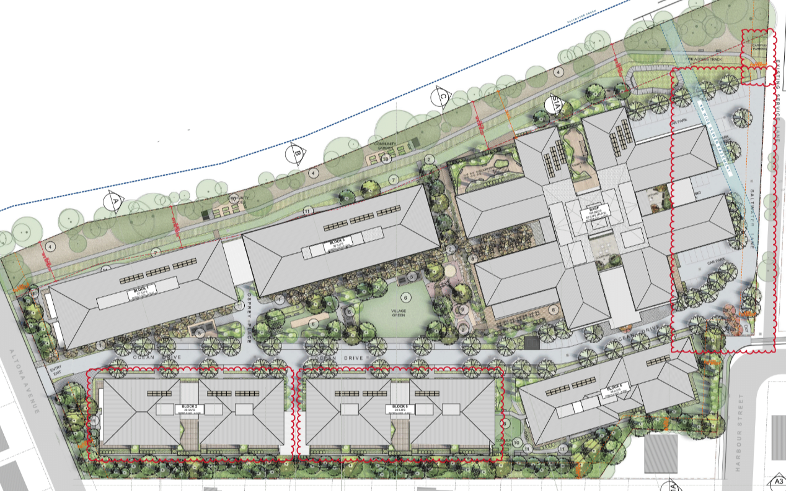
Above: Site plan for proposal
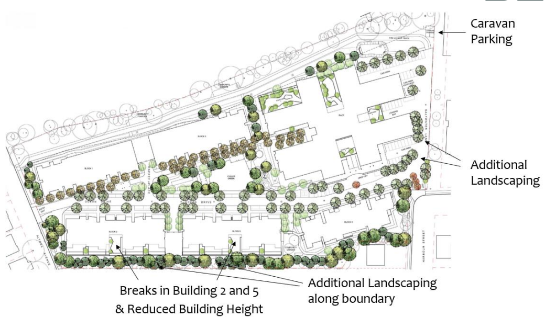

Above: Recent amendments to the development
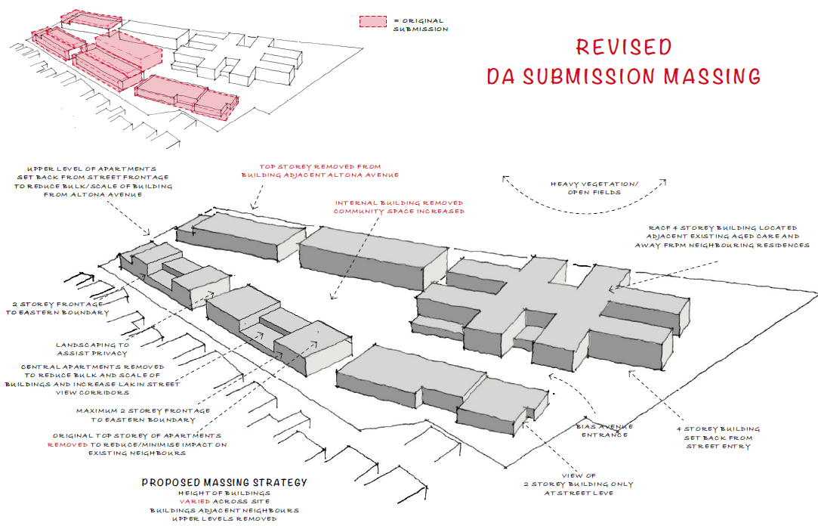
Above: Revised massing model with reductions in red.

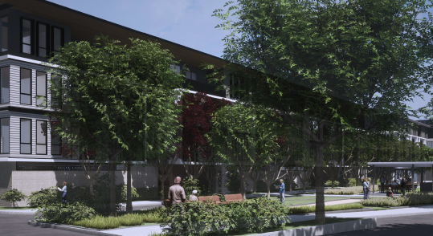
Above: Photomontage of development
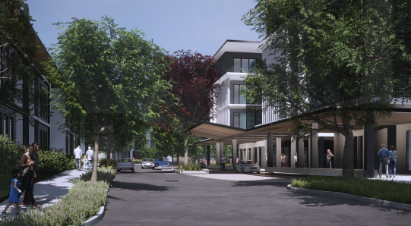
Above: Photomontage from site entry
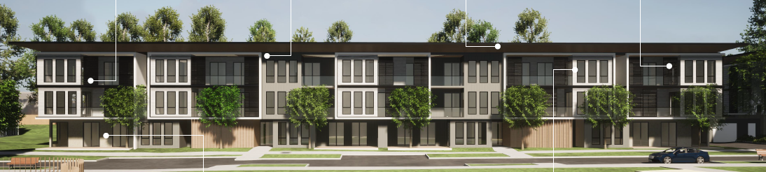
Above: View of Independent Living Units (ILU’s) external finishes

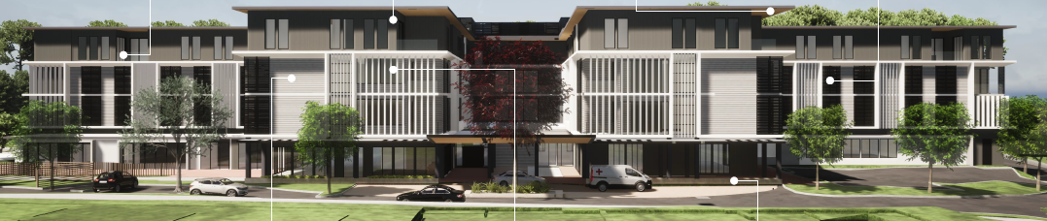
Above: View of Residential Aged Care Facility (RACF) external appearance

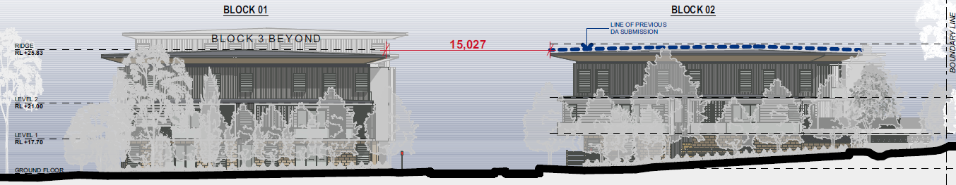
Above: Altona Avenue elevation and landscaping

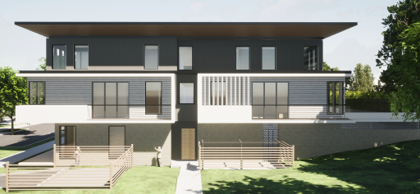
Southern elevation perspective Block 2 (Altona Ave) without landscaping shown

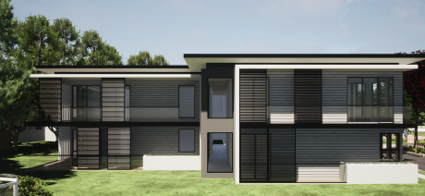
Above: North Elevation perspective Block 6 (Bias Avenue) without landscaping shown

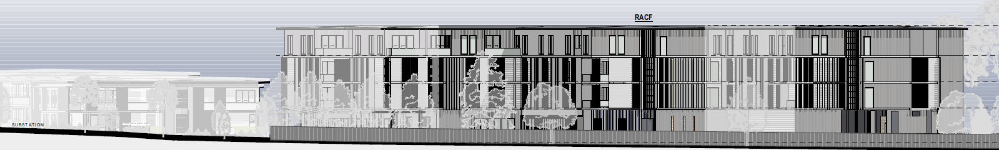
Above: Bias Ave (northern) elevation

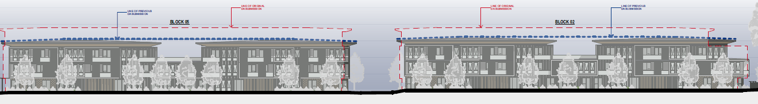
Above: Internal western elevation blocks 2 & 5

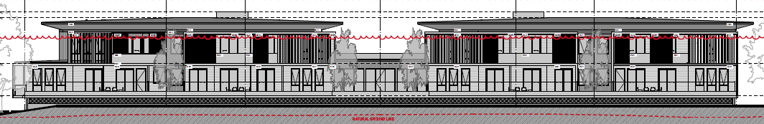
Above: East elevation Block 2

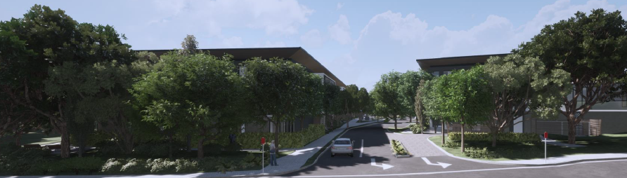
Above: Proposed Altona Avenue frontage including landscaping
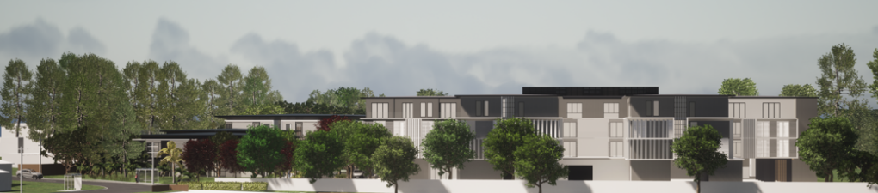
Above: North face of RACF
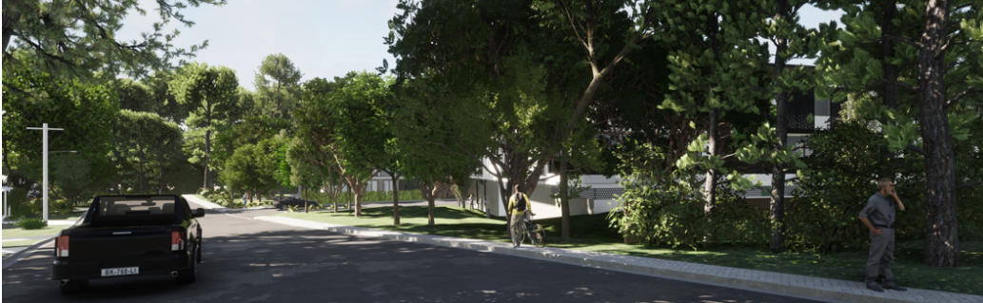
Above: Photomontage of view down Altona Ave
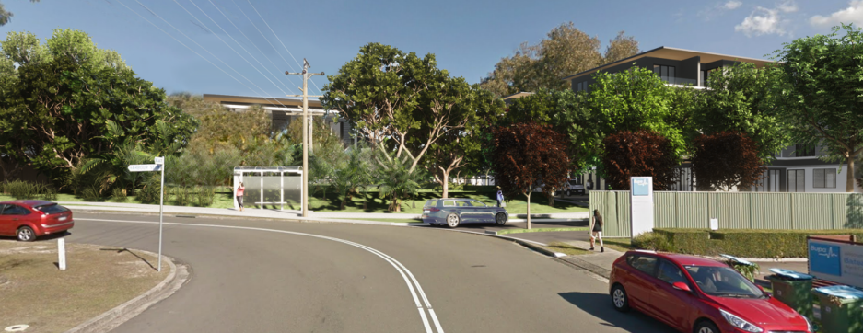
Above: Photomontage view of Bias Avenue entry

Table 1: Development Data
Control | Amended Proposal | Original proposal
Site area | 38, 240m² (total)  Comprising:  -37,000m² 19 Bias Ave (R1 zone)  -623m² 1 Harbour Street (R2 zone) | Unchanged
GFA | 33, 265m² (total)  12, 484m² RACF*  20,781m² ILU** | 39,504m²  12,171m² RACF  27,433m² ILU
FSR (combined) | 0.87:1 | 1.03:1
Clause 4.6 Requests | Yes, Parking dimension under SEPP HSPD Schedule | N/A
No of apartments | 180 apartments | 232 apartments
No. of RACF Beds | 160 Beds (no change) | 160 Beds
Max Height | 16.4m (RACF) (unchanged)  12.33m (Block 1) (reduced)  11.85m (Block 2) (reduced)  15.19m (Block 3) (unchanged)  Block 4: (removed)  11.02m (Block 5) (reduced)  9.75m (Block 6) (floor to ceiling height is 7.87m) (reduced) | 16.4m RACF  14.26m (Block 1)  13.27m (Block 2)  15.19m (Block 3)  13.88m (Block 4)  13.01m (Block 5)  8.91m (Block 6)
Landscaped area | 17,260m² (soft landscaping) 45% | 14,150m²
Car Parking spaces | 263 spaces  133 spaces - ILU’s  22 spaces ILU/ALA*** resident  70 spaces - RACF staff  20 spaces RACF resident  18 RACF visitor  Minibus – 1 space  Ambulance – 5 spaces  Caravan – 2 spaces | 309 spaces  180 ILU spaces  28 ALA residents  70 RACF spaces  43 RACF resident  16 RACF visitor  1 minibus  5 ambulance spaces  None provided
Setbacks  (Min)  Northern to adjoining RACF  Eastern (to Lakin Street lots)  Western (to Saltwater creek) | Bias Ave (Block 6):8.17m  Altona Ave (Block 2 & 1):6.6m & 8m  Northern Side (RACF): 9.85m  Eastern Side (Blocks 2 & 5): 9m  Eastern Side (Block 6): 6.2m  Western Side (Block 1 & 3):16m  Western Side RACF:19.8m | 5m  6m  8m  6m  4.2m  18m  19m
Loading | Waste collection separate exit (ILU’s) and more screening  RACF loading dock | Waste single same driveway access  No change
Communal Open Space | 26% (9942m²) (This is reflective of the deletion of Block 4 but also the removal of COS from the eastern side of Blocks 2 &5) | 25%
*RACF – Residential Aged Care Facility
**ILU – Independent Living Units
***ALA- Assisted Living Apartments

  - Background

A pre-lodgement meeting was held for the proposal on 24 March 2021 under PL/45/2021. A number of issues were were raised in relation to the proposal (and these were included in the meeting minutes). It is noted that a number of issues raised in pre-lodgement were not adequately addressed by the Development Application as lodged.

The issues raised include: Zone and boundary interface; Bulk, scale, and height of buildings; Photomontages from key areas and visual impacts; Floor space ratio calculations within the different zones; Community consultation; Social impacts; Amenity impacts both within the development and to adjoining properties; Compliance with the ADG; Consideration of DCP controls and setbacks; Landscaping screen planting to boundaries; Owners consent requirements for any pruning/removal of vegetation on adjoining properties; Arborist report requirements and protection of trees on adjoining properties; Acoustic requirements; Staging issues; SEPP (HSPD) 2004 compliance and Water and sewer servicing issues.

Although resolution of these issues has been achieved during the assessment via amendment and additional information of and to the DA, this process has prolonged and extended the timeframe that would otherwise have taken for the assessment.

The development application was lodged on 12 August 2021. A chronology of the development application since lodgement is outlined below including the Panel’s involvement (briefings, deferrals etc) with the application:

Table 2: Chronology of the DA
Date | Event
12 August 2021 | DA lodged
27 August 2021 | Exhibition of the application (to 27 Sept)  Exhibition period extended until 28 Oct 2021
20 August 2021 | DA referred to external agencies (TfNSW; RFS; NRAR)
14 November 2021 | Request for Information from Council to applicant
10 February 2022 | Panel briefing
1 March 2022 | Panel public (face to face and on-line) meeting held at Wyong
20 May 2022 | Amended plans lodged and accepted under Clause 55 of the Regulation 2000.
17 June 2022 | Exhibition of the amended application (to 15 July 2022)
12 July 2022 | Further information requested regarding stormwater and staging, and this was provided 12 July 2022.
3 August 2022 | Panel site inspection carried out including adjoining properties
9 August 2022 | Further information requested regarding impacts to residential interface with properties fronting Lakin Street; interface of RACF to Bias Avenue and impacts to sewer main and caravan parking.
17 August 2022 | Panel Briefing (discuss issues from Panel site visit)
7 October 2022 | Amended plans and information provided 13 Sept and 7 Oct 2022 and 1 November 2022 accepted under Clause 55 of the Regulation 2000
16 November 2022 | Panel Determination meeting

- STATUTORY CONSIDERATIONS

When determining a development application, the consent authority must take into consideration the matters outlined in Section 4.15(1) of the Environmental Planning and Assessment Act 1979 (‘EP&A Act’). These matters as are of relevance to the development application include the following:

- the provisions of any environmental planning instrument, proposed instrument, development control plan, planning agreement and the regulations
- the likely impacts of that development, including environmental impacts on both the natural and built environments, and social and economic impacts in the locality,
- the suitability of the site for the development,
- any submissions made in accordance with this Act or the regulations,
- the public interest.

These matters are further considered below.

The proposal is considered to be:

- Integrated Development (s4.46) under the Rural Fires Act 1997 and the Water Management Act 2000.

  - Section 4.15(1)(a)(i) - Provisions of Environmental Planning Instruments

The following Environmental Planning Instruments are relevant to this application:

- State Environmental Planning Policy (SEPP) (Resilience and Hazards) 2021
- SEPP (Transport and Infrastructure) 2021
- SEPP (Planning Systems) 2021
- SEPP No.65 - Design Quality of Residential Apartment Development
- SEPP (Building Sustainability Index: BASIX)
- SEPP (Housing for Seniors or People with a Disability) 2004
- SEPP (Housing) 2021
- SEPP (Biodiversity and Conservation) 2021
- Wyong Local Environmental Plan 2013
- Central Coast Local Environmental Plan 2022
- Draft Remediation of Land SEPP
- Draft Design and Place SEPP
- Draft SEPP (Environment)

A summary of the key matters for consideration arising from these State Environmental Planning Policies are outlined in Table 3 and considered in more detail below.

Table 3: Summary of Applicable State Environmental Planning Policies (Preconditions in bold)
EPI | Matters for Consideration | Comply (Y/N)
SEPP (Planning Systems) 2021 | - Clause 2.19 declares the proposal as regionally significant development pursuant to Clause 2 (General Development over $30 million) of Schedule 6 of the SEPP (Planning Systems) 2021. The CIV provided for the proposed development exceeds this value. | Y
SEPP 65- Design Quality of Residential Apartment Development | - Clause 30(2) - Design Quality Principles - The proposal is consistent with the design quality principles and the Apartment Design Guide (ADG) requirements, and this is discussed in detail later in the report. The proposal is satisfactory subject to conditions. | Y
SEPP (Resilience and Hazards) | - Chapter 3 (Remediation of Land) - Potential contamination and remediation has been considered in the assessment of the proposal. The site has had a historical use for aged care residential purposes. Preliminary geotechnical investigations of the site did not identify any materials suggesting the site is likely to be contaminated. These have been reviewed by Council’s relevant officer who has advised that the proposal is satisfactory subject to conditions.  - Chapter 2 (Coastal Management) - The site is not located within either the Coastal Use Area or the Coastal Environment Area. | Y
SEPP (Transport and Infrastructure) 2021 | - Clause 2.122 (& Schedule 3) - Traffic-generating development  The nearest classified road is The Entrance Road which is 350m to the west of the site, however the proposal includes parking provision (for 263 spaces) which exceeds the stated capacity under Column 2 of Schedule 3 of the SEPP. The DA was referred to TFNSW for comment and comments were received. | Y
SEPP (Housing for Seniors and People with a Disability) 2004 | The application has been lodged against the SEPP (Housing for Seniors and People with a Disability) 2004 and a table of compliance (attachment D) against the SEPP provisions is attached to the report. | Y  (except for the parking standard)
BASIX SEPP | Basix Certificate 1188112M (dated 30 Sept 2022) has been provided for the development. No compliance issues have been identified subject to the imposition of conditions on any consent granted. | Y
SEPP (Biodiversity & Conservation) 2021 | Before consent may be granted to a development application Council must first assess whether the development is likely to have any impact on koalas or koala habitat. The BDAR concluded that the site does not contain core koala habitat, and no further assessment under the Koala SEPP 2021 is required. | Y
SEPP (Housing) 2021 | This SEPP commenced on 26 Nov 2021.The DA was lodged prior to the commencement of this SEPP and the savings provisions apply. | N/A
CCLEP 2022 | CCLEP 2022 commenced 1 August 202. The savings provisions apply to this DA which was lodged prior to the commencement of CCLEP 2022. Under CCLEP 2022, the site retains its R1 and R2 Residential zonings and Seniors housing remains permissible with consent. | Y
WLEP 2013 | Clause 2.3 - Zone objectives and Land Use Table  Clause 4.3 - Height  Clause 4.4 - FSR  Clause 5.10 - Heritage conservation  Clause 5.21 - Flood Planning  Clause 7.1 - Acid Sulphate Soils  Clause 7.3 - Floodplain Risk Management  Clause 7.9 - Essential Services | Y
WDCP 2013 | -Chapter 1.2 - Notification of Development Proposals.  -Chapter 2.4 - Multiple Dwelling Residential Development  -Chapter 2.1 - Parking and Access  -Chapter 3.1 - Site Waste Management  -Chapter 3.3 - Floodplain Management | Y  (minor variations discussed)
CCDCP 2022 | The application predates the operation of CCDCP 2022 and therefore Wyong DCP 2013 applies. There is no significant change in relevant DCP controls for parking or other matters under CCDCP 2022. | Y
Draft EPIs | Draft SEPP (Remediation) 2018. No compliance issues identified. | Y

State Environmental Planning Policy (Planning Systems) 2021

State Environmental Planning Policy (Planning Systems) 2021 applies to the proposal as it identifies if development is regionally significant development. In this case, pursuant to s. 2.19, the proposal is a regionally significant development as it satisfies the criteria in s. 2 (General Development over $30 million) of Schedule 6 of the SEPP (Planning Systems) 2021. The revised proposal is development with a CIV of $129,718,351 (excluding GST). Accordingly, the Hunter and Central Coast Regional Planning Panel is the consent authority for the application. The proposal is consistent with this Policy.

State Environmental Planning Policy (Resilience and Hazards) 2021

• Chapter 4 – Remediation of Land

The provisions of State Environmental Planning Policy (Resilience and Hazards) 2021 (‘SEPP RH’) Chapter 3 (Remediation of Land) have been considered in the assessment of the development application.

Section 4.6 of SEPP RH requires consent authorities to consider whether the land is contaminated, and if the land is contaminated, it is satisfied that the land is suitable in its contaminated state (or will be suitable, after remediation) for the purpose for which the development is proposed to be carried out.

Preliminary geotechnical investigations of the site did not identify any materials within the ground profile suggesting the site is likely to be contaminated. With consideration of the historical use of the site for seniors housing and aged care purposes, it is reasonable to conclude that there is a low likelihood of contamination, and the site is suitable for the development in accordance with s. 7. The proposal is considered to be consistent with the provisions of Chapter 4 of the SEPP.

- Chapter 2 – Coastal Management

The site is not within either the Coastal Environment Area or the Coastal Use Area.

State Environmental Planning Policy (Building Sustainability Index: BASIX)

State Environmental Planning Policy – Building Sustainability Index BASIX– 2004 (‘BASIX SEPP’) applies as the proposed ‘self-contained dwellings’ component constitutes ‘BASIX affected development’ as defined within the Regulations. The objectives of this Policy are to ensure that the performance of the development satisfies the requirements to achieve water and thermal comfort standards that will promote a more sustainable development.

A Basix Certificate 1188112M (dated 30 Sept 2022) and Basix Assessment Report has been provided for the latest revised development proposal for 180 dwellings. The Certificate demonstrates the proposed development satisfies the relevant water, thermal and energy commitments as required by the BASIX SEPP. The proposal is consistent with the BASIX SEPP subject to the recommended conditions of consent.

State Environmental Planning Policy (Biodiversity & Conservation) 2021

This SEPP contains the provisions formerly contained within SEPP (Koala Habitat Protection) 2021. Prior to the granting of development consent under State Environmental Planning Policy (Biodiversity & Conservation) 2021, the consent authority must first assess whether the development is likely to have any impact on koalas or koala habitat.

It has been identified that the site contains highly suitable koala habitat, being where 15% or greater of the total number of trees within any plant community type are the regionally relevant species of those listed in Schedule 2 of the SEPP. The site assessment undertaken for the BDARprepared by NARLA Environmental at Appendix U confirms that during the site inspection, there was no sign of koalas or koala occupancy (scats, scratch marks etc) found on the site. Additionally, there is no record of a koala siting within 2.5km of the site within the last 18 months. The BDAR concludes that the site does not contain core koala habitat, and no further assessed under the Koala SEPP 2021 is required.

State Environmental Planning Policy (Transport and Infrastructure) 2021

- Section 2.122 - Traffic-generating development

The proposal includes parking provision for 263 spaces which is a type and scale of development specified under Column 2 of Schedule 3 of SEPP (Transport and Infrastructure) 2021. Section 2.122 and Column 2 of Schedule 3 specifies that proposed car parks with 200 or more car parking spaces on a site with access to a road are traffic generating development which must not be carried out unless written notice of the application is given to Transport for NSW (TfNSW) and any response received with 21 days is taken into consideration.

The application was referred to TfNSW for comment who advised:

TfNSW has reviewed the information provided and raises no objection to the proposed development as it is considered there will be no significant impact on the nearby classified (State) road network.

TfNSW also included recommended matters for consideration that have been considered in the assessment. Section 2.122 (4) also requires that before determining a DA for development to which this section applies, the consent authority must take into consideration-

(ii) the accessibility of the site concerned, including—
(A) the efficiency of movement of people and freight to and from the site and the extent of multi-purpose trips, and
(B) the potential to minimise the need for travel by car and to maximise movement of freight in containers or bulk freight by rail, and
(iii) any potential traffic safety, road congestion or parking implications of the development.

Council’s Traffic and Transport Engineer has assessed the traffic impacts of the development and has advised that it is anticipated that the proposed development will not have a significant impact on the surrounding road network and the parking exceeds the SEPP HSPD and DCP requirements. The submitted Transport Management Plan addresses a number of issues including public transport, walking and cycling and how the use of these alternative transport modes can be encouraged by staff, residents and visitors to the facility. The proposal is satisfactory with regard to meeting the requirements of the SEPP.

State Environmental Planning Policy No. 65 – Design Quality of Residential Apartment Building and the Apartment Design Guideline (ADG)

State Environmental Planning Policy 65 (Design Quality of Residential Apartment Development) (SEPP 65) applies to the development and requires the design quality of the development to be taken into consideration and evaluated against the design quality principles. Additionally, cl. 30(2) of SEPP 65 requires such development to be designed in accordance with the associated Apartment Design Guide (ADG) as follows:

30(2) Development consent must not be granted if, in the opinion of the consent authority, the development or modification does not demonstrate that adequate regard has been given to:
(a) the design quality principles, and
(b) the objectives specified in the Apartment Design Guide for the relevant design criteria.

The proposal has been designed in accordance with the ADG and a compliance table summarising the proposal against the ADG has been included as an attachment to the report (refer Attachment B). A revised Design Verification Statement has been prepared for the amended proposal. A number of minor variations are sought to the ADG criteria and are outlined below.

Although all balconies and courtyards within the block buildings comply with the minimum POS area requirements, there are five Assisted Living Apartments on Level 3 of the RACF which do not strictly achieve compliance with the required minimum area for the balcony. The extent of shortfall is minor and can be readily corrected via a condition requiring compliance under a plan amendment for these balconies prior to issue of the Construction Certificate.

The following table considers the proposal against the SEPP 65 design quality principles and includes the applicant’s relevant design comments.

Principles | Proposal (Applicant’s response)
Context & Neighbourhood Character | Context: Local Precinct  - The local precinct already has a number of other Seniors living facilities, some of which are located directly adjacent the site.  - The residential areas adjacent, are a mix of older housing stock, which are slowly being either upgraded or replaced by newer dwellings which more reflect the “coastal” feel of the area.  - As per other Central Coast precincts there is a mix of ageing residents and younger family groups.  - The new development recognises both of these demographics and provides on-site facilities to suit.  - The development’s architectural style also responds to the coastal vernacular.  Context: Access to Services  - The existing site is currently occupied by low scale seniors living operated by Uniting.  - The local precinct already has a number of other Seniors living facilities, some of which are located directly adjacent the site.  - Walking distance to public transport (bus stop at Bias Avenue entry to site)  - Close proximity to Bateau Bay Shopping centre (1.6km)  - Close proximity to Shelley Beach (1.3km)  - Close proximity to Shelley each Golf Club (1.1km)  - Close proximity to the M1 Motorway (13.3km)  - Close proximity to The Entrance (5km)  - Close proximity to Berkeley Vale Private Hospital (8.3km)
Built Form and  Scale | Setbacks – proposed buildings comply with DCP setbacks. Buildings to the eastern boundary have been set back 13.6m (6.0m required)  The buildings have been arranged to provide a series of community open spaces connected by landscaped “pedestrian” streets. This provides connectivity to public domain areas for the residents, and view corridors for the residents. Buildings are generally separated by minimum 12m, which allows sunlight to penetrate, and a comfortable distance from balcony to balcony.  The buildings are articulated with a variety of balcony treatments and recesses in the facades (no blank walls) The upper floor of the buildings adjacent the neighbours on the eastern side have been set back for greater privacy.  Building mass responds to the topography of the site, which generally falls from the eastern boundary down to the western boundary. The buildings on the eastern zone are lower, and match the height of the existing 2 storey dwellings along Lakin Street.  Similarly, the buildings at the southern Altona Avenue and the northern Bias Avenue street frontages are kept at a lower height in response to the existing dwellings on the other side of these streets.  Buildings located towards the western zone of the site are located at a lower RL, and can afford to be taller with little impact on the surrounding neighbourhood.
Density | The proposed development provides a high level of on site amenity for the residents, including social and recreational facilities (café, club rooms, function rooms, pool, gym, cinema), and external landscaped community areas (walking paths, open green areas, community garden, bbq and play areas).  This density can be sustained due to the proximity to existing infrastructure  Walking distance to public transport.  Close proximity to Bateau Bay Shopping Centre and medical centres  Close proximity to beach, golf and bowling clubs.
Sustainability | Ventilation – 60% of all residential units and housing have cross ventilation,  Sunlight – 70% of all residential units (126 out of 180 units) have min 3 hours direct sunlight.  The siting of the apartment buildings responds to the site orientation, to maximise solar access, whilst orientating towards long distance views to the west, and internal landscaped gardens.  Substantial landscaping takes advantage of large areas of deep soil zones, and the use of endemic species.  Internal spaces are generous, with glazed doors opening onto large, shaded balconies.  Energy saving strategies across the site have been investigated, and include passive thermal design principles
Landscape | The Landscape Design has been an integral part of the overall Design Strategy of the development. Detail consideration has been given to the design of usable external spaces, ease of access, privacy and sustainability.  The use of endemic species has been prioritised.  Pathways with low level ramping provides ease of access for seniors. Plant species have been selected to suit local climate conditions.  Tree planting within appropriate deep soil zones provide visual interest, and have been located for shade and amenity.  The planting along the street frontage has been selected to filter the new buildings behind at high level, whilst providing shading of safe clear zones at low level. The streetscape planting is substantially denser than the current condition.  The zone between the neighbouring Lakin Street residences and the new apartments along the eastern boundary has been detailed with dense screening trees above the fence line (for privacy), with clear areas below to assist passive surveillance.
Amenity | The residences have been designed in accordance with both the Seniors Living SEPP and the ADG controls and guidelines, with accessibility, privacy, ventilation, solar access, storage requirements achieved as recommended.  The mix of residential units, individual dwellings and independent living units includes 1, 2 & 3 bedroom apartments and a 160 bed RACF.  Accessibility within the buildings and external areas has been considered and provided.  On-site services have been accommodated, including visiting health care consultants, hairdresser, function areas (family gatherings), swimming pool, cinema and gym.  Facilities available for use by the precinct neighbours include: Café, BBQ areas, Children’s Playground, walking tracks, function rooms.
Safety | The Residents throughout the development have secure access from public areas.  Passive surveillance is available to all areas. Ground floor units provide passive surveillance to most open spaces.  All resident parking is enclosed, with a security access system.  Residents can move between areas with minimal crossing of roads.  The central common space is viewable from 4 of the 5 Residential Blocks.
Housing Diversity and Social interaction | ILU Apartments  - Provides a mix of 1, 2 & 3 bed apartments to cater for various household requirements (singles and Couples, accommodation for short term visitors)  - Provides opportunity for close connection between residents  - Apartments for persons requiring Assisted Living are provided  - 23 Affordable housing apartments have been provided  RACF  - Number of rooms: 160  - Accommodates Low-care through to High-care / Dementia  Communal Space  - A range of communal spaces provided include: Gym, Swimming Pool, Club Room, Hairdresser, Cinema, Café, Function rooms and external BBQ areas.  - Accommodates Low-care through to High-care / Dementia
Aesthetics | The development has been designed to create an internal “Village” within the  existing residential neighbourhood.  To achieve this, the strategy has been to focus on the following design elements  - Landscaped pathways to prioritise “pedestrian” circulation and connection throughout the village  - Open areas for community use  - Maintain connection between all major components (no isolated areas)  - Building scale to be “coastal residential” not commercial / institutional  - Variance in materials, based on a limited palette, to achieve a balance between consistency of detail, timelessness and a subtle variety of textures / colours  - Each of the facades of the main components (Apartments and RACF) are treated differently but sit comfortably together.

- ADG Objective 3F-1 – Adequate building separation distances are shared equitably between neighbouring sites, to achieve reasonable levels of external and internal visual privacy
Design Guidance - Separation between windows and balconies is provided to ensure visual privacy is achieved. Minimum required separation distances from buildings to the side and rear boundaries are as follows:
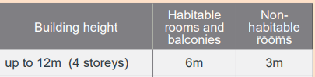
Note: Separation distances between buildings on the same site should combine required building separations depending on the type of room

The amended proposal includes an internal separation distance between the newly created voids in Blocks 2 and 5 of 9m that are less than 12m apart. It is noted that these units are dual aspect, and these windows are highlight windows and are considered satisfactory as this is not the primary aspect for these units. The design as proposed is considered a reasonable response to the site context.

- ADG Objective 4F-1 Common circulation spaces achieve good amenity and properly service the number of apartments
Design criteria- 1. The maximum number of apartments off a circulation core on a single level is eight.

Within each building block, there are 12 units per level with 2 lift separate cores with a door positioned midway between each of the lift cores. This arrangement does not strictly comply. Within the development this arrangement is needed to allow for staff to readily travel between units to provide aged care services. The layout is considered satisfactory as it is understood that suitable security arrangements will be in place for each building and the site is to be centrally managed (by Uniting) unlike typical residential buildings where there is private ownership of each unit. In this scenario, the common circulation spaces are considered suitable for the nature of the site and will promote safety and social interaction.

State Environmental Planning Policy (Housing for Seniors or People with a Disability) 2004

The proposal has been lodged under the provisions of State Environmental Planning Policy (Housing for Seniors or People with a Disability) 2004 (SEPP HSPD). The proposal provides for Seniors housing as defined under the SEPP and WLEP 2013. Seniors housing is permissible within the R1 and R2 zones under WLEP 2013. Accordingly, the proposal is not reliant on SEPP HSPD for permissibility and a site compatibility certificate is not required under Clause 24(1A). The proposed development does rely upon the Part 6 Vertical Villages provisions of SEPP HSPD that allow for an FSR development bonus to the applicable FSR.

The following definition under cl. 10 of the SEPP is relevant to the proposal and reads:

seniors housing is residential accommodation that is, or is intended to be, used permanently for seniors or people with a disability consisting of—
(a) a residential care facility, or
(b) a hostel, or
(c) a group of self-contained dwellings, or
(d) a combination of these,
but does not include a hospital.

Note—
The concept of seniors housing is intended to be a shorthand phrase encompassing both housing for seniors and for people with a disability. This Policy deals with both kinds of housing. Accommodation provided by seniors housing does not have to be limited to seniors or people with a disability. Clause 18 provides that seniors housing may be used for the accommodation of the following—
(a) seniors or people who have a disability,
(b) people who live within the same household with seniors or people who have a disability,
(c) staff employed to assist in the administration of and provision of services to housing provided under this Policy.
As defined by cl. 10, 11 and13 the development comprises ‘seniors housing’ including a ‘Residential Care Facility’, ‘self-contained dwellings’ and ‘serviced self-care housing’ which have the following definitions under Clause 13:
self-contained dwelling In this Policy, a self-contained dwelling is a dwelling or part of a building (other than a hostel), whether attached to another dwelling or not, housing seniors or people with a disability, where private facilities for significant cooking, sleeping and washing are included in the dwelling or part of the building, but where clothes washing facilities or other facilities for use in connection with the dwelling or part of the building may be provided on a shared basis.
serviced self-care housing is seniors housing that consists of self-contained dwellings where the following services are available on the site: meals, cleaning services, personal care, nursing care.
residential care facility is residential accommodation for seniors or people with a disability that includes—
(a) meals and cleaning services, and
(b) personal care or nursing care, or both, and
(c) appropriate staffing, furniture, furnishings and equipment for the provision of that accommodation and care,
not being a dwelling, hostel, hospital or psychiatric facility.
Note—The Aged Care Act 1997 of the Commonwealth requires residential care facilities to which that Act applies to meet certain requirements.

The development complies with the site-related requirements under Part 2 including:

- Clause 26 Location and access to facilities: There are bus stops in front of the site accessed via paths that meet the physical access and gradients and that are serviced by buses connecting to retail/commercial centres in a manner that complies with the service frequency needed under the clause.

- Clause 27 Bushfire prone land: The development is a Special Fire Protection Purpose as defined by the Rural Fires Act 1997 on bushfire prone land and the NSW Rural Fire Service have issued GTA’s via a Bushfire Safety Authority.
- Clause 28 Water and Sewer; Reticulate Water and Sewer are available to the site to service the development. The development will require a Section 307 Certificate under the Water Management Act 2000.
- Site Compatibility Criteria: The development meets all the criteria referred to under cl. 25 (5) (b) (i), (iii) and (v). The proposal is compatible with the surrounding land uses having regard to the natural environment in the vicinity of the site; the provision of services and infrastructure needed to service the development and the impacts of the proposed bulk, scale, built form and character of the proposal in surrounding land uses.

The amended proposal satisfactorily addresses the design principles outlined under cl. 33 – 39.

In accordance with cl. 40(4) which applies to a residential zone in which a residential flat building is not permitted (being the R2 zoned part of the site), the part of the development (ie. northern part of Block 6) located within the R2 zone complies with the maximum permitted height of 8 metres or less and is not more than 2 storeys. The proposed maximum floor to ceiling height for Block 6 is 7.87m which complies. In this regard, Height is defined under Clause 3 of the SEPP HSPD and refer to the distance measured vertically from any point on the ceiling of the topmost floor of the building to the ground level immediately below that point. It is noted that subclause 40(4)(c) does not apply to development by way of subclause 40(5) as the application has been made by a social housing provider.

The proposed development relies upon the ‘Vertical Villages’ provisions of the SEPP (under Part 6) that allow for a development bonus under Clause 45(2) to the existing applicable FSR (WDCP of 0.6:1) for an additional 0.5:1. This equates to a maximum FSR of 1.1:1 and the proposal complies with this maximum FSR. It is noted that the pursuant to subclause 45(4) GFA of 451m² for the on-site support services has been excluded from the FSR calculation. For the purposes of subclause 45(5) it is noted that the on-site services does not exceed 50% of the GFA. Under subclause 45(6), the bonus FSR will only apply where:

- the proposed development will deliver on-site support services for its residents, and
- at least 10% of the dwellings for the accommodation of residents in the proposed development will be affordable places, and
- the applicant identifies, to the satisfaction of the consent authority, which of the dwellings for the accommodation of residents in the proposed development will be set aside as affordable places.

In satisfaction of subclause 45(6) above, the proposal includes the provision of on-site support services for residents; 12.7% of the total dwellings (23) will be affordable places and these have been identified as:
15 Units - R.1.01; R.1.02; R.1.06; R.1.09; R.1.10; R.2.01; R.2.02; R.2.05; R.2.10; R.3.01; R.3.09; R.3.10; R.4.01; R.4.02; R.4.10 on level 3 of the RACF building
6 Units – 6.G.03; 6.G.04; 6.G.05; 6.1.03; 6.1.04; 6.1.05 at ground and level 1 in Block 6
2 Units – 3.1.03 and 3.1.05 at Level 1 in Block 3.

Subclause 45(7) states: A consent authority must not refuse consent as referred to in subclause (2) only because the proposed development does not comply with a standard referred to in clause 40 (4) (a), 48 (a), 49 (a) or 50 (a). These clauses all relate to the maximum permitted building height of 8 metres. In this regard, the maximum height for Blocks 1, 2, 3, 5 and the RACF building all exceed 8m. However, under the SEPP this height maximum is not a development standard that can be used to refuse consent.

Under Part 7 (cl. 48), the proposed RACF complies with the FSR of 1:1 and landscaped area minimum of 25m² per bed and parking provision (for 51 spaces) applying to the RACF but does not comply with the maximum height of 8 metres. Again, it is noted that these ‘deemed approval” standards are not development standards to be used to refuse development consent for residential care facilities. An assessment of the merits of the proposed building height for the RACF has been carried out and the height is considered suitable within the site context.

Under cl 50, the proposed self-contained dwellings comply with the applicable landscaped area minimum of 35m² per dwelling (for a social housing provider), deep soil zones (over 15% of the site area & predominantly in the boundary setbacks), private open space provision and parking provision. The nominated FSR under subclause50(b) of 0.5:1 is over-ridden by the bonus provisions that apply to the development under subclause 45(2) and proposal complies with the resulting FSR of 1.1:1. As noted above, the proposal does not comply with the maximum height of 8 metres however, it is noted that this is a ‘deemed approval” standard rather than a development standard to be used to refuse development consent for self-contained dwellings.

In accordance with Clause 18, a condition will be recommended restricting future occupation of the seniors housing and subclause 45(8) for the provision of the affordable housing. In accordance with the requirements that residential care facilities for seniors are to have fire sprinkler systems under Clauses 22 and 55, a Fire Safety Schedule will be prepared for the Construction Certificate. The proposed buildings have been designed to include fire safety sprinklers, fire exits and fire extinguishers on all floors.

The revised design is generally consistent with the accessibility standards within Schedule 3 (as outlined in the SEPP compliance table under Appendix D) with the exception of the car parking design standard set out in Clause 5(a) under Part 1of Schedule 3. This is discussed below and in the assessment section of the report with regard to cl.4.6 of WLEP 2013.

The application seeks a variation to cl. 5 of Schedule 3 of the SEPP HSPD which applies to parking to be provided for the self-contained dwellings and reads:

5 Private car accommodation
If car parking (not being car parking for employees) is provided—
(a) car parking spaces must comply with the requirements for parking for persons with a disability set out in AS 2890, and
(b) 5% of the total number of car parking spaces (or at least one space if there are fewer than 20 spaces) must be designed to enable the width of the spaces to be increased to 3.8 metres, and
(c) any garage must have a power-operated door, or there must be a power point and an area for motor or control rods to enable a power-operated door to be installed at a later date.

The car parking spaces for the self-contained dwellings do not comply with the above requirements. The majority of car parking spaces for the self-contained dwellings have standard vehicle space dimensions and do not comply with the parking for persons with a disability set out in AS 2890 as required by cl.5(a) of sch. 3. 15 spaces (or 9.7%) of the total 155 car parking spaces for the self-contained dwellings have been provided as accessible spaces. These 15 spaces are designed to comply as follows:
- 6 spaces having a space dimension of 3.8m and
- 9 spaces designed in accordance with AS 2890.6 (2009) with a shared space.

The proposal complies with cl 5(c) as all the garage doors are to be power operated.

The application has been accompanied by a Clause 4.6 Exception to Development Standards submission and related legal advice that demonstrates that Sch. 3 matters are capable of variation) pursuant to cl 4.6 and both these documents have been attached to the report.

Since SEPP HSPD was adopted in 2004, AS2890 has been updated with respect to the standards for accessible parking as set out within AS2890.6 (2009). Under AS2890.6 (2009), accessible parking spaces require a width of 2.4 metres and a length of 5.4 metres with an adjacent shared zone with the same dimensions. At the time of the original drafting of SEPP HSPD a shared space was not required under AS2890.The latest standard for accessible parking spaces results in a significantly larger parking area demand than the original requirement in 2004 being a 3.2 metre wide for a space. The proposal includes the provision of standard dimension carparking spaces with allocated accessible carparking and while the proposed arrangement does not satisfy Sch3 of SEPP HSPD in terms of either the 2004 or the 2009 requirement, The applicant contends that the development is acceptable because:

- Requiring 100% of parking spaces to be accessible is not only onerous but is not considered to be necessary to meet demand…The proposed accessible car parking provision for the ILUs has been determined on the basis of anticipated demand by Uniting (and precedent set in other seniors accommodation developments)

- The proposed carparking provision across the development, including for the ILUs (as relevant to this clause) is well in excess of the minimum requirements of the SEPP.

- …the proposed parking provision far exceeds the "standard that cannot be used to refuse consent" parking provision under Clause 50(h)(ii).

- …it should be noted that “accessible” carparking spaces are designed to enable wheelchair access. Statistically, the requirement for all carparking within a SEPP Seniors development to be accessible is not conducive to current disability standards. Approximately 18% of the population have a disability, 4.4% of these people use a wheelchair, representing less than 1% of the total population.

- Whilst accessible carparking is nominated within each carparking area, other spaces designed as “standard” spaces that will enable adaption to the current AS2890.6 (2009) arrangement through the provision of appropriate line marking. Due to the surplus of required carparking (with regard to SEPP requirements for social housing providers), we (the Access Consultant) consider that the current arrangement of carparking is fit-for-purpose. Carparking can be allocated to ILUs specific to the individual need of the residents. The quantum and design of parking enables flexibility in both configuration and allocation of carparking for the residents.

- For this development, where the ILUs are not privately owned, there is flexibility in the provision of carparking. There is the ability to provide the thirty eight (38) required carparking spaces in an accessible arrangement if needed by the residents

- …the requirement for the capability of 5% of carparking to be increased to 3800mm wide, can be met through the provision of spaces in the AS2890.6 configuration.

- …achieving compliance with the delivery of 38 “accessible” carparking spaces could be achieved, however this would result in a net loss of 12 standard car parking spaces. As outlined above, in the Applicant’s experience, the delivery of the 38 “accessible” carparking spaces is not reflection of the requirements or needs of the proposed development.

The applicant’s Access consultant has demonstrated below that 38 accessible parking spaces could be provided for the self-contained dwellings (which would be all of the “required” 36 parking spaces needed under the SEPP for a social housing provider). However, this would result in a loss of 12 spaces which would reduce the overall parking for the ILU’s from 155 to 143 spaces for limited practical benefit to the residents.

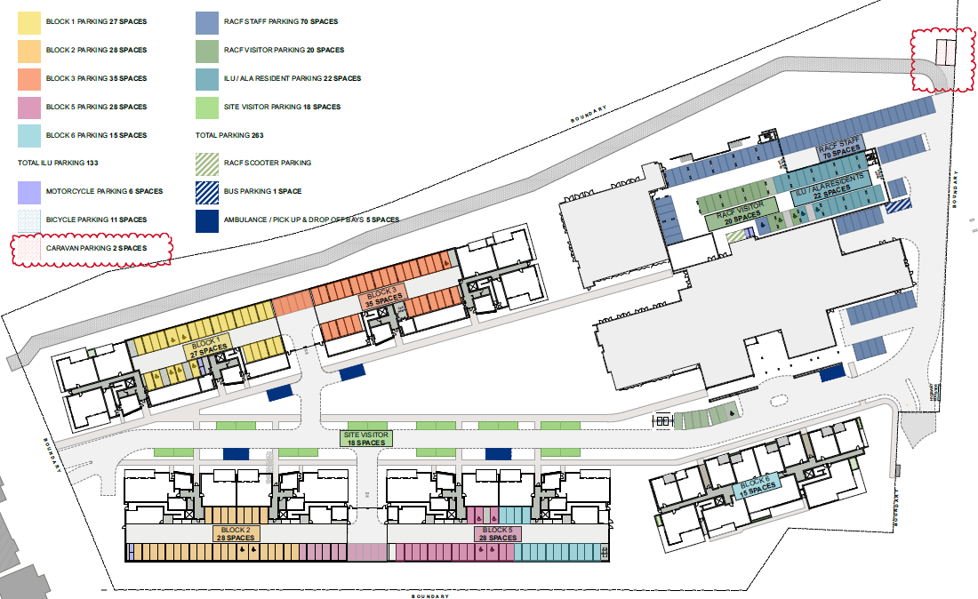
Above: Proposed allocation of accessible spaces
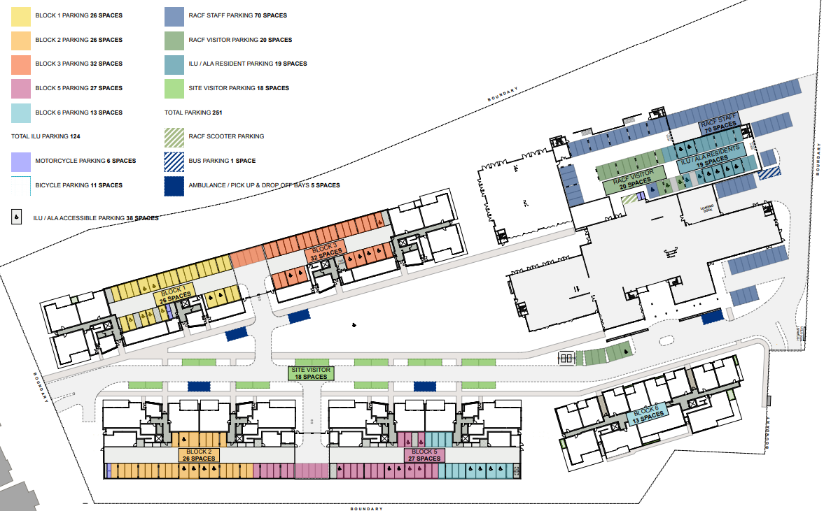
Above: Alternate allocation of accessible spaces.

In this regard, it is noted that for a social housing provider, 36 spaces are required to be provided for the 180 self-contained dwellings under the SEPP HSPD. However, 155 spaces have been provided for the dwellings which is numerically in excess the SEPP HSPD. The reduced number of 143 spaces would therefore continue to comply with the SEPP HSPD. The proposed 143 parking spaces is a more realistic parking provision for the development than the minimum 36 spaces required under the SEPP to satisfactorily minimise any off-site parking impacts in surrounding streets.

The above arguments have been considered in the applicant’s Clause 4.6 exception to Development Standards and are supported. The proposal does not involve any subdivision and so will allow for the flexibility of the spaces according to need. As there is an excess of spaces provided for the development and AS2890.6 allows for the creation of 2 shared spaces from 3 existing spaces, the applicant’s arguments appear viable and practical.

The applicant has argued that the above aims of the SEPP and the underlying aims are met as the proposal seeks to increase the supply of seniors accommodation in a locality that has increasing numbers of older people. The site is within an established urban area, reducing pressure for release of non-urban land at the periphery……The underlying objective of the standard is achieved, with adequate accessible parking provided on-site to meet the demands determined by Uniting and the project Access Consultant.

There are no stated objectives for the particular standard for Sch.3 and/or cl. 5, so in the absence of particular objectives the aims of the SEPP HSPD under cl. 2 included below are considered to be relevant:
This Policy aims to encourage the provision of housing (including residential care facilities) that will—
(a) increase the supply and diversity of residences that meet the needs of seniors or people with a disability, and
(b) make efficient use of existing infrastructure and services, and
(c) be of good design.

(2) These aims will be achieved by—
(a) setting aside local planning controls that would prevent the development of housing for seniors or people with a disability that meets the development criteria and standards specified in this Policy, and
(b) setting out design principles that should be followed to achieve built form that responds to the characteristics of its site and form, and
(c) ensuring that applicants provide support services for seniors or people with a disability for developments on land adjoining land zoned primarily for urban purposes.

Additionally, the applicant argues that the underlying inferred objective for the standard is to ensure that there is adequate accessible parking for self-contained dwellings within a seniors housing development. The proposed accessible car parking provision for the ILUs has been
determined based on anticipated demand by Uniting and is considered by the Access Consultant, to be appropriate for the development.

The proposal is deemed to be consistent with the SEPP HSPD aims under cl. 2 and with the inferred underlying objective to ensure that the parking provided is suitable for the intended occupants. The applicant has identified several environmental planning grounds to justify the departure to the private car accommodation standard. These arguments are supported by the applicant’s access consultant and traffic consultant. This is further discussed below within the WLEP 2013 section of the report.

The exception to the development standard to parking Clause 5 of Part 1, Schedule 3 of SEPP HSPD under clause 4.6 of WLEP 2013 is considered reasonable and acceptable in the specific circumstances for the development. This is further discussed later in the report in the section addressing WLEP 2013.

In spite of the exception to Clause 5, the proposal is satisfactory with regard to the matters under Schedule 3 subject to the recommended conditions. A compliance table (attachment D) has been prepared which demonstrates how the proposal generally complies with the provisions of the SEPP HSPD and the development is considered satisfactory.
State Environmental Planning Policy (Housing) 2021
The SEPP (Housing) 2021 commenced on 26 November 2021 and subsequently amended to include savings provisions under Schedule 7A (Savings and transitional provisions) that apply to the subject application and state as follows:
2 General savings provision
(1) This Policy does not apply to the following matters—
(a) a development application made, but not yet determined, on or before the commencement date…

The DA was lodged on 12 August 2021, prior to the commencement of SEPP Housing and the subject SEPP has no work to do with respect to the current application.

Central Coast Local Environmental Plan 2022 (CCLEP 2022)

The Central Coast Local Environmental Plan 2022 (CCLEP 2022) was published on 24 June 2022 commencing on 1 August 2022 and has been considered in the assessment of the application. In accordance with the savings provisions under clause 1.8A, this application was lodged prior to the commencement of the new Plan and as such the provisions of the WLEP 2013 continue to apply.

Under CCLEP 2022, the site will retain its same R1 General Residential and R2 Low Density Residential zoning and development as proposed will remain permissible with consent in the relevant zones. There are no new or amended Clauses or provisions warranting further discussion.

Wyong Local Environmental Plan (WLEP) 2013

Permissibility and zone objectives

The site is primarily located within the R1 - General Residential zone with a smaller lot included that is zoned R2 Low Density Residential pursuant to cl. 2.2 of the WLEP 2013.

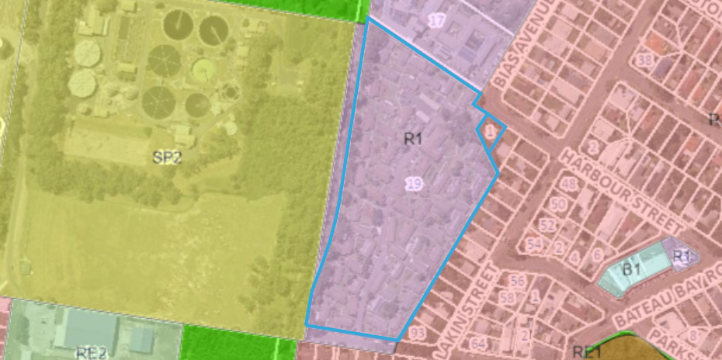
Above: Zoning of the site and surrounding under WLEP 2013.

Within the R1 zone, seniors housing, and residential flat buildings are permissible development with consent. Within the R2 zone, seniors housing, is permissible development with consent. The other aspects of the development including (café, club room, pool, cinema, hair salon/day spa, gym, consulting/meeting rooms, multi-purpose space and chapel) are all ancillary uses subservient to the primary purpose for seniors housing.

The relevant terms are defined in the WLEP 2013 Dictionary as follows:

seniors housing means a building or place that is:
(a) a residential care facility, or
(b) a hostel within the meaning of clause 12 of State Environmental Planning Policy (Housing for Seniors or People with a Disability) 2004, or
(c) a group of self-contained dwellings, or
(d) a combination of any of the buildings or places referred to in paragraphs (a)–(c),
and that is, or is intended to be, used permanently for:
(e) seniors or people who have a disability, or
(f) people who live in the same household with seniors or people who have a disability, or
(g) staff employed to assist in the administration of the building or place or in the provision of services to persons living in the building or place,
but does not include a hospital.
Note. Seniors housing is a type of residential accommodation—see the definition of that term in this Dictionary.

residential care facility means accommodation for seniors or people with a disability that includes:
(a) meals and cleaning services, and
(b) personal care or nursing care, or both, and
(c) appropriate staffing, furniture, furnishings and equipment for the provision of that accommodation and care,
but does not include a dwelling, hostel, hospital or psychiatric facility.
Note. Residential care facilities are a type of seniors housing—see the definition of that term in this Dictionary.

residential flat building means a building containing 3 or more dwellings, but does not include an attached dwelling, co-living housing or multi dwelling housing.
Note— Residential flat buildings are a type of residential accommodation—see the definition of that term in this Dictionary.

The zone objectives include the following and pursuant cl.2.3 the consent authority must have regard to the zone objectives when determining a development application with respect to that zone.

Objectives of R1 General Residential zone

• To provide for the housing needs of the community.
• To provide for a variety of housing types and densities.
• To enable other land uses that provide facilities or services to meet the day to day needs of residents.
• To promote “walkable” neighbourhoods.
• To ensure that development is compatible with the scale and character of the local area and complements the existing streetscape.

The proposal is consistent with the above zone objectives in the provision of seniors housing in an appropriate form and scale to meet the needs of the Central Coast community. The proposed development provides a variety of housing types. The proposed development provides ancillary on-site support services to meet the day to day needs to residents on the site.

The proposed development promotes a “walkable” neighbourhood through footpath upgrades external to the site and the generous pedestrian linkages through the development. The revised proposal suitably transitions to the sensitive interfaces to the east and south and is compatible with the surrounds. Further, it is considered to complement the existing streetscapes through high quality architectural finishes and importantly, generous landscaping to ensure the development is situated within a landscape context suitable for the area. The proposed development will provide additional housing to meet the demands for aged care accommodation in the Central Coast and broader community.

Objectives of R2 Low Density Residential zone

• To provide for the housing needs of the community within a low density residential environment.
• To enable other land uses that provide facilities or services to meet the day to day needs of residents.
• To maintain and enhance the residential amenity and character of the surrounding area.
• To provide a residential character commensurate with a low density residential environment.

The part of the development on the limited R2 zoned part of the site at 1 Harbour Street comprises 2 storeys in height and a scale to the streetscape that is compatible with the low density residential environment to the east and northeast similarly zoned R2. The character of the built form on the R2 zoned part of the site is compatible with a low density residential environment. There are no other land uses on the R2 zoned part of the site. The other non-residential uses proposed are ancillary on-site support services are provided internally within the site for residents as envisaged by the objectives of the zone.

General Controls and Development Standards (Parts 2, 4, 5 and 6)

The LEP also contains controls relating to development standards, miscellaneous provisions and local provisions. The controls relevant to the proposal are considered in Table 4 below.

Table 4: Consideration of the LEP Controls
Control | Requirement | Proposal | Comply
Height of buildings  (Cl 4.3(2)) | No specified height limit under Clause 4.3 (and the Height of Buildings Map) under the WLEP. | The proposal has been designed to meet the requirements of the various SEPPs. | N/A
FSR  (Cl 4.4(2)) | No specified maximum FSR applying to the site under Clause 4.4 (and the Floor Space Ratio Map) of WLEP. | The proposal has been designed to meet the FSR requirements under SEPP HSPD. | N/A
Heritage conservation  (Cl 5.10) | This clause requires consideration of both European and Aboriginal Heritage | The subject site is not in proximity to any European heritage items or heritage conservation areas. An AHIMS search was undertaken, and the site is not in proximity to any recorded Aboriginal sites or declared Aboriginal places. | Yes
Flood Planning (Cl. 5.21) | This clause requires that the Consent Authority be satisfied as to certain matters specified under the clause. | Parts of the site are identified as within a flood planning area. The applicant prepared a flood report discussing this hazard. The development is considered satisfactory with regards to Clause 5.21(2) (a)-(d). | Yes
Acid sulphate soils  (Cl 7.1) | Clause 7.1 requires assessment to be given to development on land that is mapped as being subject to actual or potential acid sulphate soils. The subject site has been identified as containing potential Class 4 and 5. | Preliminary soil testing determined that the site is impacted by acid sulphate soils. An Acid Sulphate Soils Management Plan (ASSMP) has been prepared for the development. The development will be carried out in accordance with the adopted ASSMP and therefore discharges the prior to granting consent requirements under cl 7.1. | Yes
Essential Services (Cl 7.9) | Clause 7.9 states that development consent must not be granted to a development application unless the consent authority is satisfied that the services that are essential for the development are available or that adequate arrangements have been made to make them available. | This includes the supply of water, electricity, the disposal and management of sewer, stormwater drainage and suitable vehicle access. In accordance with Clause 7.9, satisfactory servicing has been demonstrated for the development. | Yes
Flood Plan Risk Management (Cl 7.3) | Development consent must not be granted to development for the following purposes on land to which this clause applies unless the consent authority is satisfied that the development will not, in flood events exceeding the flood planning level, affect the safe occupation of, and evacuation from, the land— (p) seniors housing, | This clause provides matters for consideration related to flood prone land for sensitive uses.  In accordance this clause the proposed development comprises a flood sensitive use, therefore the development is required to be designed for safe occupation and evacuation in this flood event.  The site is mapped as flood prone land. The PMF flooding extends across the entire site. A Flooding Impact Assessment was provided with the DA. The proposed overland flow and channel works through the development will alter the impacts of the flood across the site. All habitable floor levels have been provided above the respective PMF level at that location of the site, with safe access and egress in the 1% AEP and PMF flood events available onto the existing public road network at the proposed access locations. | Yes
Clause 4.6 – Exceptions to development Standards | Development consent may, subject to this clause, be granted for development even though the development would contravene a development standard imposed by this or any other environmental planning instrument. | The application seeks a variation to Clause 5 of Part 1 Schedule 3 of SEPP (Housing for Seniors and People with a Disability) 2004. | Clause 4.6 provided to SEPP.

The proposal is considered to be generally consistent with WLEP 2013.

Clause 4.6 – Exceptions to Development Standards

The application seeks a non-numerical variation to Clause 5(a) of Part 1 of Schedule 3 of SEPP (Housing for Seniors and People with a Disability) 2004. The proposal seeks variation to the requirement that all parking provision for the ILU’s under the standard must comply with the requirements for parking for persons with a disability set out in AS 2890.

The applicant has provided legal advice to support their position which concludes that is it is open to the applicant to seek a departure from the accessible parking controls under the SEPP by relying on a Clause 4.6 variation request as Schedule 3 clause 5 of SEPP Seniors is a development standard capable of variation under clause 4.6, and the Wyong Local Environmental Plan 2013 (LEP) applies to the site.

Clause 5(a) of Part 1 of Schedule 3 of SEPP (Housing for Seniors and People with a Disability) 2004 reads:

5 Private car accommodation
If car parking (not being car parking for employees) is provided—
(a) car parking spaces must comply with the requirements for parking for persons with a disability set out in AS 2890, and
(b) 5% of the total number of car parking spaces (or at least one space if there are fewer than 20 spaces) must be designed to enable the width of the spaces to be increased to 3.8 metres, and
(c) any garage must have a power-operated door, or there must be a power point and an area for motor or control rods to enable a power-operated door to be installed at a later date.

The car parking spaces do not comply with the requirements for parking for persons with a disability set out in AS 2890. However, 10% (15 spaces) of the total 155 car parking spaces for the dwelling units are designed to comply including 6 spaces having a space dimension of 3.8m and 9 spaces designed in accordance with AS 2890.6 (2009) with an adjoining shared space.

In accordance with subclause (c), the proposal has been designed for all garage doors to be power operated so variation to this part of the clause is not sought.

Preconditions to be satisfied

Clause 4.6(4) of the LEP establishes preconditions that must be satisfied before a consent authority can exercise the power to grant development consent for development that contravenes a development standard. Clause 4.6(2) provides this permissive power to grant development consent for a development that contravenes the development standard is subject to conditions.

The two preconditions include:

- Tests to be satisfied pursuant to Cl 4.6(4)(a) – this includes matters under Cl 4.6(3)(a) and (b) in relation to whether the proposal is unreasonable and unnecessary in the circumstances of the case and whether there are sufficient environmental planning grounds to justify contravening the development standard and whether the proposal is in the public interest (Cl 4.6(a)(ii)); and

- Tests to be satisfied pursuant to Cl 4.6(b) – concurrence of the Planning Secretary.

These matters are considered below for the proposed development having regard to the applicant’s Clause 4.6 request which is attached to the report.

The applicant’s justification is included under their request (as attached) and is discussed in detail earlier under the section of the report addressing SEPP (Housing for Seniors and People with a Disability) 2004.

Briefly, the applicant has provided environmental planning grounds to justify the departure to the standard within the Clause 4.6 request. In summary the arguments include:

…it is not considered to be a practical use of land (whether at grade or below ground) to facilitate the space required to provide 100% accessible spaces given there is not the demand for it, as advised by Uniting.

In the specific circumstances of this case, we note that the proposed parking provision far exceeds the "standard that cannot be used to refuse consent" parking provision under Clause 50(h)(ii)….

…155 car spaces are proposed of which 15 of these spaces (10%) are identified to comprise accessible parking spaces. Therefore, the non-compliance with the private car parking standard has arisen because the Applicant has decided to provide more car parking than stipulated under Clause 50(h)(ii) of the Seniors SEPP to ensure demand will be met and limit any potential overflow to the surrounding street network, as well as the expected demand (market research and resident presence) for accessible spaces. In essence, the corollary of proposing a parking provision that will meet anticipated demand is a non-compliance with the requirement in Schedule 3 for additional accessible car parking.

…the variation to the private car accommodation standard does not result in any amenity impacts to the site or surrounds. ...full compliance … would result in a need for the parking areas of the development to be increased substantially to accommodate 100% accessible parking spaces for the ILUs. This would either necessitate a reduction in landscaped/open space or basement parking below the current proposed parking levels.

As identified earlier in the report, the applicant has provided an alternate parking configuration that will allow for provision of 38 accessible spaces which would meet the total parking demand required under cl. 50 of the SEPP HSPD for the development. This scenario would result in the loss of 12 spaces which is not preferred by the applicant, and it may result in off-site parking demand. In the Applicant’s experience, the delivery of the 38 “accessible” carparking spaces is not reflection of the requirements or needs of the proposed development.

Clause 4.6(3) reads:

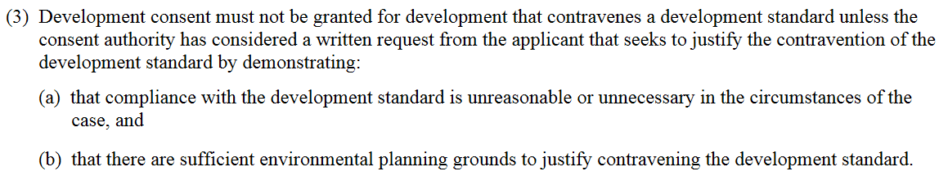
The applicant’s Clause 4.6 Exception to Development Standard adequately addresses the matters required to be demonstrated under subclause (3)(a) and (3)(b).

Clause 4.6(4) reads:

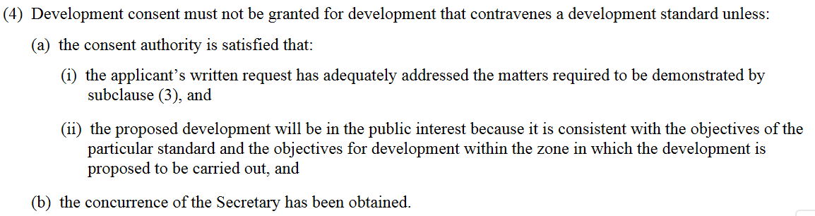

The development is considered consistent with the R1 zone objectives (which are outlined earlier in the report). The development has been found to be consistent with the aims of SEPP HSPD as detailed earlier in this report.

The applicant has argued that the above aims of the SEPP and the underlying aims are met as the proposal seeks to increase the supply of seniors accommodation in a locality that has increasing numbers of older people. The site is within an established urban area, reducing pressure for release of non-urban land at the periphery……The underlying objective of the standard is achieved, with adequate accessible parking provided on-site to meet the demands determined by Uniting and the project Access Consultant.

The proposed development is considered to be in the public interest despite the variation being sought because it is consistent with the R1 and R 2 zone objectives and the aims of the SEPP HSPD.

The exception to the development standard to parking cl. 5 of Part 1, Schedule 3 of SEPP (Housing for Seniors and People with a Disability) under cl. 4.6 is considered reasonable and acceptable in the specific circumstances for the development. The application of cl. 4.6 to allow flexibility in the application of development standards would be achieved together with a better planning outcome. The development is consistent with the inferred objectives of the development standard and the objectives of the zones, notwithstanding the variation and is therefore in the public interest.

In this instance, and on these grounds, the exception is supported and strict compliance with the development standard is unreasonable or unnecessary in the circumstances of the case. It is considered that there are sufficient environmental planning grounds to justify contravening the development standard. The extent of variation is non numerical and requires concurrence.

In accordance with the Environmental Planning and Assessment Regulation 2000, the RPP may assume the concurrence of the Secretary of the Department of Planning, for an exception to a development standard under cl. 4.6 of the Standard Instrument (Local Environmental Plans) Order 2006, having regard for the matters set out in subclause 4.6(5) and where the variation is greater than 10% or non-numerical. Clause 4.6(5) states:

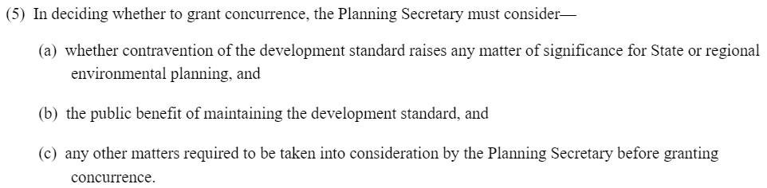
It is considered that the proposed development will be consistent with the objectives of the zone and the proposed development will be consistent with the objects of the standard which is not met. The written request demonstrates that compliance with the development standard is unreasonable or unnecessary in the circumstances and there are sufficient environmental planning grounds to justify contravening the development standard.

  - Section 4.15 (1)(a)(ii) - Provisions of any Proposed Instruments

There are several proposed instruments which have been the subject of public consultation under the EP&A Act, and which may be relevant to the proposal, including the following:

- Draft Remediation of Land SEPP

The key operational framework of the former SEPP 55 (which has been replaced by SEPP R & H) is maintained in the new SEPP which will still require consent authorities to consider whether the site is, or is likely to be, contaminated, and permit a consent authority to require additional information to satisfy itself as to whether the land is contaminated. Having regard for the Explanation of Intended Effect, and the site history of use as a recreational area and registered club, the proposed development is considered satisfactory with regard to the draft SEPP.

  - Section 4.15(1)(a)(iii) - Provisions of any Development Control Plan

The following Development Control Plans are discussed below in relation to this application:

Central Coast Development Control Plan 2022 (CCDCP 2022)

The Central Coast Development Control Plan 2022 (CCDCP 2022) commenced on 1 August 2022. In accordance with the savings provisions under clause 1.1.4 of Chapter 1.1, this application has been lodged prior to the commencement of the new Plan and as such the provisions of the WDCP 2013 continue to apply.

Wyong Development Control Plan 2013 (DCP)

The following Chapters of Wyong Development Control Plan 2013 (‘the DCP’) are relevant to this application:

- Chapter 1.2 - Notification of Development Proposals
- Chapter 2.4 - Multiple Dwelling Residential Development
- Chapter 2.11 - Parking and Access
- Chapter 3.1 - Site Waste Management
- Chapter 3.3 – Floodplain Management

DCP Chapter 2.4 - Multiple Dwelling Residential Development

DCP Chapter 2.4 - Multiple Dwelling Residential Development applies to development for multiple dwelling housing, residential flat buildings and residential accommodation in mixed use developments. This DCP Chapter applies in so far as those planning controls not already included under the other instruments, plans and policies that prevail. In this regard, the provisions of the ADG and SEPP HSPD contain more specific planning controls that have been applied rather than the similar controls applying under DCP Chapter 2.4.

The proposal is considered generally consistent with the relevant aims and requirements of DCP Chapter 2.4. A numerical table (Attachment C) accompanies the report and outlines the relevant aspects of the proposal with regards to compliance with the planning controls under DCP Chapter 2.4.

There are a number of requirements under the DCP that are relevant to the proposal but overridden by similar controls contained within SEPP ARH and the ADG. These DCP requirements include:

• Communal open space (10m² per dwelling with a minimum dimension of 5 metres),
• Private open space (a minimum area of 10m² and a minimum dimension of 2m),
• Deep soil provision (12.5% site area),
• Site coverage (soft landscaping 25%),
• Solar access (70% dwelling minimum of 3 hours midwinter between 9am-3pm),
• Storage (3m² of floor area/1-2bed dwelling),
• Parking provision for dwellings (1 space/1bedroom and 1.2 spaces/2bedroom

There are a number of other controls under the DCP that are relevant and apply to the proposal that are not provided within the SEPP or ADG. The FSR, height and setback requirements under the DCP are relevant to the proposal and provide parameters for what is considered to be an acceptable intensity, bulk, scale and form of development within the site context. The DCP also contains other relevant planning controls and objectives for the development (eg. visitor parking provision, landscaped area, solar access for adjoining dwellings, pedestrian access design, amenity, social dimensions, waste management and legibility.

The proposal includes the following variations to Council’s DCP requirements for residential flat buildings and these are discussed further below. The section below has also included discussion on the FSR, building height and solar access controls under the DCP.

Clause | 4.3.3– Building Lines- Residential Flat Buildings – 3 or more storeys in height
Standard | Front setback - 7.5m
DCP | Chapter 2.4 Multiple Dwelling Residential Development
Departure basis | 12% (0.9m) variation to the ground floor front setback of Block 2 to Altona Avenue, and  8% (0.6m) variation to the first-floor front setback of Block 2 to Altona Avenue

Clause | 4.4.4 - Bicycle Facilities
Standard | For development where resident car parking for the development is provided in a common car park area, bicycle parking facilities shall be provided at a rate of 1 per 3 dwellings.
DCP | Chapter 2.4 Multiple Dwelling Residential Development
Departure basis | Bicycle parking is provided for the development at the rate of 1 space/10 dwellings (which is the rate for other than RFBs)

Clause | 6.4.1 – Visual Privacy
Standard | Up to 4 storeys 12m separation distance between habitable rooms
DCP | Chapter 2.4 Multiple Dwelling Residential Development
Departure basis | Block 6 (23% variation) but overlooking addressed by other means

Clause | 10.1.2 - Residential Flat Buildings 3 or more storeys in height -Waste Chute
Standard and Design Guidance | - Garbage chute systems are required for developments exceeding three storeys or containing a passenger lift  - Developments which include a garbage chute system must contain recycling rooms on each floor to accommodate one day’s volume of recyclables, which are then to be transported to the bin storage room(s)
DCP | Chapter 2.4 Multiple Dwelling Residential Development
Departure basis | Non numerical – no waste chute proposed.

- Building Lines - Setbacks (Clause 4.3.4)

Clause 4.3.3 of DCP Chapter 2.4, identifies that a residential flat building 3 - 4 storeys in height require the following setbacks:
Front – a minimum of 7.5m;
Side/rear – a minimum of 6 metres (for buildings 1-4 storeys in height).
Side/rear – a minimum of 4.5m (for buildings 2 storeys in height)

With, regard to the provision of minimum building setbacks (which are not included under the SEPP’s), the proposal demonstrates compliance with the required minimum side/rear setback distances which all comply with the DCP. In this regard, Blocks 1, 2, 3, and 5 and the RACF which are 3-4 storey in height, all comply with the minimum setback of 6m. Block 6 which is 2 storey in height complies with the minimum setback distance of 4.5m. All of the buildings are mostly well in excess of the side/rear setback requirements under the DCP.

However, there are two minor variations to the required minimum front setback distance as follows:

- The development does not provide the required minimum front setback of 7.5m to Altona Avenue for Block 2 at its closest point at ground floor level which is 6.644m. This is a variation of 11% and is confined to the ground level of the building at the eastern end. It comprises a very small proportion of this elevation which will not be readily discernable. It is noted that the remainder of the building includes a greater than 7.5m setback extending out to 16.7m at the western end and to a minimum 9.1m setback at the roof level of the eastern end.

- The development does not provide the required minimum front setback of 7.5m to Altona Avenue for Block 1 at its closest point which is 6.9m. This is a variation of 8% is confined to the level 1 of the building at the eastern end. Again, it comprises a very small proportion of this elevation which will not be readily discernable. It is noted that the remainder of the building includes a greater than 7.5m setback extending out to 9.8m at the western end of the building.

The extent of variation is minor with the average distance of each of the above buildings exceeds the 7.5m distance and the front setback area to Altona Avenue is proposed to include comprehensive landscaping to the street such that the variation will not be readily observed from the public domain.

The objectives for the ‘building lines’ control under the DCP include:

• To maintain existing streetscapes
• To protect the privacy and solar access of adjacent properties
• To ensure the visual focus of a development is the dwelling, not the garage
• To maximise building separation to provide visual and acoustic privacy

The variations proposed are minor and will not be readily discernable as they are confined to one level of the building. Despite the variation proposed it is considered that the proposal demonstrates compliance with the objectives for the control under cl. 4.3 of Chapter 2.4. The elevations include sufficient articulation and there are no significant or unreasonable impacts to the streetscape bulk and scale or to solar access or to visual or acoustic privacy of any adjacent properties as a result of the variation.

- Bicycle facilities (Clause 4.4.4)

Clause 4.4.4a of Chapter 2.4 requires provision of bicycle parking facilities at a rate of 1 space per 3 dwellings whereas 11 bicycle parking spaces have been provided. It is acknowledged that the likely age and mobility of the future residents will reduce the demand for these facilities but it is noted that there is an opportunity to store bicycles within the respective basement storage areas.

The variation is considered reasonable in this instance given that that the nature of the development and that an adequately sized storage area within the basement is available for each apartment, should they wish to keep a bicycle.

- Visual Privacy (Clause 6.4.1)

The proposal seeks a variation to the recommended visual separation distances under Clause 6.4.1 of DCP Chapter 2.4. Blocks 2 & 5 of the development comply with the recommended visual separation distances to the adjoining dwellings to the eastern boundary. However, with regard to Block 6 there is a 23% variation to the visual separation distance under Clause 6.4.1c. There is a proposed distance of 9.2-11.7m between the closest habitable room (bedroom) in Block 6 and the habitable room on the adjoining lot at 1 A Harbour Street. In this regard, the dwelling on the adjoining lot at 1A Harbour Street includes a kitchen window (with a distance of 9.2m to Block 6) and a living area window (with a distance of 11.7m to Block 6). It is noted that the proposal complies with 6m to the boundary under the ADG.

The objectives under the DCP for the control are as follows:

- To provide and maintain reasonable levels of visual privacy both internally and externally, during day and night
- To maximise outlook and views from living rooms and private open space without compromising visual privacy
- To ensure a high level of amenity by protecting the privacy of residents both within the apartments and in private open space areas

The proposal is considered to be consistent with the objectives for the clause as the boundary setback of the site includes detailed landscape screening for privacy between the dwellings, aluminium privacy screens to the bedroom windows at both levels of the building and angled batten screen to the balcony side directing viewing away from the adjoining dwelling at 1A Harbour Street as depicted on the diagrams below.
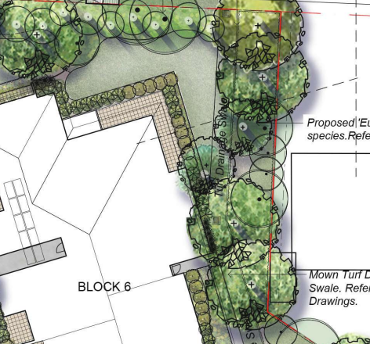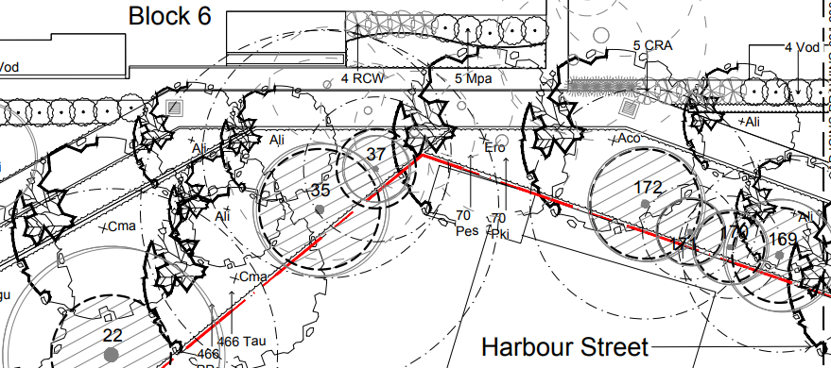
Above: Landscape plan showing the planting between 1A Harbour Street and Block 6.

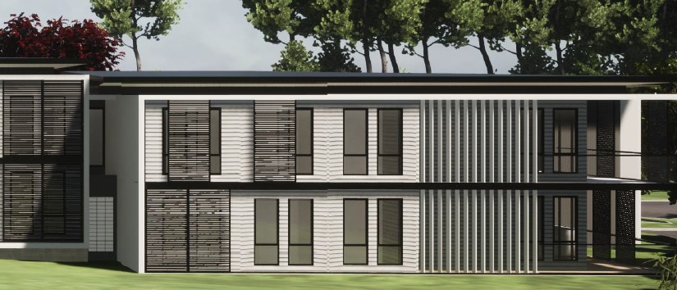
Above: Eastern elevation of Block 6 (at northern end)

- Waste Management

Clause 10.1.2 requires provision of a garbage chute system for developments exceeding three storeys or containing a passenger lift. The proposal contains a passenger lift, however, no chute system for waste is proposed.

The DCP objectives under Clause 10.1 (Waste Management) for the control area as follows:

- To avoid the generation of waste through design, material selection and building practices
- To plan for the types, amount and disposal of waste to be generated during demolition, excavation and construction of development
- To encourage waste minimisation, including material separation, reuse and recycling
- To ensure efficient storage and collection of waste and quality design of facilities

A revised Waste Management Plan and Operational Management Plan have been provided to address waste management for the development. Unlike other proposals, this development will not be subdivided by will be centrally managed and operated by Uniting Care. The waste arrangements include the provision of on-site managers and cleaners who are responsible for the transfer of waste to their collection point. Satisfactory waste rooms are included within each ground level parking area of the ILU’s. Staff and cleaning contractors will have the responsibility for transporting waste/recyclables from the ILU floors and RACF floors and elsewhere in the RACF building to the bins located in waste room.

The proposal includes satisfactory arrangements with regard to the storage and collection of waste generated by the development. Despite the variation proposed it is considered that the proposal demonstrates compliance with the objectives for the control under cl. 10.1.

- Floor Space Ratio (Clause 5.1a)

Clause 5.1 of DCP Chapter 2.4 specifies a maximum floor space ratio of 0.6:1 within the R1 zone (where not mapped under WLEP 2013). SEPP HSPD draws upon this FSR control under cl. 5.1a of the DCP Chapter 2.4 and uses it as the base FSR upon which the FSR bonus of 0.5:1 under cl. 45 of the SEPP HSPD. The proposal complies with the FSR under cl. 45 of SEPP (HSPD).

The applicable FSR for the R2 zone is not included under DCP Chapter 2.4 or Chapter 2.1 (Dwelling Houses, Secondary Dwellings and Ancillary Development) but under DCP Chapter 2.3 (Dual occupancy) which is 0.5:1. The proposed development (part of Block 6) complies with the FSR having an FSR of 0.42:1.

- Building Height (Clause 3.1.2)

Clause 3.1.2 of DCP Chapter 2.4, requires that ceiling heights within the R1 zone shall not exceed two storeys and 7 metres in height. Clause WDCP Chapter 2.1 (Dwelling Houses, Secondary Dwellings and Ancillary Development) under Clause 2.1b & c requires that the:

- maximum building height for dwellings if not specifically mapped by WLEP 2013 is 10 metres. Building Height shall generally not exceed two storeys. Three storey dwellings will generally only be supported on steeply sloping site.

The SEPP prevails for the applicable height control with no maximum restriction for the R1 zone where residential flat buildings are permissible and within the R2 zone (where RFB’s are not permitted) the SEPP requires that the development not exceed 8m and the proposal complies.

- Solar Access to adjoining properties (Clause 6.3.1)

The potential overshadowing impacts of the proposed development on each neighbouring Lakin Street property for both the winter and summer solstice have been sufficient demonstrated. The proposed development complies with the DCP requirements under Clause 6.3.1 to ensure new development maintains solar access to adjoining properties so that each neighbouring property maintains 3 hours of unobstructed sunlight to a required minimum private open space area of 24m² at the rear.

The assessment of each Lakin Street residence concludes that each neighbouring property maintains and exceeds the private open space requirements set out in the DCP. The only property which is not entirely consistent with the DCP requirement is 1A Harbour Street, however this inconsistency is due to the dwelling on that property overshadowing its own private open space. Solar access to 1A Harbour Street on a whole, is not unreasonably reduced by the proposed development.

DCP Chapter 2.11 - Parking and Access
- Parking Demand Compliance

The DCP requires parking for the development to be on the basis of the table below.

Land Use | Parking Requirements
RESIDENTIAL ACCOMMODATION
Multi Dwelling Housing and Residential Flat Buildings | 1 space per 1 bedroom dwelling  1.2 spaces per 2 bedroom dwelling  1.5 spaces per 3 (or more) bedroom dwelling  Note: The above requirements may be reduced to 1 space per dwelling if development is in a major centre or a town centre, subject to submission of a Transport Management Plan and approval by Council.  In addition, 1 space per 5 units for visitor parking with a minimum of 1 visitor space per development  1 visitor space is to be available for car washing  On average, only one space per unit is to be allocated as resident parking. The remaining spaces are to be provided as separate parking and available for common use at all times
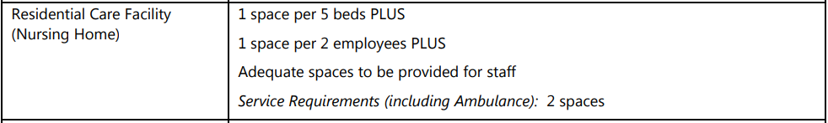
The proposal includes parking provision of 263 spaces which comprises:

- 90 spaces for the RACF (70 spaces for staff and 20 spaces for RACF visitors)
- 155 spaces for the ILU’s (including 20 spaces for the ALA and 133 spaces for the 5 Blocks of self-care housing)
- 18 visitor spaces for the ILU’s

The parking requirement for the ILU’s under SEPP HSPD is 36 spaces as the applicant is a social housing provider. However, the proposal aims to address both the SEPP and DCP in the provision of parking more suited to the nature of the likely demand (in the applicant’s experience of similar operating similar aged care facilities).

Under the DCP parking demand would equate to 213 spaces for the ILU’s and 36 spaces for ILU visitors and 67 spaces for the RACF (comprising 32 spaces residents and 35 spaces staff). This totals a parking demand 280 spaces for the development under the DCP, but the SEPP (HSPD) prevails.

Above: Proposed parking provision for the development

The proposal also includes 1 ambulance space for the RACF and 4 Ambulance spaces for the ILU’s. The RACF ambulance bay is capable of accommodating the largest NSW ambulance There are 15 accessible parking spaces for the ILU’s and 4 accessible spaces for the RACF. There is also parking for a minibus on the site and 6 motorcycle spaces which complies with the DCP.

Clause 4.4 and 4.6 requires adequate provision for the manoeuvring, loading and unloading of service vehicles on site. Two service spaces are required for the development under the DCP.There is a single loading bay proposed for the RACF, capable of accommodating a 12.5m long heavy rigid vehicle. There is a loading area for the waste collection located at the Altona Avenue end of the site. Pedestrian footpaths have been provided throughout the development that create well defined linkages between facilities. All vehicles can enter and exit the site in a forward direction, and all turning areas have been designed in accordance with AS 2890.

DCP Chapter 3.1 Site Waste Management

In accordance with DCP Chapter 3.1 the application includes a Waste Management Plan for the development outlining the waste disposal, re-use and recycling (on and off site) for the demolition, construction and operational stages of the development. A condition has been included requiring the development to be carried out in accordance with the submitted management plan.

DCP Chapter 3.3- Floodplain Management
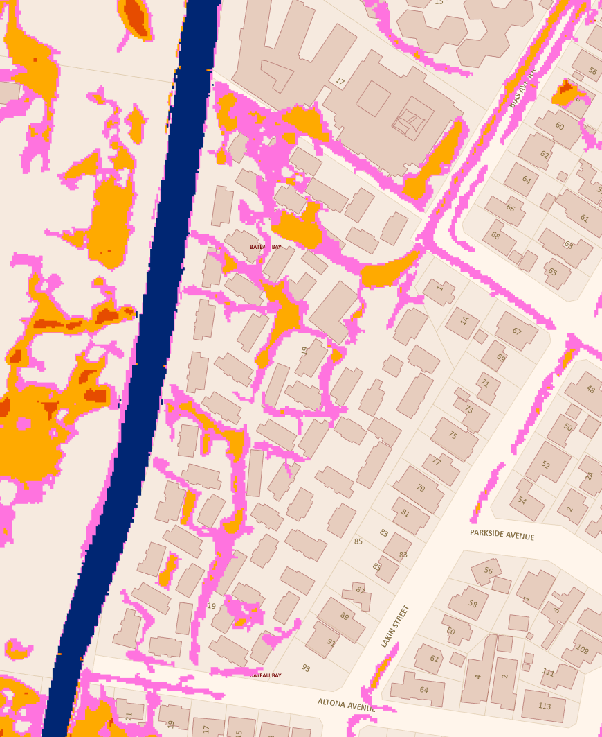
Above: Flood planning and flood storage areas mapping for the site

The site is subject is mapped as being affected by the flood planning level and contains areas of flood storage. The flood affected areas within the site are generally limited to the access and open space area between the existing buildings. The site is also subject to the Probable Maximum Flood (PMF) event.

In accordance with cl. 3.2 of DCP Chapter 3.3 Floodplain Management, a Flood Impact Assessment has been submitted to satisfy the requirements of cl. 3.3 as the development is categorized as a Sensitive (Land Use 6) development within a defined Precinct 2: Flood Planning Area and Precinct 1: Probable Maximum Flood site.

All habitable floor levels have been provided above the respective PMF level at that location of the site, with safe access and egress in the 1% AEP and PMF flood events available onto the existing public road network at the proposed access locations. The reduced fill throughout the RACF external parking and driveway areas is still above the 5% AEP flood event level in this location and compliant with the requirements of Chapter 3.3.

- S7.11 Development Contributions Plans

Direction 94E issued on 14 September 2007 by the then Minister for Planning, excludes the levying of developer contribution charges to any form of Seniors Housing development proposed by a ‘social housing provider’.

The applicant is a Social Housing Provider and therefore exempt from the payment of developer contributions under any consent to be granted.

  - Section 4.15(1)(a)(iiia) – Planning agreements under Section 7.4 of the EP&A Act

There have been no planning agreements entered into and there are no draft planning agreements being proposed for the site.

  - Section 4.15(1)(a)(iv) - Provisions of Regulations

The Environmental Planning and Assessment Regulation 2021 (2021 EP&A Regulation) commenced on 1 March 2022 and replaced the 2000 Regulation. The Environmental Planning and Assessment Regulation 2000 continues to apply to the application in accordance with the savings provisions outlined in Schedule 6 Part 1 of the Environmental Planning and Assessment Regulations 2021 as the application was submitted but not finally determined before 1 March 2022.

Clause 92(1) of the Regulation contains matters that must be taken into consideration by a consent authority in determining a development application. Demolition works are identified under the clause and are proposed under the application. The demolition works are to be carried out in accordance with the provisions of AS 2601 as addressed in the recommended draft conditions.
The plans were amended and accepted in accordance with Clause 55 of the Regulation 2000. There are no other specific clauses that warrant further discussion in relation to the Environmental Planning and Assessment Regulation 2000.

  - Section 4.15(1)(b) - Likely Impacts of Development

The likely impacts of that development, including environmental impacts on both the natural and built environments, and social and economic impacts in the locality must be considered. In this regard, potential impacts related to the proposal have been considered in response to SEPPs, LEP and DCP controls outlined above and the Key Issues section below.

The consideration of impacts on the natural and built environments includes the following:

Context and setting

The land to the north on the west side of Bias Avenue is primarily zoned R1 General Residential (with more intensive forms of residential use permissible with consent, such as residential flat buildings). This area to the north has a number of aged care facilities and retirement villages and a bowling club. On the eastern side of Bias Avenue and along the eastern and southern boundaries of the site is land zoned R2 Low Density Residential. The topography of the site generally falls away from the east and towards Saltwater Creek to the west.

Concern was raised regarding the markedly different proposed scale and form of the proposed development (at 4 storeys) from the existing development surrounding the site at 1-2 storeys. The predominant zoning of the site (other than 1 Harbour Street) is R1 which permits residential flat buildings to a height of 7m and an FSR of 0.6:1. The surrounding zones to the east, north-east and south are all R2 zones wherein a much lower scale of development is characteristic. The immediate site context needed further consideration in the design, form, and scale of the proposed development

The applicant provided amended plans to more sensitively respond to the southern and eastern boundary interface areas with a reduction in height and scale which reduces the potential visual and amenity impacts and provides a better transition between the site and adjoining R2 zone. In these locations, buildings now visually present as generally 2 storeys (to the east) or stepped 2-3 storey forms (to the south), which represent a more appropriate built form transition to the surrounding R2 zone.
The applicant provided multiple sections through the development on the site to demonstrate this change to a more appropriate scale. The fall of the land away from the east, towards the west, goes some way to further ameliorating the perceived height of buildings. Where dwellings sit at a lower RL than the proposed development, it is noted that the development remains of a compatible scale with the existing scenario, and also, the possible future outcome on those sites that would comprise two storey dwellings. The screening hedge along the eastern edge of the courtyards is expected to grow to 8m high, further addressing any privacy or overlooking concerns over and above the dense eastern interface landscaping buffer.
The building fronting Bias Avenue is two storeys and provides a good transition between the remainder of the seniors living development and the adjacent individual residences in the R2 Low Density Residential zone fronting Bias Avenue. The taller built forms comprising four storeys (the RACF and Block 3) have been retained in the northern/north-western parts of the site where the site context has a lower topography or where the additional height in these locations can be sustained. It is noted that the RACF building will sit in a landscape context being screened by proposed canopy planting and other landscaping in this location.

The landscape design not only seeks to retain many more trees than the original scheme, the increased open space across the site, and setbacks around the perimeter of the site, enable generous mature tree plantings to buffer and screen the development.

The revised landscape scheme includes locally endemic species including Eucalyptus robusta and Eucalypts pilularis species (Swift Parrot feed trees) as well as numerous other
native Eucalypt, Angophora and Corymbia species to be planted which will provide further foraging habitat for Swift Parrots and other locally occurring bird species. The revised landscape scheme, results in an outcome that is more compatible with the landscape context of the Bateau Bay locality and is responsive to its surroundings (particularly at the sensitive interfaces).

In addition, the applicant has argued that the development will remain open to the adjacent community. The large open space areas in the new development (larger and more accessible than existing) will be available for the use by the wider neighbourhood. Access to the large central common space is easily achieved from both Altona Avenue and Bias Avenue entrances. There are substantial landscaping areas throughout the site, including pathways leading to pocket parks. The design and location of the proposed open space is appropriate for the senior residents, children, and family groups, with a range of activities available including BBQ areas, children’s playground, community gardens, and exercise stations.

Privacy - internal and external

With regard to impacts external to the site, the site has two boundary interfaces (eastern and northern) that have the potential for external overlooking and privacy impacts. The potential for privacy impacts and overlooking from the development has been minimised in the design of the development by providing:

- generous setbacks
- sensitive placement of openings and open space,
- buffer/screen planting around the boundaries
- minimizing the number of units oriented to residential boundaries
- relocating living areas away from R2 zoned boundaries
- physical distance and separation to minimise potential visual privacy issues
- architectural elements to restrict and direct viewing including sliding screens and angled battens to balconiesand screening angled blades to the living rooms on the upper floors.

The newly designed courtyards within buildings 2 and 5 are designed as passive outdoor space and will only be used by the residents of Blocks 2 and 5 and will not be used for gatherings or events and are not in high traffic areas. These areas will be enhanced through the dense eastern boundary landscaping. The courtyards will be screened by planter boxes and the landscaped buffer along the eastern boundary, reducing their visibility when viewed from the Lakin Street neighbours to the east. The units adjoining the proposed new courtyards will not have internal facing balconies that overlook them and all windows facing internally will be highlight windows and be consistent with the ADG in ensuring privacy is maintained.

The physical distance and separation combined with sensitive design and layout, including comprehensive landscaping is considered to minimise potential visual privacy issues.

Overshadowing – internal and external to the site

Shadow diagrams have been prepared for the development (internally) and adjoining sites at hourly intervals between 9:00am, midday and 3:00pm, for 21 June (midwinter), in order to demonstrate a worst-case scenario for solar access on the shortest day of the year. Diagrams for summer solstice and the equinox have also been provided for assessment.

Due to the orientation of the site, the shadowing created by the development extends generally away from the Bias Avenue frontage of the site and towards the saltwater Creek side of the site during the morning and towards the neighbouring properties to the east fronting Lakin Street during the afternoon.

- Over shadowing impacts external to site

The applicant has carried out an hour-by-hour analysis of the solar impacts from the development upon neighbouring properties along Lakin Street at mid-winter and summer solstice. The afternoon at 3pm is the worst-case scenario, as prior to this there is little to no overshadowing to these adjoining yards resulting from the development. Building heights adjacent the eastern boundary has been further lowered to be more in keeping with the existing R2 development. The proposed setbacks from boundaries are greater than DCP requirements, further reducing the shadowing of neighbouring yards.

This analysis identified that Lakin Street neighbours’ solar access would be retained throughout most of the nominated (9am – 3pm) hours in mid-winter, with only partial overshadowing at 2:30pm. The further lowering of the building height and removal of six units to break up the continuous length of the buildings reduces the overall massing of Blocks 2 and 5. This improves the extent of neighbouring solar access received. The proposal complies with the DCP requirements for solar access in that at least 75% of the required private open space areas on adjoining lands shall receive at least 3 hours unobstructed sunlight between the hours of 9 am and 3 pm on June 21 (winter solstice).

There are no unreasonable amenity impacts resulting from solar access loss to any existing surrounding residential development or public areas as a consequence of the development. The overall extent of shadowing impact resulting from the proposal to surrounding properties is considered reasonable.

- Overshadowing impacts internal areas within the site

The mid-winter shadowing from the development extends towards the western side (Saltwater Creek) and Altona Avenue frontage during the morning period and much of this has receded by midday. By the afternoon (which is the time for the most significant shadowing impacts), the shadows extend across the middle of the site and the eastern boundary, towards the Lakin Street residents (as discussed above).

In this regard, overshadowing created mid-winter by the proposed development will still allow for a minimum of 3 hours solar access to the communal open space (COS) areas in the centre of the site. At least 50% direct sunlight is provided to the principal usable part of COS between 9am-1pm which is 4 hours. However, after 2pm more than 50% of the area is in shade mid-winter. It is noted that this mid-winter scenario is the worst time of the year and at all other times, solar access to this area exceeds the requirements.

Solar access to the private open space (POS) areas within the development complies with the DCP and ADG requirements in that 70% of all units (126 units out of 180 units) receive 3 hours of direct sunlight mid-winter. Only 4% of apartments receive little to no direct sunlight mid-winter which is less than the allowable number under the ADG (15% total units) and Council’s DCP (of 10% total units).

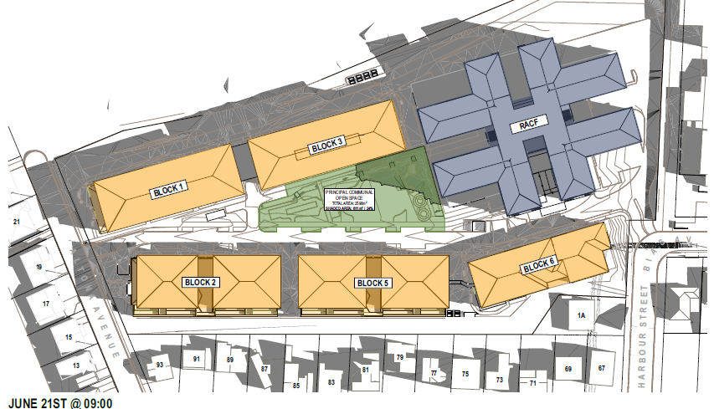

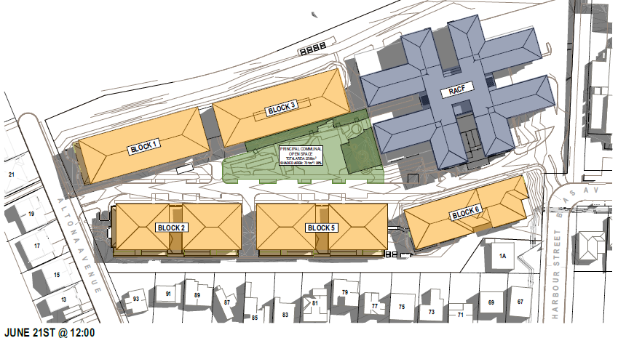
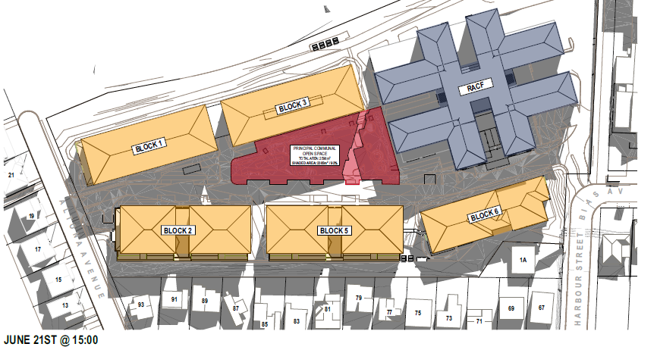
Above: Shadow diagrams for the development mid-winter at intervals of 9m, midday and 3pm.

Access and traffic

Fronting the site on Bias Avenue / Harbour Street is sealed carriageway, with upright kerb and gutter, pavement marking (double centreline), street drainage (kerb inlet pits and associated drainage line), concrete footpath, services, bus stop and signage, and a two-way bitumen access crossing servicing the site. Fronting the site on Altona Avenue is sealed carriageway, with upright kerb and gutter, street drainage (kerb inlet pits and associated drainage line), street trees, services, and a two-way bitumen access crossing servicing the site.

The existing vehicular access arrangements on Bias Avenue will service the RACF while the existing secondary vehicular access on Altona Avenue will service the ILU’s. Vehicular access to the RACF parking will only be via the Bias Avenue access as Uniting will enforce an operational policy to require all staff to use the Bias Avenue access only. No access gates are proposed across the driveways for the development, hence AS2890.1 queuing areas are not applicable to the development.

A separate dedicated exit to the east of the driveway on Altona Avenue is provided as a “Waste Contractor Exit” to allow the waste collection vehicle to collect waste within the site and exit in a forward direction. Signage will be provided on the road to ensure all vehicles turn left when exiting the site to ensure vehicles are not required to turn around within Altona Avenue in the dead end.

A Traffic Impact Assessment has been provided which includes AS2890 Swept Paths throughout the site for passenger vehicles, deliveries, mini-buses, and waste collections. The proposed development provides a drop-off for visitors on the southern frontage of the RACF and is designed to accommodate B99 design vehicles. The RACF loading dock is designed to accommodate a 12.5m long heavy rigid vehicle. The bus parking bay will accommodate a 12.5m long heavy rigid vehicle. The ambulance bay will accommodate the 7.02m 2WD Mercedes Benz Sprinter 519 Bariatric Specialist Vehicle. The loading dock, ambulance bay and bus bay all have a minimum clear head height of 4.5m.

During construction, parking for construction workers will be provided on-site (36 spaces for Stage 1 and 33 spaces for Stage 2) to minimise the impact of construction of on-street parking availability in surrounding streets. During fit-out and finishes stages (when there are the most workers onsite) the carparks on the Ground Floor of the buildings will also be made available to allow for additional parking on-site for subcontractors.

All construction vehicle access will occur via Bias Avenue during construction to ensure there are no construction vehicle impacts to residents along Altona Avenue. The construction truck routes are part of the bus routes. Further details regarding construction vehicle movements and worker numbers will be provided as a part of a detailed Construction Traffic Management Plan.

A pedestrian pathway is proposed across the full extent of the Altona Avenue frontage. A shared pathway is required across the full extent of the Bias Avenue frontage extending to a pedestrian treatment required to access the existing sheltered bus stop on the opposite side of the Bias Ave (to the north of the site).

Adequate manoeuvrability is provided through the site for an AS2890.2 HRV vehicle (Council’s Waste Services vehicle), for the proposed RACF waste collection area and along the main internal roadway to the proposed on-site residential (ILU) bin collection location adjacent to the Altona Avenue property access. The proposed RACF loading area, ILU waste collection area, manoeuvrability and internal driveway grades comply with AS2890.2:2002 – Off-street commercial vehicle facilities.

A Fire Access Trail Perimeter Road has been proposed along the western side of the development (off a separate access onto Altona Road and connecting into the RACF driveway along the northern property boundary) for compliance with Planning for Bushfire Protection. . Adequate manoeuvrability is provided throughout the site for fire and/or emergency access during both development stages.
The development will necessitate the completion of road infrastructure in accordance with the relevant provisions of Council’s Civil Works Specification Design Guidelines 2020. Conditions have been recommended below requiring the provision of suitable pedestrian crossing treatment to allow for safe access to the existing bus stop on the opposite side of Bias Avenue (north of the site), shared pathway across the full Bias Avenue frontage extending north to the new mid-block pedestrian refuge, new pedestrian pathway across the full Altona Avenue frontage, two new driveway crossings and laybacks and the removal and reinstatement of kerb to redundant driveway crossings and laybacks to match surrounding adjacent infrastructure.

Traffic Generation

Following the amendment to the application an updated Traffic Impact Assessment was provided for the development. The Traffic Impact Assessment used the traffic generation associated with the existing village as a basis for the assessment. The sidra modelling of the key intersections in the vicinity of the site indicates that the intersections currently operate a level of service B or better in both the AM and PM peaks. The report has also accounted for the proposed staff change overs associated with the RACF as peaks occurring at times between 6:30am and 7:30am, from 2:00pm to 3:00pm and 10:00pm to 11:00pm.

The additional generation of the residential and commercial components can be summarised as follows:
+70 vehicle trips per hour during the morning peak (6:30-7:30am) (+41 in, +29 out)
+30 vehicle trips per hour during the morning peak (8:30 - 9:30am) (+16 in, +14 out)
+32 vehicle trips per hour during the current site peak (10:45-11:45am) (+15 in, +17 out)
+96 vehicle trips per hour during the afternoon peak (2:00-3:00pm) (+56 in, +40 out)
+19 vehicle trips per hour during the evening peak (4:00-5:00pm) (+10 in, +9 out).

The report concludes that all intersections will continue to operate with a level of service
of ‘B’ or better during both morning and evening peak periods. The development results in no change in level of service during the morning or evening peak periods for the critical intersections with no significant increases in average delay. Therefore, the development is likely to have a very minor to minor impact on the surrounding road network.

The traffic impacts arising from the proposed development have also been assessed in a 10- year growth scenario assuming a 1.5% annual growth rate of the existing background traffic. On this basis all intersections will continue to operate with a level of service of ‘C’ or better in 10 years’ time during both morning and evening peak periods

Council’s Traffic and Transport Engineer has assessed the proposal and based on the modelling results above it is anticipated that the proposed development will not have a significant impact on the surrounding road network.

Stormwater and drainage

The site falls approx. 6.0m (at front) to 3.5m (at rear) to the west (toward Saltwater Creek). The western side of the development fronts Saltwater Creek, with the defined 40m buffer zone from this natural watercourse encroaching upon this side of the site. The proposed stormwater and drainage works are as follows:

• Create an easement for drainage along the eastern property boundary, to service neighbouring lots to the east, with concrete channels along the easement edge closest to the new proposed buildings, to capture overland flow within the easement and convey to council’s street stormwater systems in Bias Avenue and Altona Avenue.
• Direct the stormwater collected on roof and driveway / parking hardstand areas via a piped and open channel (combination of concrete and grassed) system, to an on-site bio-filtration and retention basin in the north-west corner of the site, with overflow piped to a headwall discharging into the existing concrete drainage channel between the site and Saltwater Creek at the west of the site.
• Stormwater runoff from the Saltwater Creek frontage (pervious, excluding pedestrian pathways) to remain as natural overland flow to the existing adjacent concrete drainage channel (between the site and Saltwater Creek).

The major system has been designed to ensure sufficient capacity and freeboard to ensure stormwater flows up to the 1% AEP event do not encroach upon habitable properties. The system consists of an arrangement of swales, pavements, surface inlet pits, and pipes to convey the 1% AEP design flow in conjunction with the available capacity of the minor drainage system. The revised plans demonstrate the site discharge will have a negligible impact on the existing Saltwater Creek open channel for both Stage 1 post-developed and Stage 2 final post-developed discharge from the site.

The swales are designed to carry the 1% AEP flow (without the pipe capacity), with sufficient capacity in the pit and pipe network to carry the 5% AEP flows. Overland? flow paths across the site direct flows around proposed buildings and offsite into either the existing drainage channel at the north-western corner of the site, Altona Avenue or Bias Avenue.

The existing natural flows are generally directed towards the natural fall in the north-western corner; hence, the proposed stormwater management plan discharge locations generally assimilate the existing site conditions. The eastern side of the site receives stormwater runoff from the neighbouring upstream lots, which is to be intercepted via the proposed inter-allotment drainage system and transported offsite. Due to the site’s location within the catchment, on-site detention would not be beneficial in this location.

Aboriginal Heritage

The subject site is not in proximity to any items of European heritage items or heritage conservation areas. In accordance with section 8 of the Due Diligence Code of Practice for the Protection of Aboriginal Objects in New South Wales, the subject site is classified as disturbed land. As such, it is considered that the site is highly unlikely to contain any Aboriginal Cultural Heritage due to the disturbed nature of the site, and the previous history of development etc.

An Aboriginal Heritage Information Management System (AHIMS) search was carried out which identified that the site is not in proximity to any recorded Aboriginal sites or declared Aboriginal places. A recommended condition of consent will require that if any relics are found during works, that work is to cease and the Office of Environment and Heritage and the Local Aboriginal Land Council (LALC) are to be contacted, and appropriate approvals sought.

Soils impacts, Acid Sulphate Soils (ASS) and ground water

A Geotechnical Investigation was carried out which identified that the soil profile consists of poorly drained silty-clay loams and there are shallow ground water levels on the site but that the site is suitable for the development subject to recommendations. The report concluded that earthworks for the foundations are unlikely to require any rock breaking and ripping equipment due to the alluvial soils and past fill. The report identified the highest level of groundwater seepage within boreholes occurred at a depth of 3m (in BH08). The remainder of the boreholes recorded groundwater at a much lower depth. A bulk earthworks plan has been prepared for the earthworks across the site. No excavation for bulk earthworks is proposed to exceed 3m.

The site contains class 4 acid sulphate soils in the north-west and south-east half of the site as per Council’s Acid Works Sulphate Soils Planning Map.

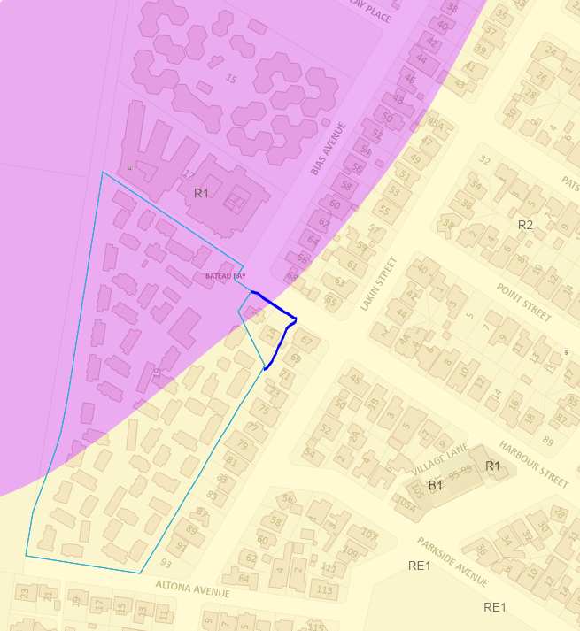
Above: Purple area denotes extent of ASS across the site

An acid sulphate soils assessment accompanied the development application which included bore hole testing across the site and identified that the site was impacted by acid sulphate soils. The assessment identified that acid sulphate soils were not a significant issue and could be appropriately managed by treating any soil in the vicinity of the identified bore hole locations to neutralise the soil acidity. An Acid Sulphate Soils Management Plan (ASSMP) has been provided for the development and recommended conditions will require that the development be carried out in accordance with the plan.

The ASSMP has identified Potential Acid Sulphate Soils (PASS) within the vicinity of Block 3 and the RACF south-west corner, noting excavation exceeding 1.0m below EGL in this location has the potential to expose PASS, which is to be treated in accordance with the recommendations within the submitted ASSMP for the development. The submitted Concept Bulk Earthworks Plan generally details fill within this PASS area, with minimal cut proposed for the stormwater overland flow paths between the RACF and Block 3.

The submitted ASSMP has also identified groundwater encountered at depths varying from 1.9m (north-east corner into centre of site) to approx. to 4.8m (western and south-eastern portion of site) below the existing ground level. Ground water is unlikely to be encountered during the excavation / construction works or interfered with from any proposed structural retaining / footings. There is no excavation proposed at a depth which would result in acid sulphate soils interacting with groundwater. The ASSMP has been revised to include control measures and a management strategy to detail how to control any run-off (to prevent leaching into waterway / downstream impacts).

Earthworks

Retained cut is proposed within the Block 2, Block 5 and Block 6 footprints (retained along the eastern wall of the structures). Retained fill was originally proposed along the northern property boundary, to support up to 1.0-1.5m of fill for the RACF accessway. However, this fill has been reduced through Council’s trunk sewerage easement along the northern side of the RACF, with reduced retaining to 0.9m max. height, now terminating immediately to the west of the Council sewerage easement.

Contamination

The applicant has addressed the requirements under Chapter 3 (Remediation of Land) of State Environmental Planning Policy (Resilience and Hazards) 2021 in respect of potential contamination and remediation impacts by reviewing the site history. As the current and existing land use is not listed as a potential contaminating activity a “Preliminary Contamination Assessment” is not required. However, due to the age of the current structures that will be required to be demolished there is a potential for asbestos building materials to be present. Therefore, to ensure no legacy issues are created and the health and well-being of the surrounding community and workers are protected, it is recommended that an unexpected finds protocol be conditioned into an overarching Construction Environmental Management Plan for any development consent issued.

Utilities

- Water and sewer servicing

    - Water

The development will require a Section 307 Certificate under the Water Management Act 2000. Water and sewer contributions are required for this proposal, which will be detailed on the WMA Section 306 Requirements letter, to be issued by the Water Assessments team. No Section 305 application was submitted with this development application.

The site is connected to Council’s reticulated water supply infrastructure, via the existing 100mm AC and PVC water reticulation main located within the Bias Avenue / Harbour Street frontage. A Water Pressure Statement has previously been obtained by the developer from Council for connection of the development to the existing 100mm water main on Bias Avenue. Due to the increased load required for the development, this main will need to be upgraded from the frontage of the site to the existing connection with the 200mm water main on Lakin Street (note: to be included in the WMA Section 306 Requirement letter).

There are currently no fire services connections to the site. The hydrant system will require a demand of 30L/s A new 150mm fire service connection will be required to serve the hydrant system.

    - Sewer

Sewer connection

The site is connected to Council’s sewerage infrastructure. Existing AC sewer mains run generally along the west and east property boundaries, with associated utility access holes and junctions within the site. The Services Infrastructure Report proposes to maintain the existing connection points to service the new development.

Protection of existing sewer rising main

An existing 600mm AC effluent main (unknown condition, installed 1970) traverses the front right portion of the property, providing a critical infrastructure link to the adjacent Bateau Bay treatment plant. This pressure main extends from the sewer treatment plant to the outfall and no filling or building over this main is permitted. The proposed fill has been reduced over/through Council’s trunk sewerage easement in this location (to comply with Council’s requirements), and amendments to the retaining wall supporting this fill will now terminate immediately west of the easement.

Council’s Water Assessments team require the protection of this critical main from heavy vehicles during construction works as part of any recommended conditions. This is due to the age and fragile susceptibility of the existing pipe to damage. A condition is recommended prior to the commencement of any works requiring confirmation as to the depth and alignment of Council’s 600mm Asbestos Cement Sewer Effluent Main. This is needed to ascertain the exact position of the pipe to ensure its protection during construction works. All design and construction are to be in accordance with Council’s Building in Proximity to Water and Sewer Pipelines Policy.

Additionally, Council’s Water Assessments team will require replacement of the critical “trunk” sewer rising main traversing the northern end of the site under the Water Management Act approval to be granted for the development.

There is an existing 300mm AC sewer main along the eastern side of the site. Adequate fall should be available to the existing junction points along this line for the connection of Stage 1 works to this main (as per the existing site arrangement). Any redundant junctions along this line will be required to be removed during the Stage 1 works. These requirements are to be conditioned in the WMA Section 306 requirements.

- Other utilities

Telecommunications: During construction the existing Telstra assets will require relocation, decommissioning and removal of the existing services within the site. The subject site is currently served by Telstra 10-pair lead-in to the existing individual lots. Both NBN and Telstra telecommunication carriers are available to the development.

Gas: There is no existing gas connection to the site. A new gas connection will be required to serve the new kitchen within the RACF. Jemena indicates a 50mm medium pressure gas main within Bias Avenue, and a 50mm medium pressure gas main within Lakin Street.

Electricity: Based on the Ausgrid database, there are existing overhead high voltage network along the Bias Avenue property boundary as well as a low voltage overhead network that serves the existing connections. Due to the estimated load demand of the proposed development, 2x 1000kVA substations will be required to provide the electrical capacity for the development.

Flooding impacts

The site is located within the Long Jetty – Killarney Vale Overland Catchment and Council’s records indicate that the site is affected by flooding and minimum floor level requirements. The 1% AEP flood level ranges from RL 10.8m to RL 15.6m AHD, with the PMF flood level ranging from RL 11.5m to RL 16.6m AHD. In accordance with Wyong LEP Clauses 5.21 and 7.3, the proposed development comprises a flood sensitive use, therefore the development is required to be designed for safe occupation and evacuation in this flood event.

In accordance with DCP Chapter 3.3 Floodplain Management, a Flood Impact Assessment has been submitted to satisfy the requirements of a Sensitive (Land Use 6) development within a defined Precinct 2: Flood Planning Area and Precinct 1: Probable Maximum Flood site. Inundation of the development area of the site during storm events is identified along the western boundary of the site. All habitable floor levels have been provided above the respective PMF level at that location of the site, with safe access and egress in the 1% AEP and PMF flood events available onto the existing public road network at the proposed access locations.

The PMF flood extends across the entire site however, there are proposed overland flow and channel works throughout the development that will alter the flood impacts across the site. Although there is some notable flooding (large ponding area) within the footprint of proposed Block 2 drainage works in relation to the overland flow easement and open swale along the rear of the proposed buildings will divert flows around the buildings and alleviate the flood affectation in this area.

The proposal was amended to reduce the amount of fill throughout the RACF external parking and driveway areas has not impacted the DCP compliance of this area, with the revised parking level still above the 5% AEP flood event level in this location.

Pedestrian and vehicle egress (including emergency vehicles) via both Altona Avenue and Bias Avenue entrances will not be obstructed during the PMF or 1% AEP flood events.

Bushfire Impacts

The site is identified as bushfire prone land and the DA was lodged as integrated development requiring issue of a Bush Fire Safety Authority (BFSA) by the NSW Rural Fire Service (RFS) under Section 100B of the Rural Fires Act 1997 for a Special Fire Protection Purpose.

A bushfire assessment report accompanied the proposal which identified proposal is subject to compliance with a Bushfire Attack Level (BAL) of BAL-12.5 for all buildings except for Building 6 as it is located greater than 100m from the bushfire hazard. Additionally, the NSW variation to AS3959 is proposed to be applied to the building design.

An alternate solution for the determination of the APZ has been developed through consultation with RFS for the proposal. The alternate solution is based on the length of fire run and type of hazard (wetland) requiring a lesser APZ than would be applicable using the Acceptable Solution criteria.
The bushfire consultant has confirmed that the landscape design achieves compliance with IPA criteria. In this regard the consultant clarifies:
The IPA landscaping design differs between the dedicated Asset Protection Zone (APZ) along the western side of the site, the central area within the site, and the eastern boundary. Vegetation and landscaping within the APZ are minimal and aimed at preventing direct fire impact from the identified bushfire hazard to the west. Landscaping within the central area is a highly managed suburban design that incorporates bushfire hazard reduction strategies. Landscaping along the eastern boundary has been designed to allow screening to adjoining residential properties whilst providing adequate protection to both adjacent buildings within the site and the adjoining properties.
The use of the fire-retardant species has been adopted in the landscape design for the proposed development. Ongoing and regular landscape maintenance will be carried out to ensure the integrity of the APZ is not compromised. The development will be carried out in accordance with the BFSA issued by the NSW RFS.
Social impact

A Social Impact Assessment (SIA) was originally prepared for the proposed development which did not sufficiently address a number of significant potential impacts of the proposal. Initial concerns were raised regarding the social impacts of the displacement of existing residents within the retirement village, the affordability of the dwellings, the adverse impacts on surrounding residential amenity, and the low level of community consultation that was carried out.

An addendum to the SIA was provided which was based on more comprehensive community consultation and considered the issues raised by council in more detail. The consultation activities included:

• proponent-led one-on-one stakeholder and resident meetings
• project email address for enquiries and feedback
• letterbox drops to nearby residents
• meetings and correspondence with Council and JRPP
• meetings and correspondence with key stakeholders
• mailout of information and invitation to get in touch and complete survey
• online information sessions
• drop-in sessions
• digital feedback collected through a consultation platform (Social Pinpoint).
Uniting provided a comprehensive response to the concerns raised including details for meetings held with existing residents and the various options available for the existing residents, to ensure they remain with suitable accommodation to suit their needs including transitional and alternative arrangements during construction and following completion.

Uniting have advised that the “redevelopment of the site has been pursued due to the ageing nature of the existing facilities and so that the new facilities could more appropriately deliver services sought by residents. The limited supply of contemporary seniors' accommodation and aged care in the area is a large driver for intensification and better utilisation of this significant land asset.”

The SIA and addendum identified a number of direct social benefits associated with the development as being:

- Provision of additional seniors housing and care for Bateau Bay and the broader Central Coast region, to meet the increasing demand for such housing and services by an ageing population.
- Replacement of the existing ageing facility with a contemporary facility to deliver a better environment for care.
- The proposed design provides the benefits of co-located ILU’s and a RACF. This provides the option of aging in place and having loved ones in close proximity should their needs change.
- Provision of both passive and active recreational facilities have been incorporated, including a children’s playground, a discovery garden, alfresco dining & BBQ facilities, shade structures, chess board, bouche court and village green (central lawn area). A circuit (fitness) path and community gardens, as well as a small pocket park between buildings 5 & 6, have also been included as common open space areas for the site. Benefits for residents within the wider Bateau Bay area, who will be able to use the central village green and additional amenities within the site.
- Despite the loss of 20% yield, continued provision of 23 affordable housing ILUs on the site, exceeding the minimum 10% requirement set out in the Seniors SEPP (now 12% versus 10% in the prior scheme).
- A considerable improvement in the level of care, service and amenity provided on-site and ability for residents to “age in place”.
- Existing and future residents will benefit from Uniting’s ‘Household Model’ which is based on long term care using a person-centred approach
- Uniting is committed to supporting the existing residents of Uniting Nareen Gardens throughout the redevelopment process. Extensive details of the offers that Uniting have made to residents in terms of transitional and alternative arrangements during construction and following completion have been provided.
- The design that enables the development, and particularly, the central village green, to effectively integrate with the surrounding area for enhanced social interaction between residents on-site and within the broader community. The design of and selection of planting within the central village green will also assist in creating habitat for wildlife through creation of a canopy bio-link through the site.
- Provision of an estimated 471 jobs created during the construction phase of the project valued at approximately $59.4m to the local economy and 70 peak capacity jobs during operation.
- The construction staging has been consolidated and refined to minimise, wherever possible, the timeframe and impacts associated with construction. The proposed staging reduces the period of disruption and also allows for resident relocation and commissioning.
The addendum to the SIA has more suitably addressed the potential social benefits and impacts to the existing and future local community. In response to concerns raised during the consultation, the bulk, scale and density of the proposed development has been reduced and the landscaped setbacks to the R2 zoned land have been increased with comprehensive screen planting proposed along the boundaries.
The potential displacement of existing residents at Nareen Gardens Village is proposed to be effectively managed by Uniting by ensuring that all existing residents are relocated to equivalent accommodation. It is considered that significant and satisfactory amendments have been made to further improve the net environmental and social impacts of the proposed development for both existing residents of the Nareen Gardens Village and neighbouring residents.
Operational Management

The applicant prepared an Indicative Operational Management Plan which has outlined the following aspects of the operation of the site:
- hours of operation,
- indicative staffing and other operational details including a concierge service,
- waste management arrangements,
- how noise is managed,
- traffic and circulation,
- arrangements for visitors,
- operational procedure for odour drift,
- use of outdoor spaces, and
- emergency evacuation plan

The proposed operational management plan is considered satisfactory.

Economic impact

The proposal will result in employment opportunities during construction and operation with potential multiplier effects into other services. The applicant provided an estimate (prepared by a quantity surveyor) for the number of labour hours and construction jobs that will be created from the construction works for the proposal. This was estimated to be the equivalent of 471 jobs for an individual in full time employment, working a 40-hour week for an average 42 weeks per annum.

Safety, security and crime prevention

The four principles of Crime Prevention Through Environmental Design (CPTED) have been considered in the design of the proposed new development. The applicant prepared and submitted a detailed CPTED Assessment Report which has identified a number of design considerations to discourage anti-social behaviour and minimise the opportunities for criminal activities.

Territorial re-enforcement
- Suitable lighting and landscaping treatments throughout the development to maximise safety and provide clear delineation between public and private areas.
- Suitable wayfinding signage throughout the site. Installation of 'place making' type structures at the entries. A site map of the entire facility shall also be provided to provide directions to visitors and occupants.

Surveillance

- Passive surveillance of all community spaces. The balconies located on the upper levels will allow for surveillance of public areas, and generous window sizes will encourage casual surveillance. The balconies will have non climbable materials and finishes.
- Surveillance will be achieved through CCTV recordings, 24 hours a day seven (7) days a week. Signage warning of CCTV coverage should be displayed.
- Authorised personnel at reception between the hours of sunrise and sunset and security guards on-site and available after-hours for patrols.
- Ceilings and walls, and connecting stairwells, should be a light colour to maximise the reflection of light. Parking areas are to be illuminated at all times or fitted with appropriate sensor lighting.
- Suitable landscaping comprising low shrubbery and high canopy trees which does not obstruct sightlines but maximise visibility and safety.

Access Control

- Lighting (including lighted letterboxes) provided at all entry points and public areas, and the areas are to be lit during night-time hours or include sensor lighting. Lighting in accordance with relevant AS.
- Gated, clear signage, feature wall, map of estate and intercom/swipe card or fob (restricted access). The security gates/doors are to be sturdy, 'vandal proof' and fast operating.
- The main entrance will have CCTV facilities that will be operating twenty-four (24) hours a day seven (7) days a week
- A perimeter fencing will be placed along the western boundary will be required as part of the development.
- The material and finishes will be non-climbable, non-graffiti and will suit the local character of the area.
- The windows and doors of the ground floor dwellings shall have security screens.
- Signage shall be provided in the vicinity of any doors for ground floor units facing external common areas, reminding occupants to lock such security doors.

Space/Activity Management

- Day to day strategies to implement this principle include, site cleanliness, rapid repair of vandalism, graffiti, and broken light fixtures/globes.
- Uniting will provide a Concierge, Reception and Wayfinding service between the hours of 8am to 6pm daily, seven days per week providing assistance to campus community users by occupying the reception area, assisting with bookings, wayfinding, security as well as providing services such as porterage.
- The removal or refurbishment of decayed physical elements which will be implemented by Uniting.
- Emergency phones or similar spread throughout the site
- Introduction of ground floor units to buildings designed to ‘face’ the communal areas to provide activation and surveillance.

Concern was raised regarding the reliance of the development on CCTV surveillance rather than design measures. The revised plans now include ground floor units to all buildings to assist in active surveillance and the removal of Block 4 has created the opportunity for passive surveillance. Additionally, the following design elements now form part of the development:
    - All east facing units have ground floor courtyards, which provide active surveillance of the heavily landscaped zone adjacent to the eastern boundary fence.
    - The Village Green / central area is now completely visible from the east facing units of Blocks 1 and 3, and the west facing units of Blocks 2 and 5 due to the removal of Block 4.
    - Ground floor units added to Blocks 1, 2, 3 and 5 (36 units). The ground floor units to Blocks 1 & 3 have improved the surveillance of the western portion of the site.
    - Access to the car parks will be through the main entry of each block, or through security gates at the vehicle entry points.
    - The exposed parking levels will be screened with a combination of mesh and feature blades to enhance the façade of the building and provide security.

A condition has been recommended to ensure that the development is carried out consistent with the recommendations of the report and the CPTED principles and requirements for safety, security and crime prevention.

Noise and vibration
An acoustic assessment report was submitted in support of the development application which was augmented through the submission of additional information during the assessment of the proposal. to the acoustical assessment provides information with respect to the potential noise impacts associated with the development including noise generated by mechanical plant and equipment, traffic noise generated by the development including that associated with waste collection and service deliveries and other noise associated with the development.

Plant and equipment will be mostly located in the central area of the roof of the new RACF building and will be screened from view. The screens will also attenuate noise emanating from this plant. The acoustic report includes other recommendations with regard to controlling mechanical plant and equipment noise emissions which have been incorporated into the design. An acoustic impact associated with construction noise has been identified.

Council’s Senior Environmental Protection Officer has reviewed the sampling data, methodology and findings of the acoustic assessment and has advised that the proponent is considered to satisfy their obligations to the future residents and surrounding community. Based on the predicted impacts on the surrounding residents, the noise control measures specified in the acoustic report will be able to resolve any potential impacts generated by this proposal with temporary mitigation measures during the construction phase of the development and permanently for the ongoing use of the proposal.

Based on the location of the proposal it is considered that the waste disposal method will be acceptable due to the orientation, manoeuvrability and location to surrounding residents. It is anticipated that during the construction phase of the proposal the predicted impacts from vibration will be reasonable provided that the site is managed with suitable monitoring equipment that has a visible alarm which notifies of any exceedances and is managed under a conditional requirement to implement a Construction Environmental Management Plan.

Odour impacts

The site is located adjacent to an existing sewage treatment plant which is a potential source of odour impacts. Council’s Senior Environmental Protection Officer has reviewed the sampling data, methodology and findings of odour assessments submitted in support of the application and has advised that the applicant has to satisfy their obligations to the future residents of the facility.

Additionally, Uniting have provided a commitment to install an appropriately sized odour control filtration system into their roof top design, so to ensure the local residents and guests are not unreasonably impacted upon from any outdoor sources associated with the operation of the development.

Along with the architectural design of the proposal, geographical features that surround the proposal also benefit and help facilitate good air quality through pollutant dispersion and deposition by vegetation buffers.

The existing odour control measures associated with the adjacent sewage treatment plant area considered to be satisfactory and Council’s Water & Sewer Department has advised that no complaints have been made about odour coming from the operation of the plant.

It is anticipated that there may be short-term air quality impacts during the construction phase of the proposal, but these can be controlled with an overarching conditional requirement for any development consent issued.

To ensure that the ongoing use of this proposal continues to operate in a manner that does not unreasonably impact upon the surrounding amenity and residents of the proposal, it is recommended that the specified conditions be applied for any development consent issued.

Light Spill Impacts

Consideration has been given to the External Lighting Strategy Statement provided for the development and whether the use and management of lighting for this proposal can be undertaken in a manner that does not unreasonably impact upon the surrounding amenity of the neighbourhood.

Council’s Senior Environmental Protection Officer has advised that based on the natural vegetative buffers, solid balustrades and no overhanging lights on balconies, outdoor lighting is controlled by sensor and timers. With over 13m setbacks from boundary fences, it is anticipated that any impacts of “light spill” from residential premises, walkways and directional lights from vehicles will be minimal on the amenity of the surrounding neighbourhood.

To ensure that the ongoing use of this proposal continues to operate in a manner that does not unreasonably impact upon the surrounding amenity, it is recommended that specified conditions related to lighting be applied for any development consent issued.

Air quality (diesel and dust emissions)
Council’s Senior Environmental Protection Officer has considered the environmental and health impacts associated with diesel emissions for this proposal (including concerns raised in submissions). Due to the scale of the proposal and the staged construction phase for redevelopment, the associated heightened health impacts on the elderly who choose to reside onsite have a potential of being unreasonably impacted upon from dust and diesel emissions.
Although, a diesel emission management plan is not specifically a regulatory requirement under the Protection of the Environment Operations (Clean Air) Regulation 2021 (POEO), the NSW EPA are encouraging best practise techniques to ensure that any diesel-powered engine is managed in accordance with the Australian standards and from a precautionary principle, operated in an environmentally satisfactory manner.
The NSW EPA (in their document State of NSW Environment Protection Authority, Reducing Emissions from Non-road Diesel Engines published August 2014) recommend the following strategies to be applied
- purchase engines that conform with the highest available US, EU or equivalent international standards
- ensure any fuel used conforms with the national diesel fuel quality standard
- ensure engines are correctly repaired and maintained
- improve an engine’s emission performance by fitting it with an anti-pollution control device
- restrict unnecessary engine idling
- locate plant and equipment away from sensitive populations (e.g. schools, hospitals, childcare facilities) and/or use lowest emissions equipment near these areas
- locate plant and equipment away from residential areas and restrict access to essential vehicles and machinery only
- avoid the onsite use of diesel- or petrol-powered generators by substituting mains electricity or battery powered equipment where possible.

Therefore, it is recommended that the objectives of a diesel emission management plan be applied in the overarching Construction Environmental Management Plan.
A condition is recommended in relation to dust control during demolition, earthworks and construction, requiring adoption of appropriate measures to minimise emissions into the surrounding environment. There is minimal potential for any air pollution, odour, fumes or other air quality impacts associated with the development on the site.
Waste Management
A revised Waste Management Plan and Operational Management Plan have been provided for the amended proposal. The Operational Management Plan provides additional details regarding ongoing waste collection, including:

• RACF waste collection: The waste collection for the RACF will occur at the loading dock at the northern end of the site. The waste will be collected on site twice a week on weekdays and only between 9am – 5pm. The waste vehicles when only collecting at the RACF, will be entering the site and leaving via Bias Avenue.

• ILU waste collection: The ILU waste will be collected on site twice a week on weekdays and only between 9am – 5pm (refer to the Waste management report for further details). The waste vehicles will be entering the site via Bias Avenue and leaving via Altona Avenue (in a left turn out only arrangement) as per the existing collection arrangement.

Waste and recycling services will be provided by a contracted commercial waste provider. The waste and recycling bins from the ILU waste rooms within each building will be transported by the on-site managers to the waste collection area adjacent to Block 2 (for servicing by the appointed contractor).
Bins will be transported from the storage area to the collection point using trolleys or electric tow tugs. A waste storage cupboard will be located in the lobby of Block 6 for temporary holding of waste and recyclables that will be transferred by a building contractor to Block 5 for storage and collection.
With regards to the RACF building, staff and cleaning contractors will have the responsibility for transporting waste/recyclables from the ILU floors and RACF floors and elsewhere in the building to the bins located in the waste room. Cleaners will have the additional responsibility for ensuring bins are cleaned as required.
Clinical waste will be stored in uniquely identified receptacles located in separate rooms from all other wastes and recyclables and disposed of according to designated Clinical and Hazardous Waste Procedures.
A designated ILU Waste Collection Area (WCA) and Waste Contractor Exit (WCE) driveway (left-out only) is proposed, adjacent to the residential Altona Avenue property access driveway, with the waste vehicle to enter the site via Bias Avenue, stand in front of the ILU WCA within the WCE driveway during servicing (outside the residential access road extent), then exit via Altona Avenue.

The proposed RACF loading bay, revised ILU Waste Collection Area and additional Waste Contractor Exit driveway, provide adequate manoeuvrability for an AS2890.2 HRV vehicle. Recommended conditions are included to address the ongoing management of the development.

Natural environment

Tree Removal and Retention

The applicant submitted an arborist report assessing all the trees (on and off the site) potentially impacted by the proposal. Under the report 216 trees were identified and assessed.

The report recommends the removal of 75 trees to accommodate the development. There are 42 trees to be removed which are a higher value category. No Swift Parrot feed trees are identified to be removed.

No trees require removal on adjoining land; however, some are still subject to encroachments (<10%). There are 141 trees identified to be retained, 25 of which will be potentially impacted and require tree sensitive construction methods to ensure their retention and long-term viability. There are 23 of the 25 trees which will potentially be impacted by fill, and the other two trees (tree 1 and 172) require tree sensitive service installation. Three of these 25 trees are located in the adjoining sites (Tree 191, 192 & 193).

All trees to be retained must be protected in accordance with AS4970-2009 details of which are included under the arborist report. Council’s Tree Assessment Officer has reviewed and supports the Arborist Assessment.

According to the Bushfire Report, the site is to achieve the standard of an Inner Protection Area (IPA). Existing and proposed landscaping meets the performance of an IPA. No native vegetation on the site requires removal to achieve an IPA in accordance with Planning for Bushfire 2019.

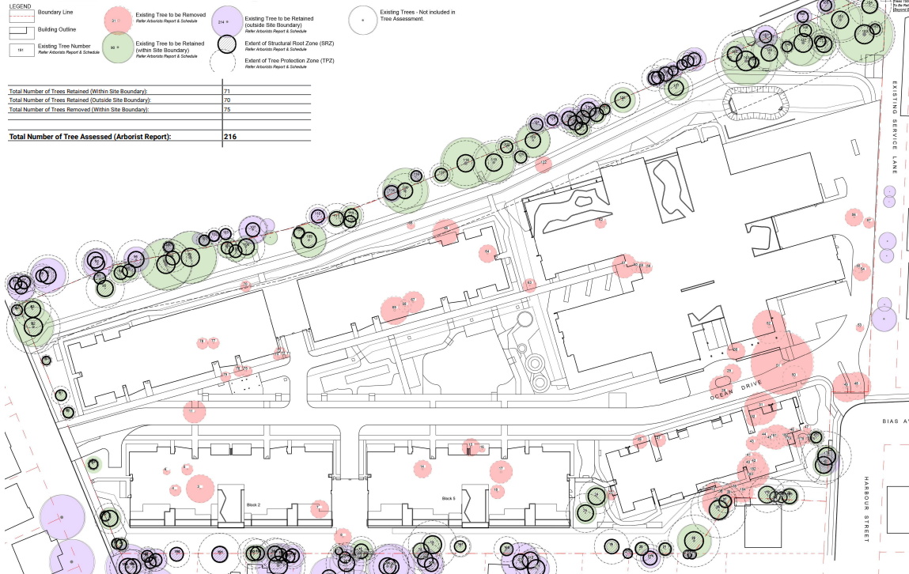
Above: Tree Management Plan

Ecology and Biodiversity

- Streamlined Biodiversity Development Assessment Report (SBDAR)

The proposal exceeds the NSW Biodiversity Offset Scheme (BOS) through the Biodiversity Values Map threshold. The application is supported by a SBDAR certified by Narla Environmental in accordance with the Biodiversity Assessment Method (BAM) 2020. The Biodiversity and Conservation SEPP 2021 has been addressed in the SBDAR for the Koala.

Native vegetation on the site was identified as Plant Community Type (PCT) 1717 - Broad-leaved Paperbark - Swamp Mahogany - Swamp Oak - Saw Sedge swamp forest of the Central Coast and Lower North Coast. PCT 1717 was stratified into two vegetation zones. Vegetation zone one is commensurate to the State listed Endangered Ecological Community, Swamp Sclerophyll Forest on Coastal Floodplains.

The planted native vegetation module was used to assess landscaped areas with planted native and exotic species. This area does not require offsetting.

Under the streamlined assessment module, targeted surveys are only required for species at risk of Serious and Irreversible Impacts (SAII) which are identified by the BAM-C. A total of six candidate SAII species required assessment by the BAM-C. Five of these species were assessed as absent due to habitat constraints and one species, the Swift Parrot, was assumed to be present. The SBDAR provides an accurate assessment of the biodiversity values of the site.

The species polygon for the Swift Parrot is 0.16 ha which encompasses the mapped important area extent within the subject site in accordance with the BAM. Two species credits for the Swift Parrot is required to be offset. An assessment of SAII on the Swift Parrot is provided in Table 15 of the SBDAR. Three native trees, none of which are key feed species for the Swift Parrot, are identified to be removed within the important habitat area. Given no Swift Parrot key feed trees will be impacted in the important habitat area or on the subject site, Council’s Ecologist is satisfied that the proposal will not result in a SAII on the Swift Parrot.

- Avoid and minimise

The site area is predominately contained to existing landscaped or cleared areas. 56% of native vegetation on the subject site which has been identified as commensurate to Swamp Sclerophyll Forest EEC will be retained under the proposal.

All Swift Parrot key feed trees on the site are retained by the proposal which includes four large Spotted Gum trees (Corymbia maculata). However, four key feed trees (all Eucalyptus pilularis), located on private properties adjoining the site will be subject to encroachments that range from 5-8% (supported by Council’s Arborist).

Mitigation measures provided in Table 7 of the SBDAR will require implementation through a Biodiversity Management Plan required as part of the Construction Environmental Management Plan (CEMP). The plant schedule in the updated Landscape Plan contains suitable species including 23 Swift Parrot feed trees (200L pots).

Overall impacts

Accordingly, it is considered that the proposal will not result in any significant adverse impacts in the locality as outlined above.

  - Section 4.15(1)(c) - Suitability of the site

The site is situated within an established and well serviced location with a high level of amenityThe design of the proposed development is of a high quality and is in an appropriate form, layout and scale that achieves a suitable balance between the opportunities and constraints of the site. Although the site is bushfire prone land and is subject to some localized flooding, acid sulphate soils and groundwater, the development has been suitably designed to accommodate these constraints. As such, there are no significant site constraints or hazards that would render the location of the development as unsuitable.

The site has been operated as an aged care development dating back to the 1980’s and the continued use of this site for an expanded and up-to-date development for this purpose is a reasonable and appropriate use of the site.

The proposed development will provide a number of social benefits to the area including the continued and expanded provision of additional aged care housing and much needed aged care infrastructure in the area. The upgraded facilities will provide more housing choice for aged residents of the Central Coast.

The proposal will not adversely impact on the character and amenity of the locality or streetscape. The site is considered to be in a suitable context for the nature, scale and type of development proposed.

  - Section 4.15(1)(d) - Public Submissions

Submissions are considered in Section 5 of this report.

  - Section 4.15(1)(e) - Public interest

The proposal provides an additional supply of housing and services to support an aging Central Coast population, whilst not compromising the characteristics of the surrounding locality. The proposal includes much needed aged care infrastructure and an expanded and modernised housing choice for older members of the community.
There are no matters associated with the proposal that are contrary to the local or community interest. The proposal is consistent with the broader strategic planning objectives to provide more aged care housing to meet growing demand in established, well serviced areas with a high level of amenity.

- REFERRALS AND SUBMISSIONS

  - Agency Referrals and Concurrence

The development application has been referred to various agencies for comment/concurrence/referral as required by the EP&A Act and outlined below in Table 5.
There are no outstanding issues arising from these concurrence and referral requirements subject to the imposition of the recommended conditions of consent being imposed.

Table 5: Concurrence and Referrals to agencies
Agency | Concurrence/  referral trigger | Comments  (Issue, resolution, conditions) | Resolved
Concurrence Requirements (s4.13 of EP&A Act)
N/A |  |  | N/A
Referral/Consultation Agencies
Transport for NSW | Section 2.122 and Schedule 3 of SEPP (Transport and Infrastructure) 2021  Development that is deemed to be traffic generating development in Schedule 3 due to parking provision exceeding 200 spaces under Column 2. | TfNSW has reviewed the information provided and raises no objection to or requirements for the proposed development as it is considered there will be no significant impact on the nearby classified (State) road network.  TfNSW recommends that the following matters should be considered by Council in determining this development:  • Council should consider the needs of active transport and it is suggested investigation of pedestrian shared path links to shops and other surrounding facilities be undertaken and provided as necessary to enable walking and use of mobility scooters as transport modes for this development.  • Council should ensure that appropriate traffic measures are in place during the construction phase of the project to minimise the impacts of construction vehicles on traffic efficiency and road safety within the vicinity.  These matters have been considered in the assessment of the application and addressed where needed under recommended conditions. | Y
Integrated Development (S 4.46 of the EP&A Act)
NSW Rural Fire Service | The development requires approval from the RFS under S100B - Rural Fires Act 1997 for a Bush Fire Safety Authority (BFSA) for special fire protection purposes. | No objection is raised subject to the previous General Terms of Approval issued 25.11.21. A BFSA has been issued for the revised development dated 3 November 2022. (RFS Ref. DA20210901003748-CL55-1) | Y
Natural Resources Access Regulator | The development requires a Controlled Activity approval under the Water Management Act 2000 (s89,90 or 91) | General Terms of Approval issued for IDAS-2021- 10023. | Y

  - Council Referrals (internal)

The development application has been referred to various Council officers for technical review as outlined below.

Table 6: Consideration of Council Referrals
Officer | Comments | Resolved
Senior Development Engineer | No objection subject to recommended conditions. Any relevant discussion is included in the assessment section of the report. | Yes  (conditions)
Traffic & Transport Engineer | Council’s Traffic and Transport Engineer reviewed the proposal including the traffic modelling in the submitted Traffic Report and the Transport Management Plan and raised no objection.  Based on the modelling it is anticipated that the proposed development will not have a significant impact on the surrounding road network and parking provision exceeds the SEPP requirements for a social housing provider. Additionally, no objection is raised to the variation sought to the accessible parking requirements as the site is managed by a social housing provider. | Yes (conditions)
Water and Sewer Engineer | Council’s Water and Sewer Assessments Team has advised that works for the proposal will need to ensure the integrity of Council’s existing 600mm Asbestos Cement Effluent main that extends through the site is not impacted upon. No objection subject to conditions related to site management during construction with the main needing to be replaced subject to terms under the Water Management Act 2000. | Yes (conditions)
Senior Environment Protection Officer | Council’s Senior Environmental Protection Officer has assessed lighting impacts, odour impacts, noise impacts, contamination and ASS impacts, and air quality impacts during construction are acceptable or can be managed via the imposition of appropriate conditions of consent. These issues are considered in more detail in the Key Issues section of this report. | Yes (conditions)
Architect | No objection subject to conditions requiring the balconies of five Assisted Living Apartments to be adjusted to comply with the minimum area under the ADG. | Yes (conditions)
Waste Services | No objection subject to conditions. | Yes  (conditions)
Contributions Officer | . No contributions are imposed as the proponent is a social housing provider in accordance with Ministerial Direction. | Yes
Ecologist | Council's Ecologist has assessed the ecological impact of the proposed development in accordance with section 4.15 of the Environmental Planning and Assessment Act 1979 (EP&A Act) and the Environment Protection and Biodiversity Conservation Act 1999 (EPBC Act). Impacts to biodiversity values have been assessed in accordance with the Biodiversity Conservation Act 2016 (BC Act).  Council’s Ecologist has no objection to the proposal subject to the attached conditions being included within any consent granted. | Yes  (conditions)
Social Planner | Initial comments were received raising concerns regarding the lack of community engagement and the affordability of the units for current residents. Community meetings carried out and an addendum to the SIA was prepared by the applicant which addresses the concerns initially raised. The proposed social impact has been appropriately considered. | Yes
Environmental Health Officer -Food & Health | Limited detail has been provided regarding the proposed café, the central club room kitchen, hair salon / day spa and the treatment room. Recommended conditions will require further detailed plans and specifications to demonstrate compliance with the health requirements and (for the food areas) compliance with AS4674-2004: Design, Construction and Fit-out of Food Premises and the Food Standards Code. If the food in the club room kitchen is not ‘food for sale’ these details are not required. Additionally, a pool is identified on the plan however the pool does not fall under the NSW Public Health Act 2010 definition. | Yes  (condition)
Tree Officer | Initial concerns were raised regarding the removal of large and significant trees from the site and adjoining properties. Amended plans have reduced the number of trees to be removed and increased the tress to be retained and protected. No trees on the adjoining sites are to be removed although some are subject to encroachment. The recommendations of the Arboricultural Impact Assessment prepared by Urban Arbor are supported, and no further objection is raised subject to conditions including adherence to the tree protection measures and other recommendations in the report. | Yes (conditions)

The issues raised by Council officers are considered in the Key Issues section of this report.

  - Community Consultation

The proposal was notified in accordance with the Council’s DCP Chapter 1.2 (Notification of Development Proposals). The original proposal was notified from 27 August 2021 to 28 October 2021. The exhibition period was initially to conclude on 26 September 2021 but was formally extended until 28 Oct 2021 due to requests from the public. A total of 90 unique submissions comprising 85 objections and 5 submissions in favour of the proposal and a petition with 440 names.

Amended plans were submitted by the applicant on 20 May 2022. The amended plans reduced the proposal from 232 to 190 apartments. The amended proposal was notified from 17 June 2022 to 15 July 2022. The Council received a total of 173 unique submissions plus a petition 459 signatories. Of the 173 submissions received there were 161 objections and 13 submissions in favour of the proposal. The proposal has since been further amended with a reduction of the unit total to 180. These latest amended plans were not required to be notified under Clause 2.10c of DCP Chapter 1.2.

A public meeting was held with the Hunter and Central Coast Regional Planning Panel on 1 March 2022 (with 2 sessions) at Council’s Administration Centre at Wyong. Minutes from this meeting are available on the Regional Planning Panel website.

In addition, to the above notification, the applicant held their own community consultation initially during May 2021 and subsequently from late 2021 through to April 2022 comprising:

- 3 x online meetings on 11 January 2022 and 3 x online meetings on 12 January 2022.
- in-person session was held on 16 February 2022 and 2 online sessions were held on 17 February 2022
- 3 group meetings to outline the revised redevelopment plans were held on 16 February 2022
- Direct phone calls were placed to community leaders and some neighbours
- Emails with information and invitations to the meetings, together with hard copy invitations, were sent to the neighbours and broader community.
- A Social PinPoint website was prepared to present project information and documentation, in addition to providing a platform through which the community could provide feedback. Feedback was collected via Social PinPoint in 2 phases:
o 22 December 2021 – 31 January 2022
o 16 February 2022 – 13 March 2022
- Feedback via phone, email, and the general Uniting website. The project website will remain ‘live’ for the duration of the project, so that Uniting can continue to keep the community informed.
- Individual meetings were held with residents from 9 – 14 February 2022.

The Panel members also conducted an on-site inspection on 3 August 2022 which included viewing from adjoining properties along Lakin Street and Bias Avenue that are potentially affected by the proposal.

In the last round of notification during June July 2022 period, Council received a total of 173 unique submissions plus a petition 459 signatories, and a summary of the main issues raised in these submissions are considered in the table immediately below.

Table 7: Community Submissions
Issue | Council Comments
Social impacts on existing residents | The applicant has provided further information in relation to this concern advising that there will be no displaced existing SAHF residents. There are 23 affordable housing apartments to be provided and these will be allocated to the 21 existing SAHF residents.
Excessive density, scale, height, bulk | It is noted that the FSR for the proposal is well below that permitted on the site under Clause 45 of SEPP (HSPD) 2004. The amended plans have reduced the scale and density of the proposal as follows:  • Reduced the total number of ILUs from 232 to 180;  • Removed the top floor of blocks 1,2 and 5;  • Set back the upper floors of blocks 1 and 2;  • Stepped Blocks 2 & 5 to include a view corridor  • Removed Block 4 building in its entirety  • Considerably increased the setback of buildings along the eastern boundary; and  • Increased tree retention, improved landscaping and communal open space.  The design changes present a more compatible interface with surrounding development, focussing height and density towards the north and western side of the development, away from sensitive interfaces/ streetscapes, primarily to the east and south.  The proposed development presents a “stepped” two to three storey appearance to all adjoining residential land, which is a scale compatible with the neighbouring development  (Noting that compatible, does not necessarily need to be, entirely consistent with). The new RACF building articulation includes a combination of materials and varied built form. The building is set back from the entry and sits within a landscaped setting with generous planting and large screening trees.
Amenity Impacts on neighbouring lots | Amenity impacts by way of visual massing/amenity, overshadowing and privacy have been addressed by:  • Internal replanning of the layouts of blocks 2, 5 and 6 to reduce the number of east facing ILUs with the potential to overlook to the east.  • Removal of 6 Independent Living Units (ILUs) from the central portions of Blocks 2 and 5 along the eastern interface to create “breaks” in the built form, reduce the perceived length of those buildings, reduce their overall massing, and to promote view corridors and daylight access through the buildings.  • To further enhance the above, inclusion of solid balcony balustrades and screening angled blades to the living rooms of upper floors to limit overlooking into neighbouring properties to the upper levels and to reduce overlooking even further  • Increased setback of all buildings from the eastern boundary.  • Retention of existing trees along the eastern interface.  • Planting of new trees along the eastern interface to enhance softening of the built form, supplement biodiversity and improve privacy (refer to buffer planting, illustrating how this will be achieved within the Landscaping Plans Appendix G).  • Increased height of boundary fencing (1.8m to 2.1m) along the east for further privacy mitigation.  • Removal of the upper floor of blocks 2 and 5, reducing visual bulk and scale and quantum of ILUs with potential to overlook to the east, and subsequent reduction in shadow impacts.  • A reduction in visual massing/scale to Altona Avenue due to the increased setbacks, reduction in height, increased setback to the (reduced) upper level and increased landscaping.  • The layout of block 6 has been reconfigured to increase the setback at the closest point to 1A Harbour Street. This increased setback allows for additional more substantial trees/landscaping to be planted at the boundary intersection to minimise sight lines.  The proposal does not unreasonably impact on the privacy of, or solar access for, any of the neighbouring properties.
Lack of community consultation | Prior to lodgement of the DA, the Applicant held community consultation sessions at the existing facility to inform neighbours regarding the upcoming development. Neighbours were informed of the session through a letter box drop of the surrounding neighbourhood. However, very few members of the community attended the session, and it was noted that the Covid situation was prevalent at this time.  Following receipt of the RFI from Council, the applicant engaged a Consultation Consultant to undertake additional community consultation sessions to understand the community’s concerns and seek the community’s feedback on a revised scheme. Additionally, there has been two separate notification periods held for the DA and the Regional Planning Panel held a public meeting regarding the proposal to listen to community concerns.  There has been a sufficient level of consultation and engagement with all key stakeholders, including the broader community, to ensure that the concerns raised regarding this proposal have been considered and ameliorated in the design of the development and the assessment of the proposal.
Bias Avenue access exiting conditions & sightlines and safety of accessing bus stop | The plans have been amended to shift the access north along Bias Avenue which will limit the availability of kerb area for parking in this section which will improve sightlines.  Conditions have been recommended requiring provision of a shared pathway along the Bias Avenue frontage and mid-block pedestrian refuse to improve pedestrian safety.
Impact of additional traffic using Altona Avenue. | The plans have been amended to include:  • Left turn only and line marking/signage for the exit on to Altona Avenue.  • Clear signage at the entry point (as part of a future development application) to ensure vehicles/ patrons will not miss the entry and conduct U-turns at the end of Altona Avenue.  • The proposed staging has been reduced from three to two stages to ensure no construction vehicles are required to use the existing Altona Avenue driveway for access and to reduce the construction timeframe.
Character of area | It is noted that the local precinct is undergoing a transition as older building stock is being removed and replaced with new or substantially refurbished dwellings. As such the character of the area is evolving. The proposed setbacks are generally compliant with the DCP, and the FSR complies with (and is well under) the prevailing SEPP standard. The height is considered to suitably respond to the transition in zone from R1 on the site to the R2 sensitive interfaces to the east and south. It should be noted that the maximum height for a dwelling house in the R2 zone under Council’s DCP Chapter 2.1 is 10m. The architectural style of the proposal has a coastal character which will complement the future character of the area.  The revised proposal has employed a number of design techniques to break up the visual appearance of the development including generous boundary setbacks, large building separations and vegetative screening. The proposed development has been designed to respond to the existing topography and locate taller buildings (particularly block 3 and the RACF) in locations that have limited visibility externally from the site. The built form suitably transitions down towards the sensitive interfaces of the site, which combined with the other revised characteristics of the development, ensures it sits comfortably within a landscape context.  The materials and building forms chosen are of high architectural quality, are contemporary in nature, and consistent with those used in most new developments. The revised design is intended to be in keeping with the evolving character of Bateau Bay. Coastal materials will be used in the construction of the buildings, including sandstone sourced locally from the Central Coast, weatherboard cladding and render.  The bulk and scale of the revised proposal is consistent with the four planning principles established under GPC No 5 (Wombarra) Pty Ltd.
Impacts to vegetation. significant tree removal | The original DA proposed the removal of 133 of 216 trees across the site. Several of the trees identified for removal were on adjoining properties due to the potential impact on tree root zones when undertaking construction along the boundary. The increased setback along the eastern boundary suitably avoids the need to remove any trees on neighbouring properties.  The revised development has resulted in a reduction of tree removal from 133 to 75 trees across the entirety of the site. The vast majority of these 75 trees are not native and comprise small scale vegetation interspersed between existing ILUs on the site. There are no trees requiring removal on the adjoining land, but some will still be subject to encroachments. The proposed central village green will also assist in creating habitat for wildlife.  To ensure that the leafy character of the area is maintained, the applicant is committed to delivering over 3 new trees (256 in total) for each tree that is removed as part of the offset commitment. The proposal achieves an improved vegetation outcome for the site compared to what currently exists.
Swift Parrot habitat loss | Although there are no historical records of the Swift Parrot within the subject site, the Swift Parrot was assumed to be present in the BDAR methodology. Two species credits for the Swift Parrot are required to be offset. An assessment of SAII on the Swift Parrot is provided in Table 15 of the SBDAR. Three native trees, none of which are key feed species for the Swift Parrot are identified to be removed within the important habitat area. Given no Swift Parrot key feed trees will be impacted in the important habitat area or on the subject site, Council’s Ecologist is satisfied that the proposal will not result in a SAII on the Swift Parrot.  More swift parrot feed trees (23 trees) are being planted as part of the amended design. The proposal promotes a canopy bio-link through the site to encourage swift parrot habitat growth and stabilisation well into the future.  The proposed development will include considerable landscaping and 256 new trees in addition to the 141 trees being retained across the site. The landscaping plan identifies that the species of vegetation proposed to be planted will be endemic to the area, which will create a far more suitable habitat for the Swift Parrot compared to existing conditions.
Safety and security | The development has been designed in accordance with CPTED principles and a report (and addendum report for the revised proposal) has been provided identifying the design and other measures to be adopted to ensure the safety and security of residents and others within the development.
Pedestrian road safety | Recommended conditions will require footpath provision/upgrades for the Altona and Bias Avenue frontages and a suitable pedestrian crossing treatment in Bias Avenue to ensure safe crossing to the bus stops either side of the road.
Construction impacts (excessive length of time and amenity impacts) | The applicant has revised the staging plan to construct the development in two stages rather than three. Consolidation of the construction stages will result in a reduced length of construction and associated impact to the broader locality. All construction vehicle access will occur via Bias Avenue to ensure no impacts to residents along Altona Avenue. During construction, parking for construction workers will be provided on-site to minimise the impact in surrounding streets.  Stage 1 comprises the area closest to neighbouring residential properties to the east. The completion of this stage will provide a buffer to most of the neighbouring properties. A comprehensive construction management plan will also be prepared to limit the on-site construction impacts on the surrounding neighbourhood.
Traffic generation | Concern was raised regarding the traffic impacts to the existing road network and the impacts from construction traffic. A revised Traffic Impact Assessment was provided which assesses the traffic impacts arising from the proposed revised development.  Council’s Traffic and Transport Engineer has assessed the proposal and advised that based on the SIDRA modelling results it is anticipated that the proposed development will not have a significant impact on the surrounding road network.
Impacts from light spill | The applicant’s lighting impact assessment report identifies that the proposed lighting schemes will be designed in accordance with AS4282-2019 -Control of the obtrusive effects of outdoor lighting. The report includes additional sites pecific outcomes and recommendations to be adopted to minimise light spill impacts:  • The number and mix of ILUs facing the Lakin Street neighbours have been revised so there is less ILUs and therefore less light spill at night.  • All balcony balustrades facing the Lakin Street neighbours are solid (no longer glass) further obscuring and mitigating light spill from ILUs and moveable screens will be installed to further assist with this mitigation.  • All balcony lights will be low wall lights (and not overhead ceiling fittings) so they will not be able to be seen by the neighbours as they will be blocked by the solid balustrades.  • Increased setback to 13.6m+ from the Lakin Street neighbours boundary fence and increased depth and density of the landscaping will further obscure and mitigate light spill.  • External lighting controlled by timers and sensors to ensure a minimum amount of safety lighting during non-curfew hours.
Impacts on local infrastructure (footpaths,  services, roads, etc unsuitable to support density) | Recommended conditions will include the upgrading of footpaths along the site frontage and other civil works. The recommended conditions will also require the construction of a new bus shelter in front of the site and provision of suitable pedestrian crossing treatment to the opposite side of Bias Avenue. Once operational, the development is expected to have a relatively low net increase to local traffic volumes and minor impact on the surrounding road network.
Noise impacts | A Noise Impact Assessment was prepared to evaluate noise impacts of the revised proposal. The noise impact assessment concludes there will be no adverse acoustic impacts to neighbours noting that:  • The demographic of the future occupants favours a quiet environment.  • The number and mix of apartments facing the Lakin Street neighbours were reduced.  • The setback from the Lakin Street neighbours boundary fence was increased which also increased the depth and density of the landscaping.  • The boundary fence on the east has been increased from 1.8m to 2.1m  • The road/driveways between B1 + B3 and B2 + B5 is internally positioned which will further reduce potential noise impacts from vehicles entering or exiting the ILU carparks.  Recommendations have been provided for mechanical plant and equipment noise emissions, which have been incorporated into the design of the development.
Noise and vibration impacts during construction | The applicant’s Noise Impact Assessment was amended to better address construction noise and vibration impacts. The number of stages has been reduced to 2 which will shorten the duration of the works on site. It is unlikely, given the soil conditions assessed within the Geotechnical report, that any rock hammering will need to occur on the site for the foundations. Standard construction hours will apply to the development under recommended conditions.
Inconsistent with established strategic direction. | Concern was raised that the Bateau Bay area was not identified as a growth area nor as a local centre for infill development under any Strategic plans (I.e., Central Coast Regional Plan and Wyong Settlement Strategy). Despite not being identified for infill development, these strategies do not make recommendations to preclude development that is consistent with relevant planning controls. In this instance, the proposal is consistent with the relevant provisions of the SEPP (HSPD) 2004 that applies to the site. The SEPP prevails over Council’s planning controls. The site is within an existing established and well serviced location so (unlike new centres and greenfield areas) there is no need to forward plan for services and infrastructure to support permissible development (that is within the planning controls that apply) within this area.  The proposal is consistent with these strategic documents in meeting the critical demand for housing supply and aged care services for the aged community, whilst not compromising the characteristics of the surrounding locality. The proposal provides an additional supply of housing and services to support an aging Central Coast population.  In this regard, the applicant has stated:  Prioritising seniors housing was also identified within evidence prepared by the Urban Development Institute of Australia’s titled “Chronic Shortage of Seniors Living Land on the Central Coast”, published in 2018, identifying that there was a chronic shortage of seniors living opportunity on the central coast. It was recognised within the paper that there is a shortage of sites where seniors development is able to be supported and more efforts should be made to support seniors development on what limited sites are available if the 41,525 additional persons over the age of 65 over the next 20 years are to be accommodated. As noted earlier, this site provides the unique opportunity to assist in meeting this demand, but also, to accommodate a mix of ILUs and a RAC to enable seniors to “age in place”. This not only results in an increase in seniors accommodation provision from the site, but a social benefit in enhancing the quality of accommodation by supporting residents moving from independent living to assisted or full-care.
Stormwater Management.  concerns the stormwater system not adequate to cater for the stormwater in the north-east and from the eastern boundary. | An inter-allotment drainage line (swale and pit/pipe system) is proposed along the eastern boundary of the site and has been sized to capture runoff from the adjacent properties in the 1% AEP storm event. Part of this runoff is directed into Council’s system on Bias Avenue, with the remainder directed to Council’s system on Altona Avenue.
Impacts to Altona Avenue streetscape appearance | The applicant has made a number of design changes along the southern boundary to better address the Altona Avenue interface:  • Remove the top floor of both buildings,  • Setback the upper level of the resultant top floor,  • Increase the setback to Altona Avenue,  • Refine the building façade,  • Retain the existing trees and,  • Enhance the landscaping within the street setback which will screen the proposed development at street level.  The revised design is considered to lessen the visual prominence of Blocks 1 and 2 when viewed along Altona Avenue which more suitably addresses the zone transition to R2 on the opposite side of the road.
Total occupancy of the proposed development & if other than seniors as residents | The Seniors SEPP, identifies who can live in the development and this will be a requirement of the consent.  The applicant advises:  The applicant understands that there is demand for 3-bedroom ILUs in retirement and independent living villages. This stems from the fact that many people downsize from larger homes and have a substantial number of belongings that they would like to bring with them to their new retirement and independent living apartment.  The presence of the third bedroom does not necessarily mean that there will be three people living in an ILU. In fact, the average population of comparable Uniting developments is 1.13 occupants per ILU. Rather, it provides residents with the opportunity to have extra storage space or somewhere for family and friends to stay when they visit. Uniting’s focus is on providing services to older people as their needs change, so the proposed ILUs that will be available for purchase will only be offered to seniors.  Residents may invite visitors and guests to stay with them temporarily for visiting purposes. All visitors must also follow the village rules. For example, visitors must not disturb other residents’ quiet enjoyment of the village. With approval of village management, visitors are able to period. Only those on the contract are allowed to reside permanently within the Village. Adult children of residents are not allowed to live with their parents unless approved by Uniting under exceptional circumstances. For example, an adult child living with a disability may be approved. stay for a maximum of 28 nights in any 12-month period. Only those on the contract are allowed to reside permanently within the Village. Adult children of residents are not allowed to live with their parents unless approved by Uniting under exceptional circumstances. For example, an adult child living with a disability may be approved.
Concern Acid Sulphate Soils and groundwater not considered | An Acid Sulphate Soils Management Plan has been provided for the development in accordance with Clause 7.1 of WLEP 2013. The development will be conditioned to be carried out with the adopted plan. The Geotechnical report identified that the highest level of groundwater seepage within boreholes occurred at a depth of 3m and the other boreholes recorded groundwater at a much lower depth. No excavation for bulk earthworks is proposed to exceed 3m. There is no excavation proposed at a depth which would result in acid sulphate soils interacting with groundwater.
Affordable housing provision. Only 10% of units affordable whereas all 114 existing units are affordable due to their age & design. | The proposal includes 23 affordable housing units which is above the minimum number of 10% of total units required. The existing dwellings and facilities on the site were constructed in the 80’s and are no longer fit for purpose or align with the modern standards and needs of Seniors. The affordable units will be offered to the existing residents on the site should they wish to continue to reside on the site.
Need to consider proposal against SEPP (Housing) 2021 | The DA was lodged on 12 August 2021, well before the gazettal date of the new Housing SEPP on 26 November 2021. Under Schedule 7A Savings and Transitional Provisions  Clause 1 (a) of the Housing SEPP states … this policy does not apply to the following matters – a) a development application made, but not yet determined, on or before the commencement date (being 26 November 2021)  The SEPP (Housing) 2021 is not applicable.
Odour Impacts | The site is located adjoining the Bateau Bay Sewage Treatment Plant and an Odour Study accompanied the DA. The assessment included several on-site odour impact tests to ascertain the likely odour impacts expected to be experienced across the site. An addendum to the odour impact assessment was prepared in response to particular concerns.  The odour expert, after reviewing the revised landscaping and air conditioning plant design, has concluded that the outcomes of the original report have not changed and that all reasonable, practicable measures have been incorporated to mitigate potential future odour impacts. The odour impact assessment and addendum both concluded that the Bateau Bay sewerage treatment plant is not adversely impacting the existing development or likely to impact any future proposed development on the site.
Air quality impacts | Given the scale of the construction and the existing aged residents who will be living on the site during works, conditions have been recommended to address air quality on the site including dust control and diesel emissions during construction.

- KEY ISSUES

The following key issues were raised with the applicant in RFI’s in relation to the application having considered the relevant planning controls and the proposal in detail:

Issue | Applicant’s response and discussion | Resolved
Scale, form and character – eastern and southern boundary interface (proposal 4 storey but site surrounded by 1-2 storey scale.  Bulk, scale and continuous length of Blocks 2 and 5’s  do not provide sufficient view corridors or solar access to neighbouring Lakin Street properties. | Blocks 2, 5 & 6 have been lowered 300mm, 300mm and 200mm respectively. This has been achieved by reducing the structural floor to floor heights to 3,200 mm. This is the minimum height required to adequately accommodate the structure and services and provide a finished ceiling height of 2,700 mm to meet ADG requirements ie the building cannot be lowered further. The parking level cannot be lowered any further into the ground due to the flood levels (PMF), acid sulphate soils and groundwater levels, and car park ventilation, DDA requirements for accessible paths to building entries, and internal road/boulevard alignment.  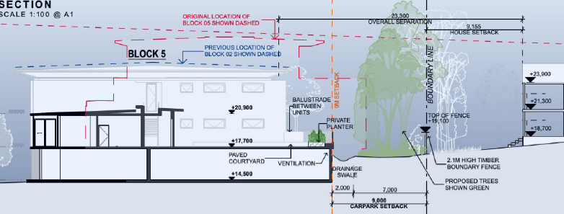  Above: Cross section through No.81 Lakin Street  The amendments to the development have reduced visual mass and improved overall amenity for those residents to the east. Solar access will also be improved. Overall, the reduction to the building height and breaking up of the continuous length of Blocks 2 and 5 presents a positive reduction in the built form outcome which more suitably and sensitively addresses the zone transition between R1 and R2 along this boundary. | Yes
Although notably reduced, concern remains with the bulk and scale and continuous length of the proposed buildings (Blocks 2 and 5) along the residential interface of those residential properties fronting Lakin Street. | To reduce building bulk and any continuous length, Buildings 2 & 5 have been redesigned to provide a large 9m break in the middle of each building. There are now four large breaks along the eastern interface. This has been achieved by removing the two middle units on the top floor, and one middle eastern facing unit on the lower floor of each building. This results in a reduction of 6 units across Block 2 & 5 (2 x 1 bed units, 8 x 2 bed units removed, 4 x 3 Bed units added) The western unit of each of those buildings has been retained to maintain resident and staff access and egress to all units and lifts should one lift be out of service.  By breaking up the façade with the courtyards, the buildings now appear as 4 separate smaller 2 storey buildings in lieu of the longer original form when viewed from the eastern boundary interface. Additionally, the trees located in the centre of each of these four facades assists in further reducing the bulk of built form by giving the perception of 8 residential forms along the Eastern part of the site.  Revised individual sections and elevations have been provided. With the removal of the apartment of the upper floor facing the west it opens up the sightlines across the development from east to west to distant tree canopies in the village green beyond buildings 2 and 5. The apartment to the west and N-S corridor have been retained in order to ensure that Uniting can service the residents in each building. As a home and community care provider, Uniting will offer all residents additional assisted living services across the site. Staff need to use the corridors from one side of the building to the other to provide care services to residents.  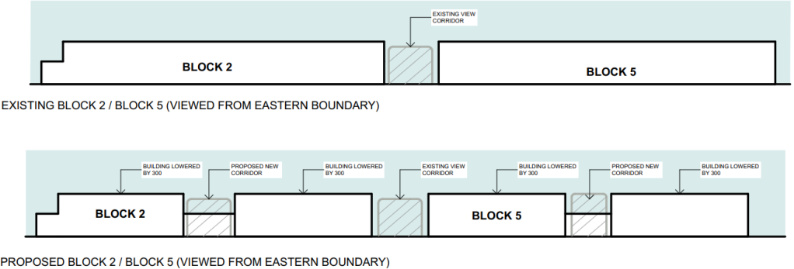  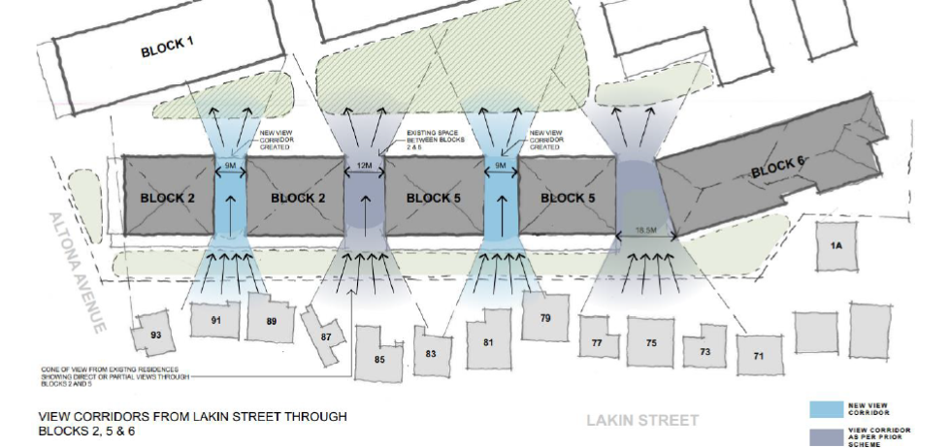  The scale of the development at the residential interfaces has been reduced to better respond to the constraints and context of the site. | Yes
Critical Sewerage Easement & Water supply-  The potential impact of the development on the 600mm Asbestos Cement Effluent main located within the sewer easement traversing the site and capacity of the existing water main currently servicing the site.  Proposed filling up to 2m in depth not permitted. Proposed retaining wall through easement not permitted. | Discussions have been held with Council’s Water and Sewer Assessments Team. It is noted that no structures are proposed to be located within the easement. All building structures are supported on pile foundations to depths below the zone of influence in elevation. The building structure is typically located 3m clear of the asset based on the assumption the pipe is located centrally in the easement. A condition is recommended requiring confirmation of the depth and alignment of the main.  Council’s Water and Sewer Assessments Team have agreed that the realignment of Council’s 600mm Asbestos Cement Effluent main outside of the existing alignment was not required. However, the applicant is required to replace the asset due to the age of the pipe and the proposed site works and operation of heavy machinery over the main potentially impacting on the integrity of this main. The main will need to be protected as part of the works under the DA and replaced as part of the Water Management Act approval.  Design and construction of the new main shall be in accordance with Council’s standards. A construction methodology and detailed bypass plan is required to accompany the design plans for approval prior to commencement of works. | Yes, subject to conditions
Visual impact/interface of the proposed residential aged care facility (RACF) building | Additional landscaping at the frontage (and northern interface) of the RACF, as well as along the eastern site boundary, to further screen the RACF, Block 2 and Block 5, will further enhance the landscape setting of the site. | Yes
Increased discharge to Saltwater Creek (or any Council system), above pre-development flows, for Stage 1, will not be accepted.  Water quality controls will be required to treat all Stage 1 run-off | At present, pre-development water drains from the site into Saltwater Creek via multiple pipe outlets. The post-development Stage 1 catchment diverts stormwater into a single drainage line. This diversion requires an increase in pipe size. Although the post-development Stage 1 reflects a larger pipe, it replaces the multiple discharge pipes and represents an equivalent discharge rate to what currently occurs on the site. Moreover, given the proposed is not likely to alter discharge rates entering Saltwater Creek.  The staged stormwater runoff will need to satisfy the same water quality targets as the full site development. For Stage 1, to deliver appropriate water quality control, this consists of utilising the interim water quality basin and proprietary devices as required. | Yes, subject to conditions
Block 6 building is positioned too close to adjoining properties zoned R2 to the east resulting in amenity impacts and insufficient room for planting. Also, lower Block 6 with removal of subfloor facing Bias Ave | Block 6 has been amended to ensure that the minimum DCP rear setback of 4.5m is achieved and that the height complies with the maximum 8m height limit within the R2 zone under the SEPP.  The proposed minimum setback for this part of the building is now 6.2m and the maximum floor to ceiling height is 7.87m which complies with the maximum permitted under the SEPP of 8m. The revised floor plan allows more landscape screening to 1A Harbour Street. The layout has also been amended to reduce direct visual intrusion by orientating living rooms to the north and providing screens and battens to direct viewing. | Yes
Privacy Impacts  Tree retention and further landscape screening to eastern boundaries needed  Lowering of Blocks 2, 5 & 6  Detailed assessment of privacy needed | The plans have been amended to ensure a greater level of privacy is afforded to neighbouring properties.  The bulk, density and scale of the ILU’s has been significantly reduced and greater setbacks have been provided to the eastern boundary to reduce adverse privacy and overshadowing impacts to the east. Considerable improvements have also been made to the streetscape and site boundaries with more generous tree retention and planting, the reduction in quantity of ILUs at interfaces, and the provision of boundary fencing (to the east) and screening. Blocks 2, 5 and 6 have been redesigned so fewer units are oriented to the eastern boundary. Internal layouts have been revised to reduce direct privacy impacts by orientating living away from R2 zoned boundaries and providing screens to other spaces.  Screening angled blades to the living rooms on the upper floor have been provided to limit the overlooking  of neighbouring backyards. Sliding screens provided to balconies.  Detailed planting plans of the proposed buffer/screen planting along the east boundary have been provided incorporating endemic species. | Yes
SEPP(HSPD) 2004- Compliance with design principles (Part 3 including Clauses 33,34 & 35) | A compliance table (Attachment D) has been provided that demonstrates compliance with the SEPP with the exception of the variation to the relevant Australian Standard for the accessible parking under Clause 4.6 that has been sought. | Satisfactory
Legibility, wayfinding, identity and uniform appearance.  Architectural variation needed to distinguish each building to create a distinct identity | All building elevations have been modified to reflect the changes to the layouts and building heights. Although there are some variations within the various buildings, a uniformity of architectural detail has been adopted. However, every building has a clearly identifiable entry, internal road address and associated pedestrian paths.  The amendments to the building forms and elevations provide a variation of facades within a consistent architectural language.  Identity tree planting has been provided to indicate a hierarchy of planting such as street avenue trees, pedestrian boulevard trees, common open space trees and smaller trees for private open space areas. | Satisfactory
Tree removal including on adjoining land. 43 trees impacted with 25 on adjoining land and 18 high retention stems. | The proposal includes removal of 75 trees to accommodate the development. There are 141 trees identified to be retained, 25 of which will be potentially impacted and require tree sensitive construction methods.  No trees are being removed from neighbouring sites. There are no existing Eucalyptus pilularis or Eucalyptus robusta species (key food plants for the threatened swift parrot) being removed as part of this development.  An increase in the building setback for blocks 2 and 5 has provided the opportunity to retain additional existing trees  within the site boundary particularly along the eastern boundary. Retaining walls, paths and paved areas have been minimised to avoid encroachment into the tree protection zone (TPZ) and encroachment into the structural root zone (SRZ) of existing trees so they are able to be retained in accordance with AS4970 Tree Protection of Trees on Development Sites. | Yes
Visual impacts to character of area from loss of tree canopy | A proposed tree planting plan has been provided indicating 256 new trees for this development which will provide habitat, shade and amenity and assist in reducing the perceived bulk and scale of the proposed buildings. This will offset the 75 trees to be removed and will complement the 141 trees to be retained and protected. | Yes
Tree retention at Bias Ave entry | The Applicant’s traffic engineer has advised: The proposed driveway location is considered the most appropriate and safe location to provide improved sightlines to Harbour Street compared with the existing access location…This location also provides separation from the bus stop…which improved safety for pedestrians. With reference to landscaping, any obstructions greater than 600mm in height or 300mm in diameter must be located outside the visual splay (2.0m by 2.5m). Therefore, the existing trees must be removed to comply with the pedestrian visual splay requirements at the proposed Bias Avenue access  Despite being unable to relocate the entrance and avoid the removal of the two Broad-leaved Paperbark trees for the above safety reasons, the design has been altered to support new trees/landscaping in front of the RACF building and generally, at the frontage of the site. This has resulted in some modifications to the internal road networkfor the latest plans.  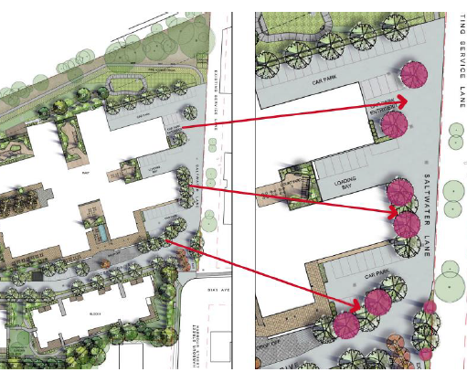  Above: Proposed replacement tree planting  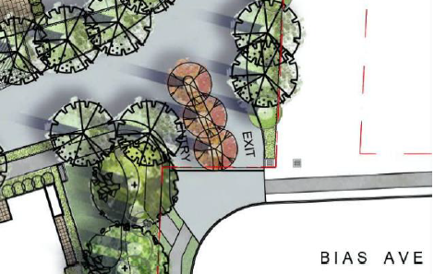  Above Proposed entry planting | Yes
Clarification demolition 1 Harbour Street as not included in demolition plan | A revised demolition plan has been provided which includes 1 Harbour Street for demolition. | Yes
Social impacts – Displacement existing residents and affordability. | The applicant provided detailed information identifying how the social impacts of the proposal are being addressed and this is detailed in the ‘impacts’ section of the report. Existing tenants have the option of relocating to another uniting independent living village or continue living at Nareen Gardens at no greater financial outlay than their current accommodation. The affordable housing units will be allocated to existing residents. | Yes
Affordable Housing Provision – 10% required and clarify whether existing displaced residents eligible | 23 (12%) affordable units are to be provided. The affordable housing apartments will be allocated to the 21 existing SAHF residents, with the remaining apartments to be allocated to others on the Housing Pathways list.  The existing residents may need to move to a temporary unit within the village, depending on where their current unit is situated, before they move to their new apartment, due to the staging process. There will be no displaced SAHF residents. | Yes
CPTED design  Need design for crime prevention than reliance on CCTV. | The proposal includes several design modifications that improve personal safety and security within the development. This includes increased active surveillance with the inclusion of ground level units (to replace the inactive parking façade). All east facing units have ground floor courtyards, which provide active surveillance of the heavily landscaped zone adjacent to the eastern boundary fence. Access to the car parks will be through the main entry of each block, or through security gates at the vehicle entry points. The Village Green is now completely visible from the east facing units of Block 1 & 3, and the west facing units of Blocks 2 & 5 due to the removal of Block 4. An addendum to the CPTED report has been provided. | Yes
Identify the availability of on-site support services  for the residents (of the 82 units) after completion of  Stage 1 in the event of any delay in Stage 2 works | The proposed development will ensure that there will always be a clubroom and administration space available during each stage of the redevelopment. Temporary facilities will be set up in the area proposed to be redeveloped as part of stage 2, for use while the new clubroom is being constructed in stage 1. Residents will then be able to utilise the new clubroom once it is completed. Home and community care services will continue to be provided across the site during construction to support residents, consistent with current arrangements. | Yes
COS and solar access and deep soil zones – compliance ADG | Revised plans show 26% of the site area (9942m²) as COS and that 50% of the area receives direct sunlight to principal usable parts for 4 hours midwinter. Deep soil includes 10,984m² or 28.7% of site area. The ILU’s also comply as 70% of units (126 units) receive 3 hours of direct sunlight midwinter in accordance with the ADG. | Yes
Removal of Block 4 to -improve separation distances; allow for central COS; allow for boundary setback for Blocks 2 & 5 | The centrally located building known as Block 4 containing 36 dwellings was removed from the plans. This has created a centrally located communal open space area. This has also allowed Blocks 2 and 5 to have a greater setback from the adjoining residential properties. An increase in the building setback for blocks 2 and 5 has provided the opportunity to retain additional existing trees within the site boundary particularly along the eastern boundary. | Yes
FSR clarification- demarcation plan needed (SEPP RACF max 1:1 and self-contained dwellings 0.5:1 & on-site services excluded from FSR) | Revised calculations and plans have been provided for the amended proposal. The site comprises one lot with two types of development for which different FSR’s apply. There is no intention to subdivide the site. A nominal area has been provided for the calculations. The proposed RACF has an FSR of 1:1 and does not exceed the maximum of 1:1 permitted under the SEPP. The FSR for the self-contained dwellings includes a base FSR of 0.6:1 (from Council’s DCP) and an FSR bonus of 0.5:1 under Clause 45 of the SEPP which allows for a total FSR maximum of 1.1:1. The FSR proposed for the self-contained units is 0.81:1 which is well below the SEPP bonus requirements. The overall total proposed FSR for all the development on the site (both the RACF and ILU’s) is 0.87:1. | Yes
Acoustic impacts (from roof top plant and loading dock) | A revised noise impact assessment report was provided which addresses the potential construction and operational noise and vibration impacts of the proposal on the site and surrounds and particularly, the nearest sensitive receivers to the site, and includes recommended mitigation measures to be adopted. | Satisfactory
Odour impacts (proximity to BB STP) and a/c intake on roof | Advice has been received from The Odour Unit which addresses concerns raised regarding potential odour impacts from the Bateau Bay Sewerage Treatment Plant. The advice confirms that all reasonably practicable measures have been incorporated to mitigate potential future odour impacts from the treatment plant on the proposed development. | Satisfactory
Parking provision  - Dimensions of spaces need to comply with SEPP(HSPD)  -Confirmation total spaces  -Safe all-weather access to parking (Block 6 parking is in Block 5 and Block 5 is in Block 2)  -On site car queuing areas to entry gate  -Manoeuvrability AS2890.1 to be demonstrated | The parking is located in an all-weather, safe and covered form (except the visitor spaces). The proposed RACF loading area, ILU waste collection area, manoeuvrability and internal driveway grades comply with AS2890.2 – Off-street commercial vehicle facilities. Adequate manoeuvrability is provided throughout the site for fire and/or emergency access during both development stages. No access gates are proposed across the driveways for the development, hence AS2890.1 queuing areas are not applicable.  Parking provision in excess of the SEPP requirements have been provided, however, a variation is sought to the SEPP with regard to the requirement for all parking to be designed in accordance with the relevant Australian standard as accessible parking spaces. Under the SEPP, 36 spaces are required for the ILU’s within the development and 155 spaces are provided. To provide all of these spaces as accessible would not appear reasonable or warranted. The applicant has therefore sought variation to the standard as discussed earlier in the report. | Satisfactory
Fencing details and pedestrian sight clearances.  Details of gates | A proposed 2.1m high solid panel fence at the eastern boundary (replacing existing fence). The existing colorbond fence to the northern boundary of the site (adjacent the RACF) will remain. No front fences or entry gates are proposed within the development. | Yes
Details of any signage | All signage has been removed from development under the DA and will be the subject of a future application. | Y
Ground floor units | Ground floor units have been added to Blocks 1, 2, 3 & 5.  - Block 1 has 3 ground floor units.  - Block 2 has 9 ground floor units.  - Block 3 has 3 ground floor units.  - Block 5 has 9 ground floor units.  - Block 6 lower floor is at ground level and has 12 ground floor units | Y
Emergency access through the site with the impact of  staging | The revised staging drawings indicate resident and emergency services access during stage 1 and stage 2 works. During Stage 1 existing emergency access arrangements will continue to be available to the remaining residents on-site with access from Bias Avenue, Altona Avenue or both. Once Stage 1 is complete ambulance bays for Blocks 2 and 5 also will be available. During Stage 2 emergency access arrangements will continue to be available from Bias Avenue. Altona Avenue or both via the newly built Ocean Drive. | Satisfactory
Clarification staging arrangements | It is noted that the original scheme included three construction stages, and this has now been consolidated down to two stages. The revised staging drawings and supporting infrastructure staging plans satisfactorily identify how access to water and electricity will be maintained across the site during construction.  Construction parking for stage 1 includes provision of a car park with 36 spaces on site near the Bias Ave frontage. For stage 2 there are 33 spaces provided in a car park towards the north-western corner in the location for the RACF parking. | Satisfactory
Stormwater – DRAINS model requested.  Clarification for stage 1 stormwater arrangements. | DRAINS model provided. The plans and information satisfactorily demonstrate no/negligible impact on the flows/levels in Saltwater Creek for both Stage 1 and Stage 2 post-developed scenarios. | Yes
Relocation 2 substations on Bias Ave frontage as not well screened and close to proposed and existing residential | 2 x substations will be required to provide electrical capacity. Both of these are now to be provided within the development site with no impact to the Bias Avenue frontage or streetscape. | Yes
No connection to 100mm recycled water main NW corner | The Services Infrastructure Report has been revised to note that connection to Council’s 100mm recycled water main, in the north-western corner of the site, is no longer proposed, in response to Council’s Water Assessments section previously confirming this would not be supported. | Yes
Evidence of social housing provider status for applicability SEPP(HSPD) & contributions | The applicant provided the Certificate of Registration for the Uniting Church in Australia Property Trust (NSW) for Uniting (NSW ACT) a registered community housing provider. | Yes
Waste Management – revised WMP required | A revised Operational, Demolition and Construction Waste Management Plan has been provided by Waste Audit in response to the revised scheme. Waste pick-up has been allocated into two locations:  - RACF waste will be picked up adjacent the RACF Loading dock area.  - ILU Waste will be picked up from a designated area adjacent the Altona Avenue exit.  The plan confirms that through the appropriate mitigation measures, operational, demolition and construction waste can be managed throughout the entirety of the proposed development. | Yes
Updating of landscape plan | Amended landscape plans have been provided that included additional planting and corrected plant names. Landscaping has been increased, particularly on the eastern boundary. A review of species and tree removal has been undertaken. | Yes
Caravan parking | 2 caravan/boat parking spaces have been included in the north-western corner of the site. Notwithstanding the above, Uniting has advised that by the time individuals become residents of its facilities, they are generally past the caravanning stage of life. | Yes
Sewer servicing | There are multiple connections to the sewer within the site boundary and based on proposed discharge rates, these connections can be maintained. | Yes
Parking for Block 6 is in Block 5 and parking Block 5 is in Block 2 but no convenient, safe, direct, all-weather connection for these residents. | A covered walkway between the buildings has been provided, with security access to each building | Yes
Plan details – RL’s setbacks and reference errors | a) RLs have been placed on drawings  b) Staging plans have been updated  c) Level 3 of Block 2 and 5 have been removed | Yes

  - Outcome of Issues raised

The above issues have all been satisfactorily resolved through amendments to the plans and information and as further addressed in the recommended conditions of consent.

  - Urban Design

Urban design looks at a development in its context, considering the existing and desired future character of the local area, compatibility with the built form of surrounding development, and the setting including the landscape and natural areas. In a development the size of Nareen Gardens, urban design will also consider the spaces created within the development and the resulting overall experience.

The proposed seniors living development is located in the predominantly residential area of East Bateau Bay. It is surrounded by low density residential development and natural vegetation. The site is currently occupied by low scale seniors living and is within a larger area of numerous other seniors living and aged care facilities. The site is west of the headland between Shelly and Bateau Bay beaches. One of the key features of East Bateau Bay is the large number of significantly sized trees on public and private land. There is a continuity between these trees and the vegetation of the National Park surrounding the headland and beaches. The impression is of a residential community nestled among the trees, rather than a streetscape where urban forms are dominant.

In terms of urban design, the final amended scheme (revision D) provides a very good quality design outcome. The proposed development is for a seniors living complex that has a high level of amenity for future residents. The development has been designed to create a sense of community, with buildings of 2-4 storeys orientated around a central outdoor space that is attractive and inviting. A sense of arrival is created on the driveway from Bias Avenue, with landscaping and signage implying a “gateway” into the community. The porte cochere of the RACF signals an entry point to a reception area and provides a sheltered area for pedestrians into vehicles.

Moving into the middle of the site, it is clear that apartments are orientated towards the activity of the communal open space, in a parkland like setting. A bushfire protection zone along the western boundary provides an opportunity for a landscaped walkway that is less busy than the centre of the development. Generous setbacks to the eastern boundary with the neighbouring residences allows for the retention of mature trees and significant landscaping.

Following feedback, the built form and scale has been modulated so that taller (4 storey) buildings are located in the middle of the development where there are less impacts and intrusions. Other buildings have a 2-3 storey address to the street and to adjoining residences. The building form of the two blocks adjacent to the Lakin Street residences, has been further broken up by reducing the number of apartments and creating a void in the building to allow for view corridors, sunlight and natural ventilation. The height of these buildings has also been reduced to further decrease the impacts on adjoining residents. In addition, the deletion of one of the apartment blocks early on in the DA process has made this development a much better fit for the site, so that it sits comfortably and unobtrusively within its context.

The architects have produced a quality outcome and the facades of the buildings show a high level of articulation. Different architectural treatments have been used to “pop-out” certain aspects of the buildings, so that they don’t appear as simple boxes with windows, doors, and balconies. Clever expressions in the treatment of the ground floor alternatively recede the use behind or connect to the street with apartments. Ground floor apartments in all of the residential blocks assist in providing a sense of ownership and identity at the street level, and an increase in perceived safety with street-level surveillance. The floor plans are generally very well considered with only minor issues that are to be expected in a development of this scale. The architects have suitably responded to each of the concerns that have been raised during the assessment.

Overall, the final amended scheme (revision D) provides a very good quality urban design outcome. The site is operating as an existing senior living development and this DA will allow more residents to enjoy the location with a higher level of amenity than is experienced for residents in the existing development. The impacts of the proposed development on neighbours have been minimised as much as possible and a balanced outcome has been achieved. The facility is to be owned and operated by the same organisation and there is higher level of care and site management that would occur within an apartment complex where units are all privately and separately owned. Where there are still minor concerns, these can be addressed in any management plan. For example, caravan or boat parking can be mandated to be off-site in a storage facility or other location, and residents can use the two spots for temporary access and loading of vehicles.

The development of this scheme has followed an iterative process where concerns and issues have been addressed through considered revisions, producing a very good quality development. In terms of urban design, it is recommended that this proposal should be supported subject to recommended conditions.

- CONCLUSION

This development application has been considered in accordance with the requirements of the EP&A Act and the Regulations as outlined in this report. Following a thorough assessment of the relevant planning controls, issues raised in submissions and the key issues identified in this report, it is considered that the application can be supported.

The site is considered suitable and the proposal in its revised form is compatible with the locality. There is a 20% reduction in overall density from the previous scheme from 232 to 180 units. The proposal complies with the maximum FSR permitted under Clause 45 of SEPP (HSPD) 2004. The R2 zoned part of the site complies with the maximum height under the SEPP. It is noted that the maximum height limit within the R1 zoned land under the SEPP is a standard that cannot be used as grounds to refuse consent. The part of the development within the R2 zoned land complies.

Further lowering and increased setbacks for the buildings located adjacent to the eastern residential boundary and street fronts have been made. A merit assessment has been carried out regarding the proposal and the revised height and this is considered satisfactory. The built forms that attribute to FSR/density within the development have been designed to respond to the context of the site and the sensitive interfaces, particularly to the east and south. The proposal ensures there is a generous provision of perimeter and on-site landscaping, deep soil planting and communal open space. There is a social benefit in the delivery of the proposed “density” on the site in that it will provide aged care accommodation, facilities and services and 12% affordable ILU places.

It is considered that the key issues as outlined in Section 5 have all been resolved satisfactorily through amendments to the proposal and in the recommended draft conditions at Attachment A.

- RECOMMENDATION

That the Development Application DA/882/2021 for a seniors housing development in stages comprising demolition works, construction of a residential care facility (RACF) with independent living units (ILU’s) with associated on-site support services and communal facilities, car parking, landscaping, and other ancillary works under SEPP (Housing for Seniors or People with a Disability) 2004 at 19 Bias Avenue and 1 Harbour Street Bateau Bay be APPROVED pursuant to Section 4.16(1)(a) or (b) of the Environmental Planning and Assessment Act 1979 subject to the draft conditions of consent attached to this report at Attachment A.

The following attachments are provided:

- Attachment A: Draft Conditions of consent
- Attachment B: ADG Compliance Table
- Attachment C: Tables of Compliance - WLEP and DCP Planning Controls
- Attachment D: SEPP (Housing for Seniors and People with a Disability) 2004 Compliance Table
- Attachment E - Architectural Plans
- Attachment F: - Applicant’s Clause 4.6 Exception to Development Standards

